Final Report for ADRIFT in the California Current Survey: Passive Acoustic Monitoring in the California Current using Drifting Recorders

[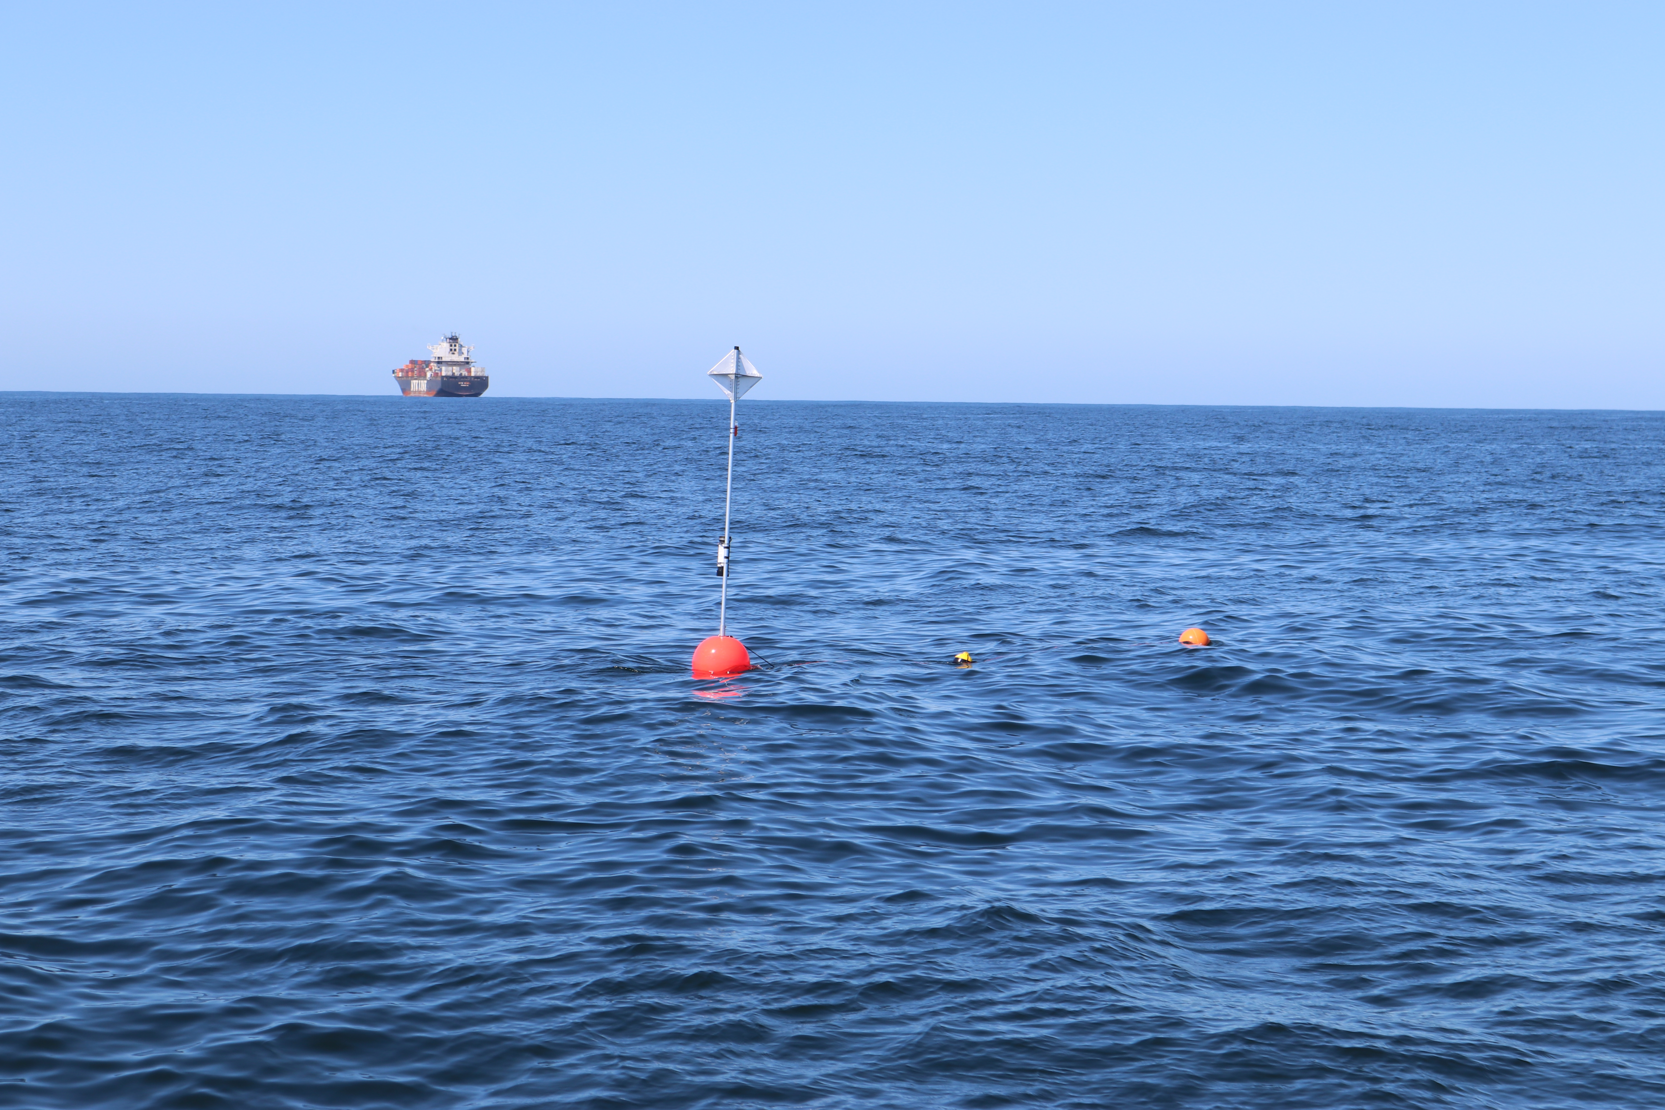](https://github.com/shannonrankin/ADRIFT_Report/blob/main/figs/drifterShip_Rankin_SWFSC_ACCESS_2021_MULTI-2019-005.JPG)

**Final Report for ADRIFT in the California Current Survey: Passive Acoustic Monitoring in the California Current using Drifting Recorders**

September, 2024

Authors:

Shannon Rankin

Kourtney Burger

Cory Hom-Weaver

Kaitlin Palmer

Taiki Sakai

Anne Simonis

Prepared under Interagency Agreement G14M20PG00013

by

Southwest Fisheries Science Center

NOAA Fisheries

8901 La Jolla Shores Dr. La Jolla, CA 92037

**DISCLAIMER**

This study was funded, in part, by the U.S. Department of the Interior, Bureau of Ocean Energy Management (BOEM), Environmental Studies Program, Washington, DC, through Interagency Agreement Number G14M20PG00013 with the Southwest Fisheries Science Center. This report has been technically reviewed by BOEM, and it has been approved for publication. The views and conclusions contained in this document are those of the authors and should not be interpreted as representing the opinions or policies of BOEM, nor does mention of trade names or commercial products constitute endorsement or recommendation for use.

**REPORT AVAILABILITY**

To download a PDF file of this report, go to the U.S. Department of the Interior, Bureau of Ocean Energy Management Data and Information Systems webpage (<http://www.boem.gov/Environmental-Studies-EnvData/>), click on the link for the Environmental Studies Program Information System (ESPIS), and search on 2024-047. The report is also available at the National Technical Reports Library at <https://ntrl.ntis.gov/NTRL/>.

**CITATION**

Rankin, S., Burger, K., Hom-Weaver, C., Palmer, K., Sakai, T., Simonis, A. (Southwest Fisheries Science Center, NOAA Fisheries, La Jolla, CA). 2024. Final Report for Adrift in the California Current Survey: Passive Acoustic Monitoring in the California Current using Drifting Recorders. Camarillo (CA): U.S. Department of the Interior, Bureau of Ocean Energy Management. 98 p. Report No.: OCS Study BOEM 2024-047. Contract No.: G14 M20PG00013.

**ABOUT THE COVER**

A drifting acoustic recorder floats offshore San Francisco with a large container ship in the background. Photo Credit Shannon Rankin, Southwest Fisheries Science Center, NOAA Fisheries.

**ACKNOWLEDGMENTS**

This project benefited from a large number of partnerships with external organizations, including: California Polytechnic University at Humboldt (Erik Bjorkstedt, Blair Winnacott), San Francisco State University (Marina Bozinovic, Jackson Vanfleet Brown), Moss Landing Marine Labs (Jack Barkowski, Alison Stimpert), Oregon State University (Kate Stafford, Angela Szesciorka), National Marine Sanctuary Foundation (Lindsey Peavey, Erin Jaszczak, Cassandra Erickson), Greater Farallones National Marine Sanctuary (Jan Roletto), Cordell Bank National Marine Sanctuaries (Dani Lipski), NOAA's Ocean Acoustics Program (Jason Gedamke). We also thank the captain and crew of the R/V *Shearwater*, R/V *Fulmar*, R/V *Pacific Storm*, R/V *Coral Sea*, and R/V *Scrimshaw*.

Contents

List of Figures vi

List of Tables viii

List of Abbreviations and Acronyms ix

1. Background 1

2. Objectives 2

3. Study Area 3

3.1. Oregon 6

3.2. Humboldt 7

3.3. San Francisco 8

3.4. Morro Bay 9

4. Drifting Recorders 10

5. Marine Mammal Detections 13

5.1. Sperm Whales 15

5.2. Beaked Whales 17

5.3. Dolphins 20

5.4. Narrow Band High Frequency Species (*Kogia* spp., porpoise) 23

5.5. Blue Whales 25

5.6. Fin Whales 28

5.7. Humpback Whales 31

5.8. Bryde’s and Sei Whales 34

5.9. Gray Whales 35

5.10. Minke Whales 37

6. Soundscape 38

6.1. Soundscape 38

6.2. Ship Noise 40

6.3. Contributors to the Soundscape 42

6.3.1. Oregon 42

6.3.2. Humboldt 43

6.3.3. San Francisco 44

6.3.4. Morro Bay 46

7. Data Sharing 48

8. Education and Outreach 49

9. Conclusions and Future Directions 51

9.1. Summary of Results 52

9.2. Recommendations 56

9.2.1. Data Collection Recommendations 56

9.2.2. Data Analysis and Archive Recommendations 56

10. References 58

Appendix A. Adrift Expanded Datasets 62

Appendix B. PASCAL Expanded Datasets 67

Appendix C. CCES Expanded Datasets 73

Appendix D. Sperm Whales Demographic Composition 77

Appendix E. Beaked Whales Density Estimation Tools 80

Appendix F. Acoustics Classification of NBHF Species 81

Appendix G. Deep Learning to Detect Fin Whales 84

Appendix H. Modeling Habitat Use 86

Appendix I. Spatial Variation in Noise 89

Appendix J. Open Science 92

Appendix K. Education and Outreach Details 94

# List of Figures

Figure 3.1. Geographical regions for data collected during Adrift and related drifting recorder surveys (PASCAL, CCES). 3

Figure 3.2. Plot of all successful drifts deployed during the Adrift in the California Current project. 5

Figure 3.3. Plot of all successful drifts in the Oregon region during the Adrift project. 6

Figure 3.4. Plot of all successful drifts in the Humboldt region during the Adrift project. 7

Figure 3.5. Plot of all successful drifts deployed in the San Francisco region during the Adrift project. 8

Figure 3.6. Plot of all successful drifts in the Morro Bay region during the Adrift project. 9

Figure 4.1. Diagram of drifting recorders used in the Adrift project. 10

Figure 5.1. Hourly sperm whale events by month, region for Adrift and combined PASCAL, CCES surveys. 16

Figure 5.2. Hourly beaked whale events by month, region for Adrift and combined PASCAL, CCES surveys. 18

Figure 5.3. Hourly goose-beaked whales and Baird's beaked whales by month, region. 19

Figure 5.4. Hourly dolphin events by month, region for Adrift and combined PASCAL, CCES surveys. 21

Figure 5.5. Hourly NBHF events by month, region for Adrift and combined PASCAL, CCES surveys. 23

Figure 5.6. Hourly blue whale events by month, region for Adrift and combined PASCAL, CCES surveys. 25

Figure 5.7. Hourly presence of blue whale D calls by month, region for Adrift. 26

Figure 5.8. Hourly fin whale events by month, region for Adrift and combined PASCAL, CCES surveys. 29

Figure 5.9. Hourly presence of fin whale 20, 40 Hz calls by month, region for Adrift. 30

Figure 5.10. Hourly humpback whale events by month, region for Adrift and combined PASCAL, CCES surveys. 31

Figure 5.11. Hourly presence of humpback song, social calls by month, region for Adrift. 32

Figure 5.12. Hourly gray whale events by month, region for Adrift and combined PASCAL, CCES surveys. 35

Figure 5.13. Hourly minke whale events by month, region for Adrift and combined PASCAL, CCES surveys. 37

Figure 6.1. Power spectral density for Adrift deployments by season and region. 39

Figure 6.2. Polar plots of seasonal detection of ship noise in Oregon, Humboldt, San Francisco, and Morro Bay regions. 41

Figure 6.3. Acoustic scene for Oregon, 2023. 42

Figure 6.4. Acoustic scene for Humboldt, 2021. 43

Figure 6.5. Acoustic scene for Humboldt, 2022. 44

Figure 6.6. Acoustic scene for Humboldt, 2023. 44

Figure 6.7. Acoustic scene for San Francisco, 2021. 45

Figure 6.8. Acoustic scene for San Francisco, 2022. 45

Figure 6.9. Acoustic scene for San Francisco, 2023. 46

Figure 6.10. Acoustic scene for Morro Bay, 2022. 47

Figure 6.11. Acoustic scene for Morro Bay, 2023. 47

Figure B‑1. Plot of all successful drifts deployed during the PASCAL Survey. 67

Figure B‑2. Hourly presence of sperm whales, beaked whales, dolphins, and NBHF during the PASCAL 2016 survey. 68

Figure B‑3. Hourly presence of blue whales (all calls), blue whale D calls, fin whale 20 Hz, and fin whale 40 Hz during the PASCAL 2016 survey. 69

Figure C‑1. Plot of all successful drifts deployed during the CCES Survey. 73

Figure C‑2. Hourly presence of sperm whales, beaked whales, dolphins, and narrow band high frequency species during the CCES 2018 survey. 74

Figure C‑3. Hourly presence of blue whales (all calls), blue whale D calls, fin whale 20 Hz, and minke whale calls during the CCES 2018 survey. 75

Figure D‑1. Example ICIgram GUI for November 9th, 2023 from Adrift-105. 78

Figure D‑2. Total length calculated using IPI, ICI; time series of animal length estimations across six deployments, and histogram of animal length. 79

Figure F‑1. NBHF BANTER classification results from the training dataset. 82

Figure F‑2. Maps with drift tracks and predicted species labels for NBHF events. 83

Figure G‑1. Number of hourly detections of fin whale calls from PAMGuard and DeepAcoustics Methods. 85

Figure H‑1. Tracks of 8 clustered drifting recorders with simulated fin whale call density. 86

Figure H‑2. Variability in sound source location using multiple sensors. 87

Figure H‑3. Histogram densities and scatterplot of estimated sound source location size based on number of drifting recorders. 88

Figure I‑1. Time series of noise levels in 500 Hz and 20 kHz third octave bin. 90

Figure I‑2. Correlation scores in 500 H z and 20 kHz third octave bins. 90

Figure I‑3. Noise map from clustered drifting recorders off Morro Bay. 91

# List of Tables

Table 3.1. Summary of drifting recorder deployments for Adrift, PASCAL and CCES surveys. 4

Table 5.1. Summary of sperm whale detections for regular and slow clicks in hourly bins for Adrift data. 16

Table 5.2. Summary of beaked whale detections for Hubb’s beaked whales, Baird’s beaked whales, Stejneger’s beaked whales, and goose-beaked whales in hourly bins for Adrift data. 19

Table 5.3. Summary of dolphin detections (by species) in hourly bins for Adrift data. 22

Table 5.4 Summary of NBHF detections in hourly bins for Adrift data. 24

Table 5.5. Summary of blue whale detections in hourly bins for Adrift data. 27

Table 5.6. Summary of fin whale detections in hourly bins for Adrift data. 30

Table 5.7. Summary of humpback whale detections in hourly bins for Adrift data. 33

Table 5.8. Summary of gray whale detections in hourly bins for Adrift data. 36

Table A‑1. Summary of Adrift deployments. 62

Table B‑1. Summary of PASCAL deployments. 71

Table C‑1. Summary of CCES Deployments. 76

Table F‑1. Summary of predicted NBHF species occurrence in Adrift survey, including *Kogia* spp (Kspp), Dall’s porpoise (Pd) and harbor porpoise (Pp). The total number of acoustic events shown, separated by season and study area. 81

Table G‑1. Precision ('Precise'), recall, and F-Score for Tiny Yolo (TY), CSP-DarkNet-53 (CSP), and ResNet-50 models ran on test Adrift drifting recorder data. 84

# List of Abbreviations and Acronyms

|  |  |
| --- | --- |
| ACCESS | Applied California Current Ecosystem Studies |
| BANTER | BioAcoustic EveNT ClassifiER |
| Bb | *Berardius bairdii* |
| BOEM | Bureau of Ocean Energy Management |
| BWC | Cross Seamount Beaked Whale |
| BW43 | *Mesoplodon ginkgodens* (Beaked Whale 43 kHz) |
| CCC | Central Coast Collaborative |
| CCES | California Current Ecosystem Survey |
| CHI | Channel Islands |
| COL | Columbia River |
| CRAN | Comprehensive R Archive Network |
| DCLDE | Detection, Classification, Localization and Density Estimation |
| FOSSA | Free and Open-Source Software for Acoustics |
| FFT | Fast Fourier Transform |
| Gg | Grampus griseus |
| GPL | Generalized Power Law |
| GUI | Graphical User Interface |
| HUM | Humboldt |
| ICI | Inter-Click Interval |
| IPI | Inter-Pulse Interval |
| K.spp. | *Kogia* species (*K. breviceps* and *K. simus*) |
| Lo | *Lagenorhychus obliquidens* |
| LTSA | Long Term Spectral Average |
| MBY | Monterey Bay |
| Mc | *Mesoplodon carlhubbsi* |
| Md | *Mesoplodon densirostris* |
| Mg | *Mesoplodon ginkgodens* |
| MND | Mendocino |
| MOB | Morro Bay |
| Ms | *Mesoplodon stejnegeri* |
| MTC | Matched Template Classifier |
| NBHF | Narrow Band High Frequency |
| NCEI | National Center for Environmental Information |
| NOAA | National Oceanographic and Atmospheric Administration |
| NMFS | National Marine Fisheries Service |
| ORE | Oregon |
| PACM | Passive Acoustic Cetacean Map |
| PAM | Passive Acoustic Monitoring |
| PASCAL | Passive Acoustics Survey of Cetacean Abundance Levels |
| Pd | *Phocoenoides dalli* |
| Pp | *Phocoena phocoena* |
| PTA | Point Arena |
| RoboJ | Robotic Jay |
| SFSU | San Francisco State University |
| SND | San Diego |
| SNR | Signal to Noise Ratio |
| SR | Sample Rate |
| SUD | Symantec Undodata |
| SWFSC | Southwest Fisheries Science Center |
| UC | University of California |
| US | United States (of America) |
| UTC | Universal Time Coordinated |
| WAS | Washington |
| WEA | Wind Energy Area |
| YOLO | You Only Look Once |
| Zc | *Ziphius cavirostris* |

# Background

Cetacean distribution and abundance data are traditionally collected by large vessels and aircraft conducting surveys in offshore areas. These surveys provide important data, but due to the expense and difficulty in collecting data during bad weather or during times of low visibility, these surveys are generally conducted intermittently during the summer and fall seasons. As such, these data suffer from spatial and temporal gaps, especially for cryptic species. Since sound is the primary sensory modality of marine mammals, passive acoustic monitoring (PAM) is an efficient approach to monitoring marine mammals as well as simultaneous characterization of the overall soundscape.

There are a variety of PAM platforms that vary in strengths and limitations: towing hydrophones behind a ship provides good geographic resolution, while seafloor hydrophones allow for good temporal resolution. Passive acoustic drifting recorders can record for weeks or months (depending on recording characteristics and local currents) and their low cost allows for deployment of multiple instruments, which increases spatial coverage and provides a model for intermediate geographic and temporal resolution. Furthermore, the hydrophones for drifting recorders can be positioned near animals in the water column (and away from surface noise), which allows them to collect high-quality data without affecting animal behavior. Drifting recorders have been increasingly deployed during large scale shipboard surveys to augment visual line-transect surveys for cryptic and deep-diving species (Keating et al. 2018; Simonis 2020), and methods have been developed to estimate density and abundance of goose-beaked whales (*Ziphius cavirostris*) (Barlow et al. 2021). As drifting recorders are not tethered to the seafloor or to a ship, they have shown potential as an alternative PAM platform for the wind energy areas identified in the deep waters offshore the U.S. West Coast.

The goal of the Adrift in the California Current Project ('Adrift') was to use passive acoustic drifting recorders deployed offshore the U.S. West Coast to assess the distribution of marine mammals and to characterize the marine soundscape. This three-year study was initiated in the Northern California region in 2020, was extended to Central California in 2021, and an additional pilot study off Oregon was initiated in 2022. A concerted effort was made to develop a streamlined open-source workflow for passive acoustic analysis that would promote reproducible research, with all methods, data, and metadata being publicly accessible. This report outlines methods, results, and recommendations for future research.

# Objectives

The Adrift study uses passive acoustic drifting recorders to collect acoustic data on marine mammals and the ocean soundscape offshore California and Oregon. This work will complement ongoing studies by National Oceanographic and Atmospheric Administration (NOAA) and the Bureau of Ocean Energy Management (BOEM) to assess the potential impacts of offshore renewable energy activities on marine mammals in order to inform environmentally responsible management of renewable energy efforts in the California Current.

Specific objectives include:

* Identification of marine mammal species that frequent the Wind Energy Areas (WEAs)
* Description of the seasonal occurrence/distribution of marine mammal species in the California Current Ecosystem and WEAs
* Estimate densities for various marine mammal species when data are suitable
* Describe the ambient noise level(s) in the California Current ecosystem and WEA(s) and identify the major contributors to the soundscape.

# Study Area

The Adrift project surveyed the California Current between Point Conception to the south and Newport, Oregon to the north. This greater study area was subdivided into three sub-areas: Oregon, Northern California, and Central California. Initial funding (2020) focused on Northern California, ranging from San Francisco to the California-Oregon border, and encompassing the Humboldt Wind Energy Area. In 2021, funding was expanded to include Central California, with focus on the Morro Bay Wind Energy Area. Finally, in 2022 the area studied expanded to include a pilot study in Oregon. In addition to focused data collection efforts, this study analyzed data from two previous offshore surveys: Passive Acoustic Survey of Cetacean Abundance Levels (PASCAL 2016, Keating et al. 2018) and the California Current Ecosystem Survey (CCES 2018, Simonis 2020).

Seasonal and regional designations were selected based on those identified in (Southall et al. 2023). For the purpose of identifying approximate location of data collection efforts, we subdivided our larger study area into nine smaller latitudinal regions (Figure 3.1). Seasonal variation considered the oceanographic seasons designated in (Southall et al. 2023): upwelling (March - June), post-upwelling (July - November), and winter (December - February).

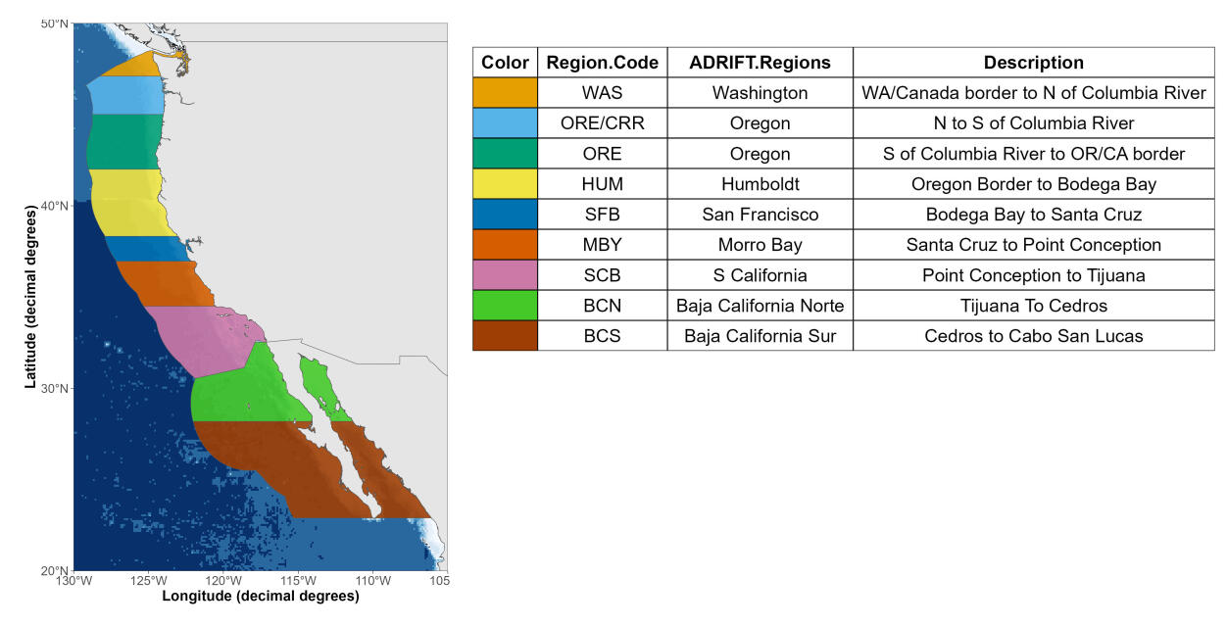

Figure 3.1. Geographical regions for data collected during Adrift and related drifting recorder surveys (PASCAL, CCES).

Each region is named according to its geographical location, and upper and lower latitudinal bounds are provided in the description.

The Adrift project started in June 2020, during the COVID-19 Pandemic. All fieldwork in 2020 was canceled due to the pandemic, and these impacts greatly hampered research efforts in 2021. In addition to the initial cessation of all fieldwork efforts, secondary impacts continued to negatively impact fieldwork well into 2022. Secondary impacts included disruptions to the supply chain and extreme short-staffing due to outbreaks and exposure, as well as the widespread post-pandemic changes to the workforce.

Prior research efforts include the 2016 PASCAL survey and the 2018 CCES survey. These surveys were conducted in late summer through late fall during the post-upwelling season and data collection was not impacted by strong currents or inclement weather. Weather conditions are typically less ideal, and currents stronger, during the upwelling and winter season. The California Current experienced three consecutive years of La Niña between 2020-2022 (Thompson et al. 2024). The increased wind and currents caused by these conditions led to decreased windows of good weather, even during summer. After the initial loss of several drifting recorders due to extreme weather and current conditions, we limited our deployments to good weather windows, which dramatically decreased the duration of our deployments from ~ 30 days during PASCAL (10-19 days) and CCES (10-79 days), to less than 1 week during most of the Adrift study. Strong currents and high seas also created self-noise such as strumming, which periodically impacted data quality. Use of spar buoys instead of hi-flyer pole buoys may be preferred to minimize strumming.

The cumulative impacts of the pandemic and poor environmental conditions ultimately required us to shift our survey approach and abandon our efforts to coordinate data collection using vessels of opportunity. Instead, we focused on directed deployment of drifting recorders in collaboration with regional partners. Our partners in Humboldt (Cal Poly Humboldt) and Oregon (Oregon State University) were able to use a combination of opportunistic and dedicated vessel time for data collection. We partnered with the NOAA Sanctuary Applied California Current Ecosystem Studies (ACCESS) Surveys to collect data offshore San Francisco up to three times per year, and developed a collaborative partnership for fieldwork in Morro Bay.

Table 3.1. Summary of drifting recorder deployments for Adrift, PASCAL and CCES surveys.

|  |  |  |  |
| --- | --- | --- | --- |
| **Characteristic** | **ADRIFT,** N = 104 | **CCES,** N = 15 | **PASCAL, N = 30** |
| **Status** | - | - | - |
| Complete | 90 (86.5%) | 15 (100.0%) | 29 (96.7%) |
| Failed | 8 (7.7%) | 0 (0.0%) | 0 (0.0%) |
| Unusable | 6 (5.8%) | 0 (0.0%) | 1 (3.3%) |
| **Deployment Duration (days)** | - | - | - |
| Sum | 493 | 529 | 421 |
| Median (Min - Max) | 4 (1 - 20) | 27 (5 - 80) | 19 (2 - 23) |
| **Recording Duration (hours)** | - | - | - |
| Sum | 8,736 | 11,022 | 9,451 |
| Median (Min - Max) | 93 (24 - 328) | 581 (125 - 1,800) | 362 (36 - 562) |

Note: Unsuccessful buoys are reported for Adrift.

A total of 90 drifting recorders were successfully deployed during the Adrift survey, for a total of 493 deployment days which resulted in a total of 8,736 hours of recordings (Table 3.1, Figure 3.2). Analysis included additional recordings from the 2016 PASCAL Survey (29 successful drifting recorders for a total of 421 deployment days and 9,451 hours of recordings) and the 2018 CCES Survey (15 successful drifting recorders for a total of 529 deployment days and 11,022 hours of recordings). Expanded deployment details are provided in Appendix: Adrift Expanded Datasets, Appendix: PASCAL Expanded Datasets, Appendix: CCES Expanded Datasets.

The primary focal regions included areas of importance to the initial phases of offshore renewable wind energy development, including two locations in Oregon (Coos Bay to the North, and Brookings to the South), Humboldt, and Morro Bay, with sampling of San Francisco as opportunity allowed (Figure 3.2). The 100 m and 200 m isobaths are shown on the maps to identify the shelf break and potential for increased biological activity associated with upwelling (Figure 3.2 and regional maps). Regional description of partners and data collection efforts will be presented from the northern region (Oregon) to the southern region (Morro Bay).

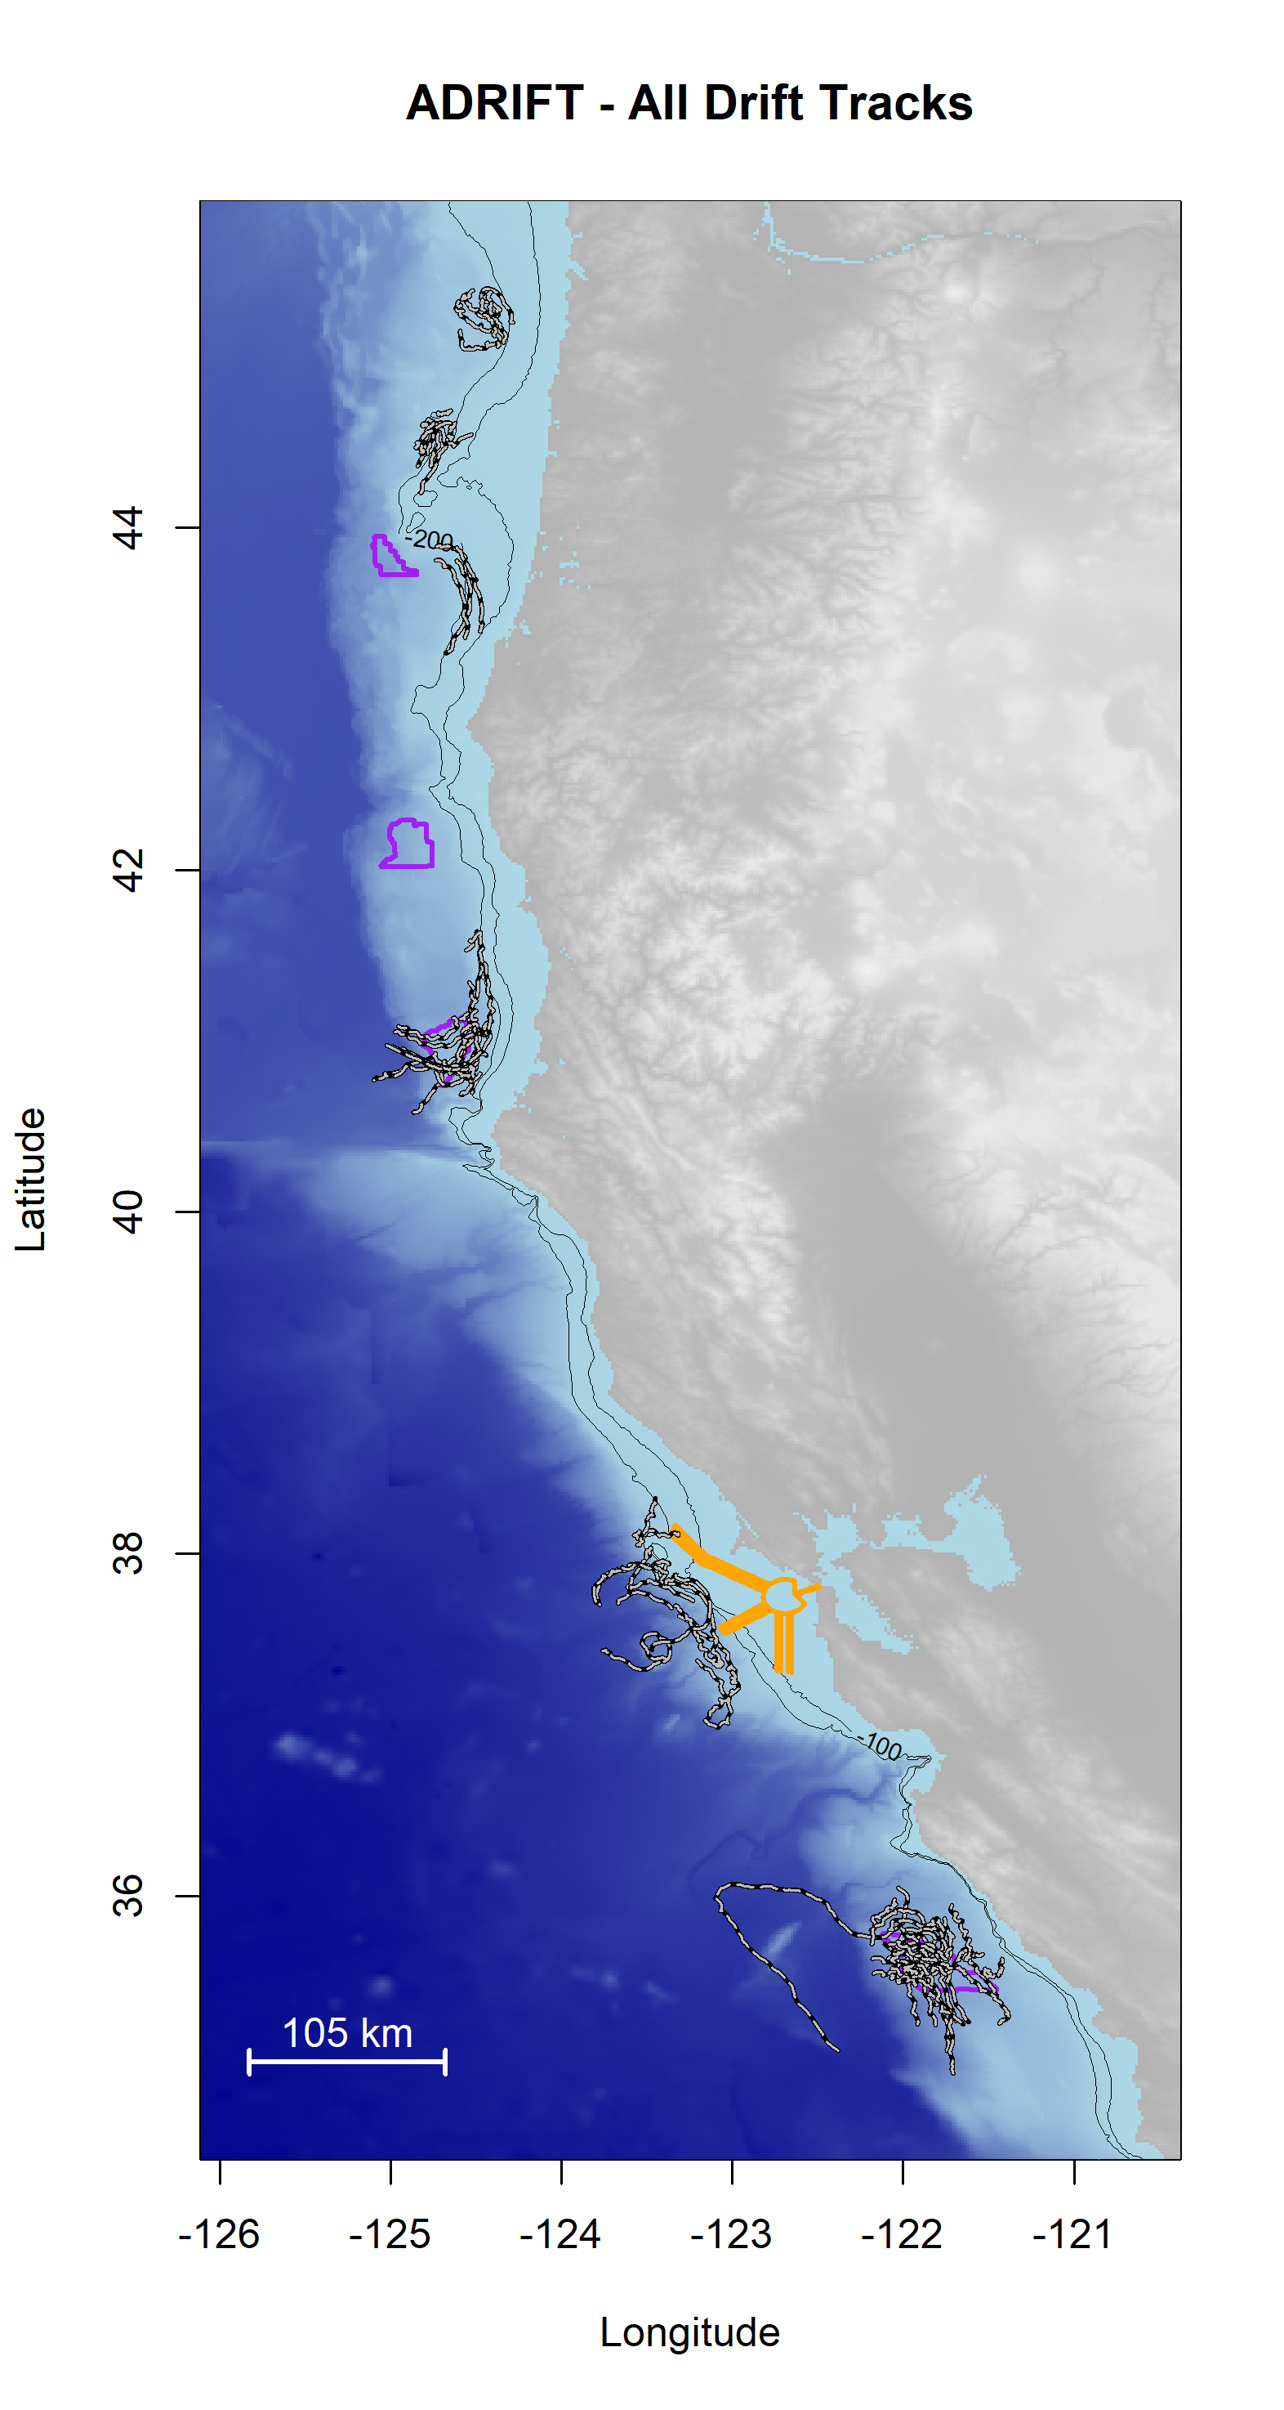

Figure 3.2. Plot of all successful drifts deployed during the Adrift in the California Current project.

Drifts are shown as black/white lines; Wind Energy Areas are outlined in purple (Coos Bay and Brookings in Oregon, Humboldt, and Morro Bay), and shipping lanes for entry to San Francisco Bay are outlined in yellow.

## Oregon

We collaborated with Oregon State University to conduct a pilot study offshore Oregon in order to understand if data collection using drifting recorders could be conducted in this study area (Figure 3.3). Our partners were able to deploy a cluster of 4 drifting recorders at least monthly between March and August 2023 (21 total deployments), using both opportunistic and dedicated surveys. More information is provided in the Adrift GitHub Repository Supplement folder.[1]

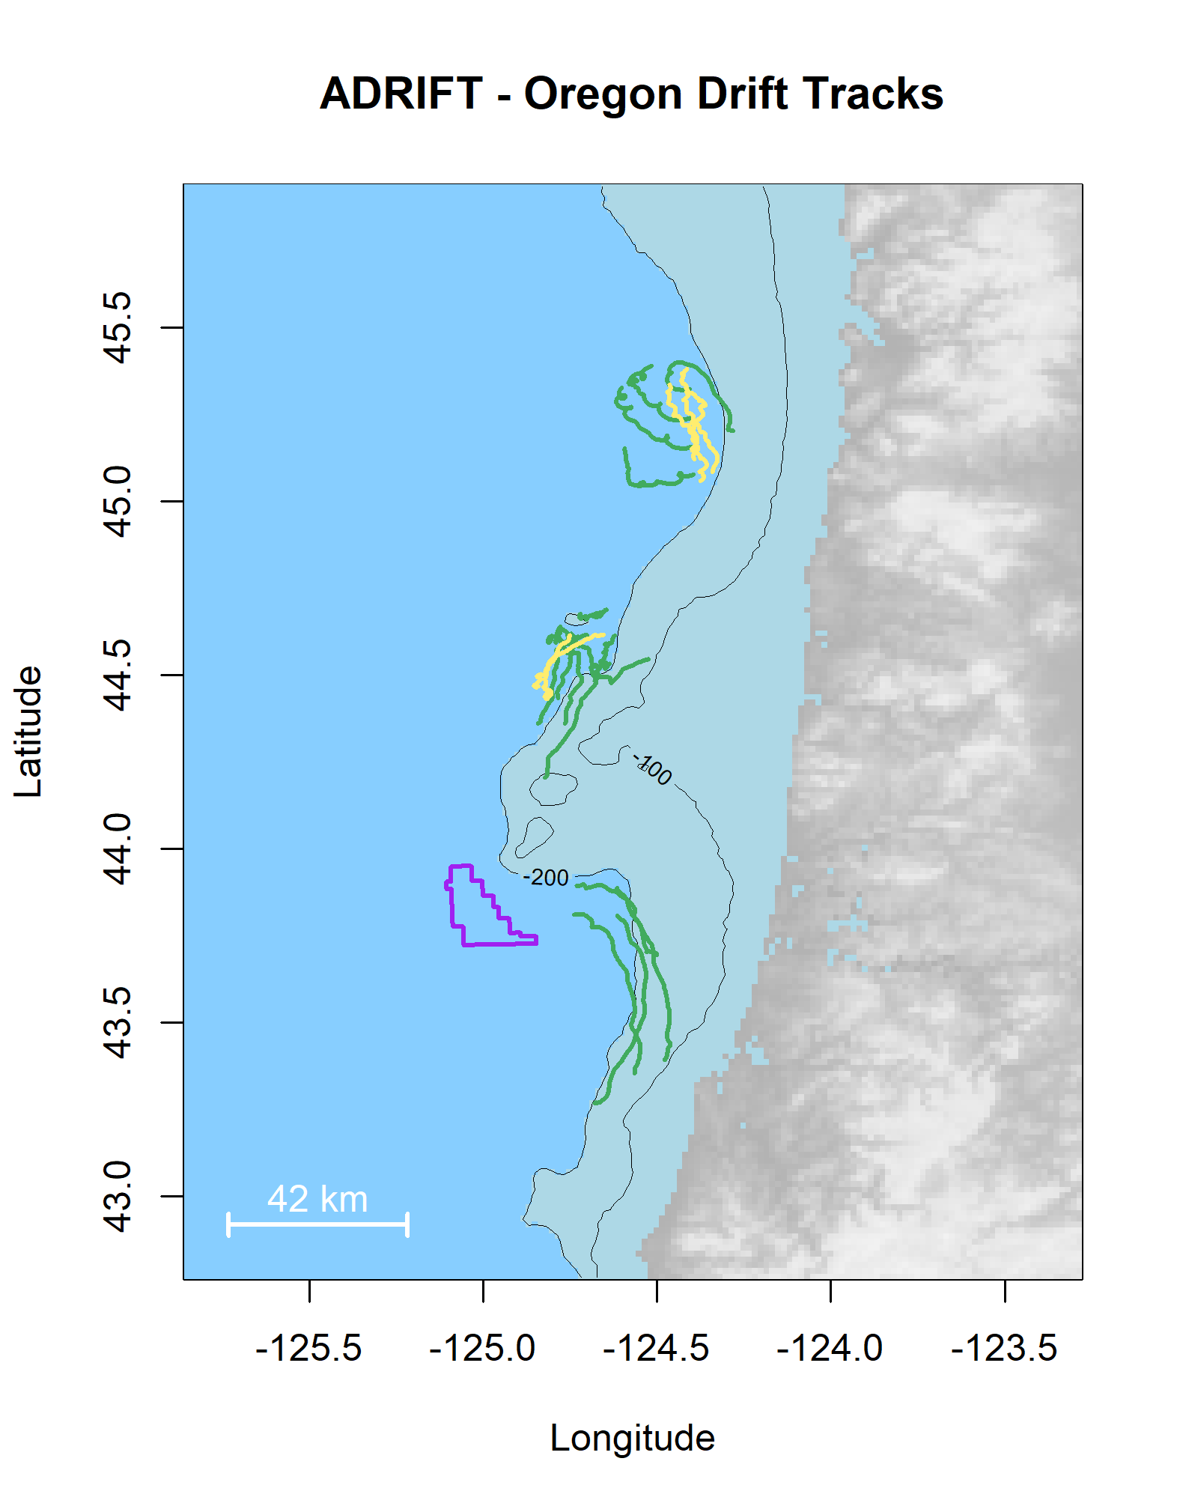

Figure 3.3. Plot of all successful drifts in the Oregon region during the Adrift project.

Drifts deployed during upwelling are green, and post-upwelling are yellow. Wind Energy Areas are outlined in purple.

## Humboldt

Adrift data collection in the Humboldt region was coordinated with our partners at Cal Poly Humboldt (Figure 3.4). The first drifting recorder was deployed in fall 2021, with more frequent deployment of clusters of 2-4 buoys starting in spring 2022 (28 total deployments).

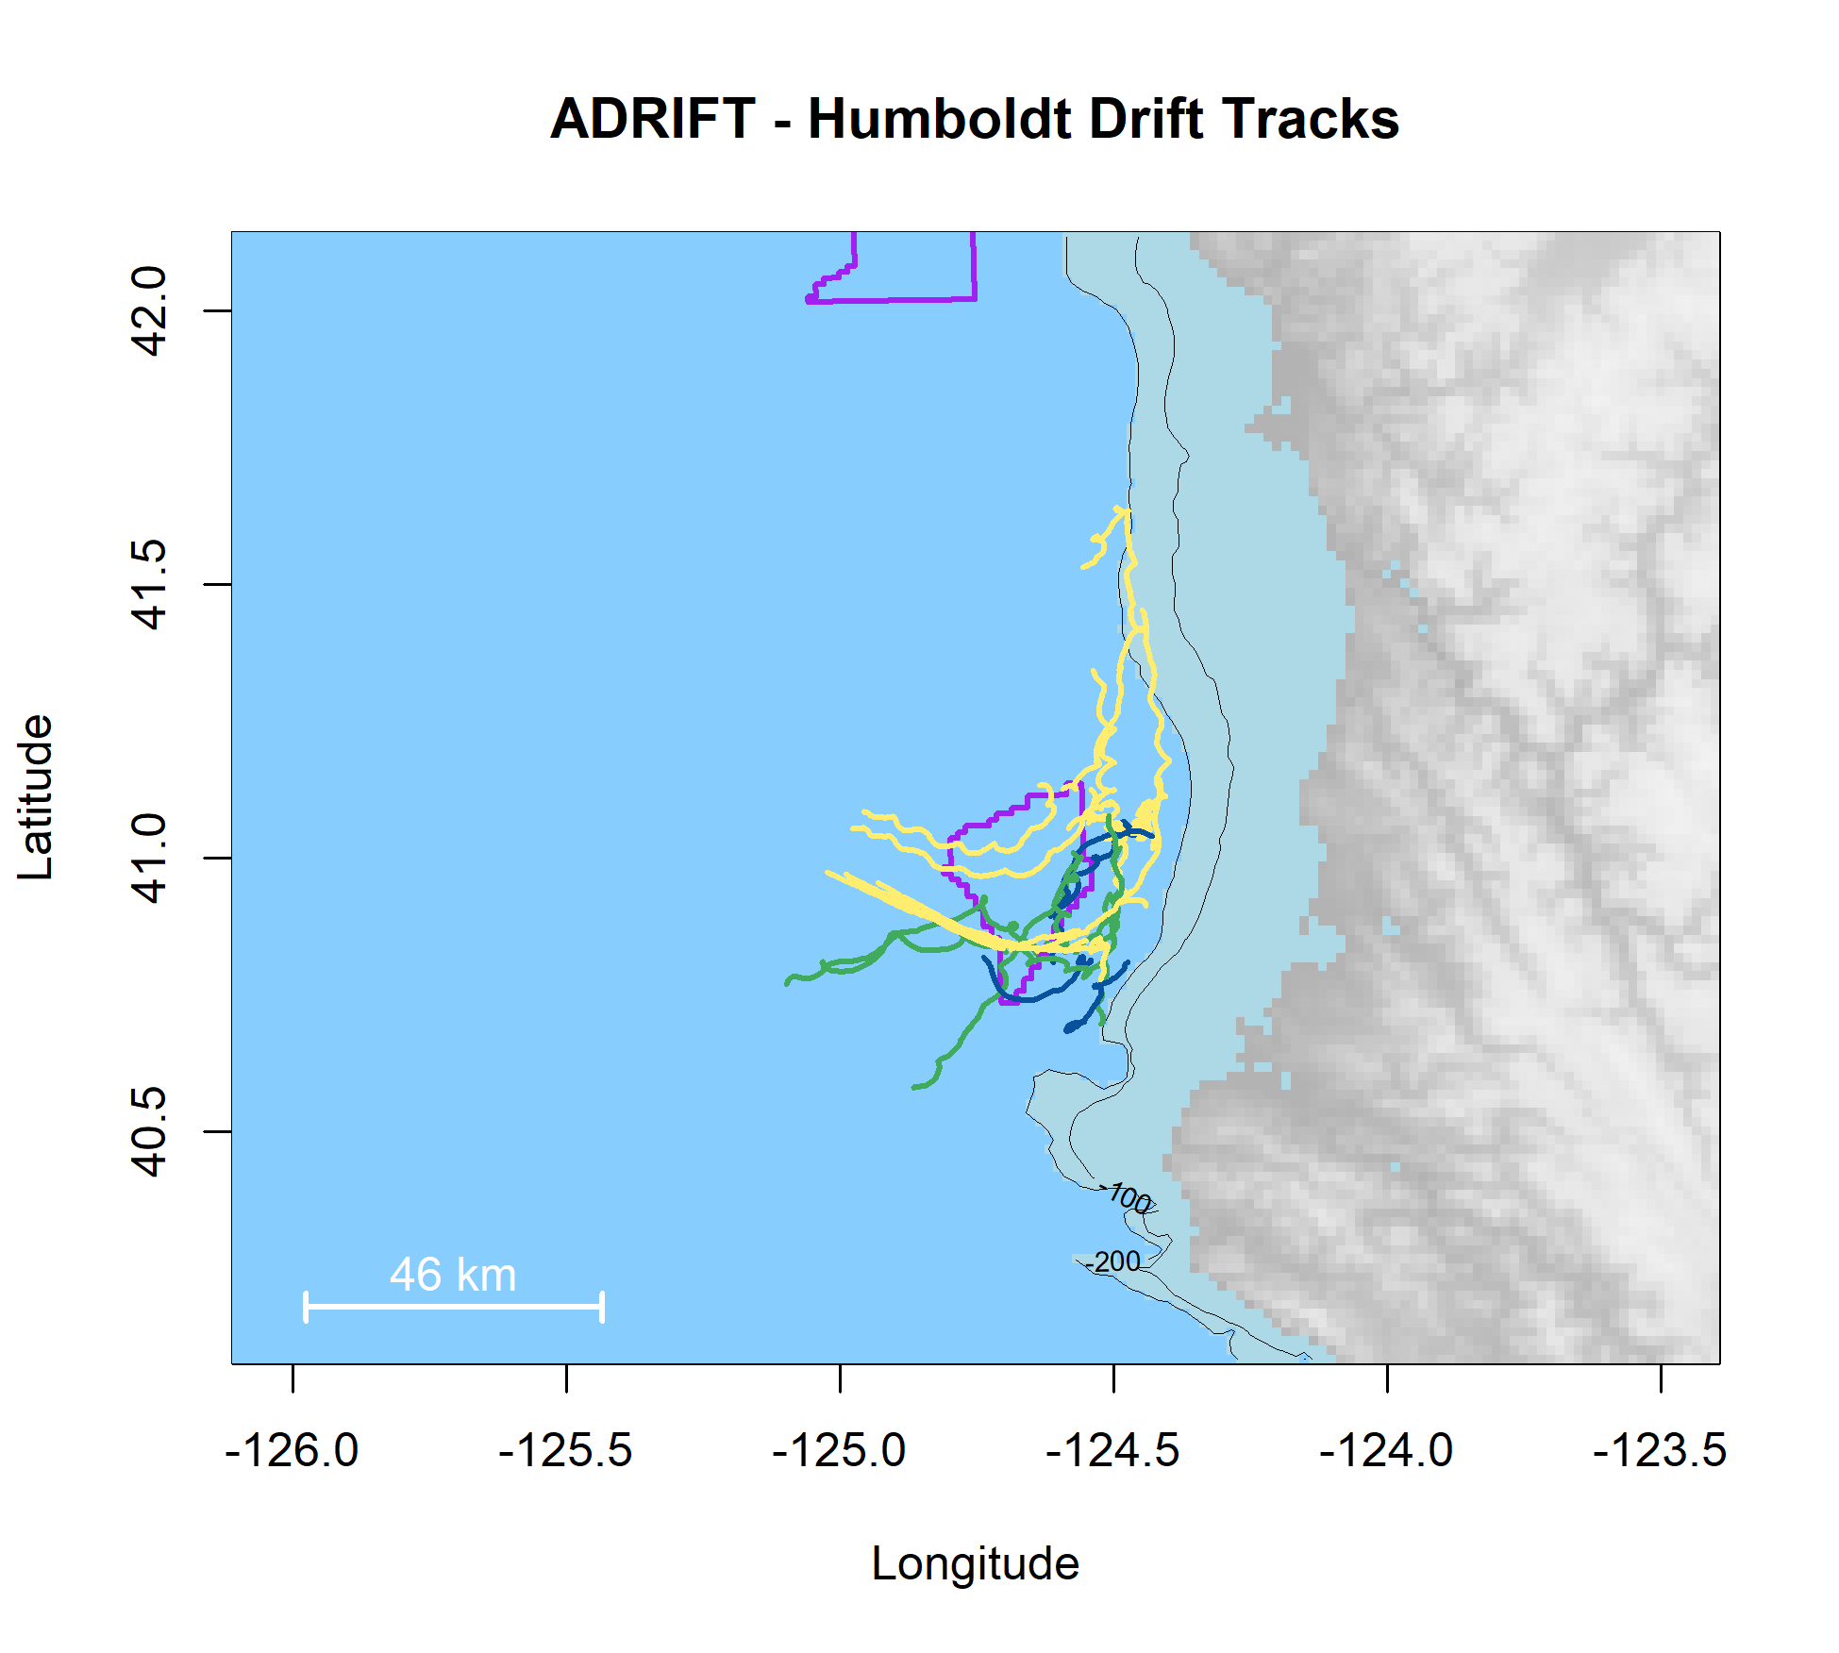

Figure 3.4. Plot of all successful drifts in the Humboldt region during the Adrift project.

Drifts deployed during winter are blue, upwelling are green, and post-upwelling are yellow. Wind Energy Areas are outlined in purple.

Drifting recorders had previously been deployed in the Humboldt region during the 2018 CCES survey (Appendix: CCES Expanded Datasets) and the 2019 Express Pilot Survey. Both previous drifts were entrained in the recirculating current offshore Humboldt (Largier et al. 1993) that allowed for repeated sampling during each deployment. Unfortunately, during the Adrift survey these drifting recorders encountered strong southward currents that prevented the repeated sampling provided during previous surveys. The extreme weather conditions, variable currents, and proximity to Cape Mendocino (and lack of ports south of this point) created a high-risk scenario. After the loss of 3 drifting recorders in the first survey year, we reduced deployments to open weather windows to ensure opportunity for retrieval.

The monthly Trinidad Head Line survey provides year-round ship observations of oceanography (hydrographic and biological) and terminates just inside the boundary of the Humboldt WEA. Efforts to deploy monthly during these surveys were complicated by personnel shortages and poor environmental conditions, and deployments were frequently shortened due to prevailing environmental conditions. Data collection in Humboldt was negatively impacted by competition for resources (vessel and seaboard technician time) and poor weather conditions, especially during the winter months. The increasing need for offshore research in the Humboldt WEA combined with the University's new status as a polytechnic institution suggest collaborative field efforts such as those conducted in Morro Bay may be welcome.

## San Francisco

We partnered with the Greater Farallones and the Cordell Bank National Marine Sanctuaries and Point Blue to participate in their tri-annual ACCESS surveys. These surveys provided an opportunity to deploy and retrieve 1-2 drifting recorders in the area offshore San Francisco Bay, providing data to inform the Sanctuaries and to provide an additional dataset between the Morro Bay and Humboldt WEAs (total 11 deployments, Figure 3.5). This partnership was mutually beneficial; however, these surveys are only conducted in late spring through late summer. Deployments in the post-upwelling season extended further south than deployments in the upwelling season (Figure 3.5); these geographic differences may contribute to seasonal differences in marine mammal detections.

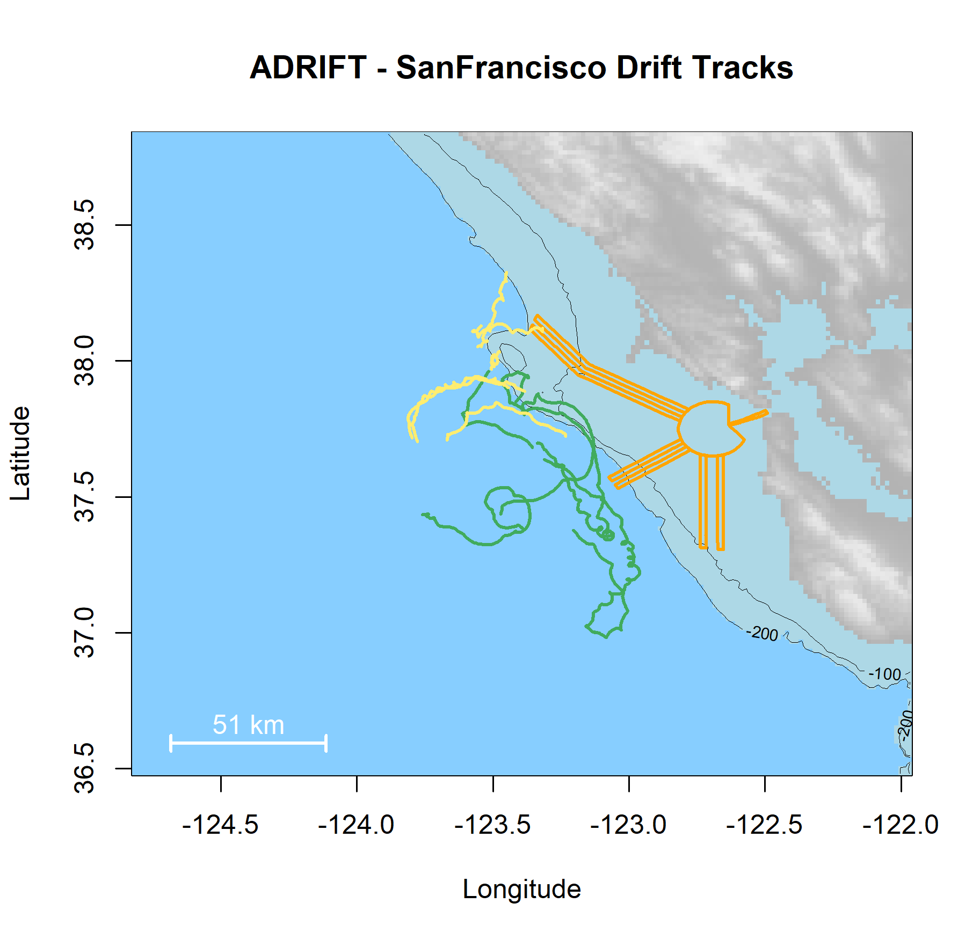

Figure 3.5. Plot of all successful drifts deployed in the San Francisco region during the Adrift project.

Drifts deployed during upwelling are green, and post-upwelling are yellow. Wind Energy Areas are outlined in purple, and shipping lanes for entry to San Francisco Bay are outlined in yellow.

## Morro Bay

The Morro Bay WEA is located offshore the remote coastal region of Big Sur, south of Monterey Bay and north of the small harbor at Morro Bay. We had difficulty identifying suitable partners for this remote study area and the high cost of vessel charters in the Morro Bay region led us to seek what resulted in a highly successful collaboration with regional scientific partners. After a successful pilot study in June 2022, we initiated the seasonal Central Coast Collaborative passive acoustic monitoring survey (CCC). These highly successful surveys brought together scientists, educators, tribal representatives, and regional community members to collect data, form collaborations, and strengthen bonds across communities to better serve our combined priorities. These surveys allowed us to collect data from clusters of eight drifting recorders during each survey, providing improved geographic coverage during these seasonal surveys. We conducted a total of four CCC surveys with a total of 30 Adrift deployments (Figure 3.6).

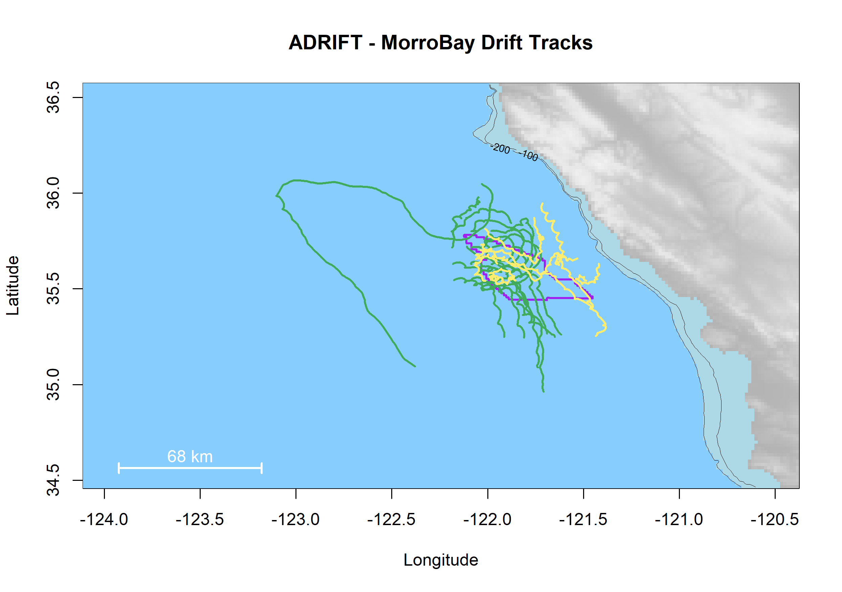

Figure 3.6. Plot of all successful drifts in the Morro Bay region during the Adrift project.

Drifts deployed during upwelling are green, and post-upwelling are yellow. Wind Energy Areas are outlined in purple.

# Drifting Recorders

Drifting recorders consist of a hydrophone array and autonomous recorder at depth with a surface buoy and satellite GPS at the surface to allow for tracking and retrieval (Figure 4.1). Components are continually modified to address problems and accommodate improved technologies.

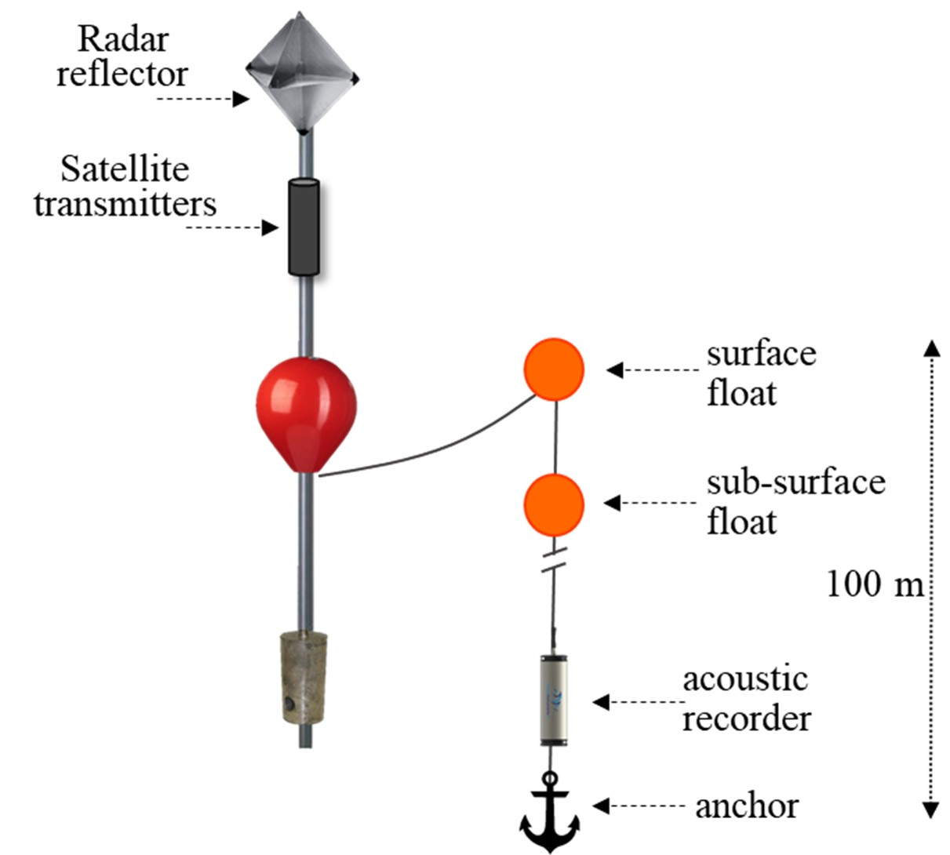

Figure 4.1. Diagram of drifting recorders used in the Adrift project.

The surface buoy transitioned from a spar buoy to a high-flyer pole buoy after CCES and prior to Adrift in an effort to minimize buoy loss due to ship strike. The pole buoy includes a radar reflector for visibility and a satellite GPS tracker mounted to the pole. Pole buoys included the now discontinued Lindgren-Pitman high-flyer buoy, a custom high-flyer developed by Fisherman Dick Ogg, and a custom in-house high-flyer pole buoy. Initial GPS trackers included two SPOT GPS trackers (for redundancy) mounted in a waterproof canister on the pole buoy. The modifications made to these trackers to increase their battery power led to increased failure (modifications weakened the units). These were replaced with Solar GPS that were easier to use, more robust, and could be used for extended periods with solar recharge of the internal battery.

A trawl float was attached to the surface buoy with a short length of floating line to allow for retrieval using a grappling hook.

The hydrophone array, recorder, and ancillary components were deployed vertically from the surface trawl float, with the hydrophone array and recorder located 100 or 150 m depth. While movement of the surface buoys would be affected by wind, variable surface currents, and swell height, instrumentation at depth were minimally affected by modest and relatively stable subsurface current. The different forces at the surface and depth occasionally led to strumming of the line and hydrophones. Additional ancillary components were added in 2022 to minimize vertical and horizontal movement of the instruments, reduce tension induced strumming, and reduce displacement of hydrophones from a vertical orientation. Also, several initial losses were due (at least in part) to failures in the primary vertical line; this line was replaced with a significantly stronger line that eliminated this failure point.

To improve vertical alignment of the hydrophones at depth, a subsurface trawl float was placed immediately above the instruments, with a 30 lb mushroom anchor below the instruments. This effectively reduced vertical displacement of the hydrophone array. A small drogue was used to decrease horizontal movement of the hydrophone array at depth, and a dampener plate was used to minimize vertical movement. While these helped alleviate tension and movement that attributed to strumming noise, an additional bungee was added to the line to further reduce strumming. The anchor was attached using a small rope with low breaking strength as a 'weak-link' to mitigate entanglement risk.

The acoustic recording equipment consisted of a two-element vertical hydrophone array below the recorder. A Sensus Ultra depth sensor was attached directly above the top hydrophone and recorded depth at 60s intervals. The top hydrophone consisted of an HTI-92WB and the lower hydrophone consisted of an HTI-96min positioned 5m below the top hydrophone. Recorders consisted of either the (now discontinued) SoundTrap 4300 or the SoundTrap 640 which allowed for extended deployments (Ocean Instruments, NZ).

Initial recordings included a duty cycle to extend deployment, and then all recordings shifted to continuous sampling. Sample rate varied according to the instrument, with a minimum sample rate of 288 kHz. A summary of deployment details can be found in Appendix: Adrift Expanded Datasets.

More information on drifting recorder components and design can be found on our GitHub pages for Adrift field methods[2]. Methods for drifting recorders deployed during PASCAL and CCES can be found in their respective reports (Keating et al. 2018; Simonis 2020)

***Results***

Clustered drifting recorders provide an opportunity to improve our understanding of the spatial and temporal variability of the contributors to the soundscape. Preliminary results suggest that clustered drifting recorders can be used to reduce the possible range of sound source location (see Appendix: Modeling Habitat Use) and can provide information on the spatial variation in soundscape (see Appendix: Spatial Variation in Noise). Drifting recorders were deployed in clusters of 4 in Humboldt and Oregon study areas, and in clusters of 8 in the Morro Bay Study area. In some cases, drifting recorders in close proximity to each other followed dramatically different drift trajectories.

There were multiple cases of equipment and data loss, especially during the initial deployments. Losses were due to a variety of reasons, including inclement weather, strong currents, and recorder failures. We mitigated these problems through modifying components and altering survey methods. A number of gear modifications were made to improve robustness and to decrease self-noise that interfered with recording quality. We recommend additional buoy modification to reduce noise associated with strong currents and inclement weather. Southwest Fisheries Science Center (SWFSC) will be using an alternative buoy design developed by Pacific Islands Fisheries Science Center during the CalCurCEAS 2024 survey, which may reduce strumming noise.

Drifting acoustic recorders are not appropriate for all geographic regions. We recommend conducting a regional pilot study to determine the region-specific environmental conditions, and to identify local partners. The Humboldt study area was especially affected by strong currents combined with the close proximity of the study area to Cape Mendocino, in which options for retrieval south of Cape Mendocino are rare. The success of the CCC-PAM survey in Morro Bay included the financial benefit of sharing vessel resources, improved scientific collaborations, and it provided an opportunity for scientists to share and learn from other community members. We recommend consideration of a collaborative fieldwork pilot study in Humboldt and other regions.

There were multiple recorder failures, and different problems were associated with different recording models, including: failure to start, instrument flooding, and low received levels on one or more channels. Initial deployments (including the previous PASCAL and CCES Surveys) used the multi-channel SoundTrap ST4300, which is easy to use and provides high quality recording for up to four channels (max 256 Gb flash drive, battery for 4-5 days continuous recording). Recorder failures for these devices included failure to start (instrument failure or user error) and low received levels on one or more channels. The SoundTrap ST4300 was discontinued and replaced by the higher capacity SoundTrap ST640 in 2021. The SoundTrap ST640 with removable components can accommodate up to 2Tb memory and has battery capacity for up to 90 days. This newer model provided the capacity needed for continuous recordings but required significantly more experience to use and had an increased risk of failure due to leaks. Four 640s were lost during a sea trial and one was lost during Adrift data collection effort.

Drifting acoustic recorders contain instrumentation at depth, and are not appropriate for use on the continental shelf. Seafloor recorders should be used for nearshore monitoring in depths less than 300 m.

# Marine Mammal Detections

The purpose of the Adrift project was to collect baseline data to identify which marine mammal species frequent the Morro Bay, Humboldt, and Oregon Wind Energy Areas, and to describe their seasonal occurrence and distribution within the greater California Current Ecosystem. Different call types are understood to be associated with specific behaviors and therefore provide information related to habitat use. For mysticete (baleen) whales, we focused on blue whales (*Balaenoptera musculus*), fin whales (*B. physalus*), Bryde’s whales (*B. edeni*), sei whales (*B. borealis*), humpback whales (*Megaptera novaeangliae*), gray whale (*Eschrichtius robustus*) and minke whales (*B. acutorostrata*). For odontocetes (toothed whales), we focused on sperm whales (*Physeter macrocephalus*), beaked whales (all regional species), dolphins (including Risso’s dolphins, *Grampus griseus*, and Pacific white-sided dolphins, *Lagenorhynchus obliquidens*), and narrow band high frequency (NBHF) species (harbor porpoise, *Phoceona phocoena*, Dall’s porpoise, *Phocoenoides dalli*, and *Kogia* spp.). Passive acoustic monitoring relies on sounds produced by animals for detection, and therefore PAM studies cannot identify the absence of animals. Data analysis for fin, sei, and Bryde’s whales was contracted through OSA (Ocean Science Analytics).[3] Specific details on detection methods are provided in our GitHub Analysis Methods.[4]

Raw data were shipped from regional partners to SWFSC for archiving, pre-processing, and acoustic analysis of marine mammals and ambient noise (soundscape). Deployment metadata and species detection metadata were stored to a Tethys database stored on a local server. Data and metadata were archived to National Centers for Environmental Information (NCEI) and detection data products were archived at the Pacific Acoustic Cetacean Map (PACM) (see Data Sharing).

Prior to analysis, compressed SUD (Symantec UndoData) data files stored on the SoundTrap recorders were downloaded, extracted, and decimated to 500Hz, 12 kHz, and 48 kHz. A series of full bandwidth Long Term Spectra Averages (LTSAs) were generated using Triton software with 200 Hz, 5 s resolution. LTSAs were then scanned to assess overall data quality and to identify recording data start and end times. A series of custom quality assurance and quality control functions provided a check for appropriate time format, eliminated spurious GPS tracks, and identified unexpected recording gaps. More information on pre-processing methods can be found on GitHub.[5]

Our intention was to develop a streamlined open-source workflow for passive acoustic analysis that would promote reproducible research. Raw recording data were processed and analyzed to detect the presence of calls associated with mysticete species (blue, fin, Bryde's, sei, humpback, gray, and minke whales) and odontocete species (sperm whales, beaked whales, dolphins, and species known to produce narrow-band high frequency sounds (porpoise and *Kogia* spp.)). Presence of sounds were noted in hourly bins; and detection methods varied by species. Analysis was not conducted on recordings deemed unusable due to excessive self-noise.

In addition, an acoustic event of unknown species (possible sei/blue whale) was detected on Adrift-060 off Oregon in 2023. This extended acoustic encounter includes a number of frequency-modulated call types. More information can be found in our GitHub Repository.[6]

Initially, our ability to access and process our archived data was extremely limited due to the COVID-19 pandemic. Our archived data was largely inaccessible for the first 6 - 12 months, and we were limited to small scale processing on our laptops. Early on we initiated the purchase of a larger server that would allow larger scale remote processing of archived data, but supply chain issues and a series of technical problems delayed use for an additional 18 months. Between accessibility and supply chain issues associated with the pandemic, processing archived data took significantly more time than expected. The cumulative effect of these problems resulted in decreased opportunity to provide higher level analysis within the timeframe of this study. Where possible, we have provided preliminary analysis within the appendices to understand potential for future analysis.



## Sperm Whales

***Methods***

An experienced analyst manually scanned 1 hr LTSA windows created with 48 kHz decimated data (Triton[7] software in MATLAB, 100 Hz and 5 s resolution) to identify the start and end times of sperm whale encounters. An encounter was defined as a series of clicks separated by no more than 30 min from other clicks. When potential sperm whale clicks were identified in the LTSA, 10 s spectrograms were used to confirm species identification. Opportunistic detections of slow clicks (lower frequency emphasis at 2-4 kHz, longer inter-click interval, ICI) associated with adult males were also logged. Sperm whale clicks can be masked by impulsive signals from ship propeller cavitation or high amplitude ambient noise. Detailed methods are provided in our GitHub online analysis methods.[8]

Additionally, a pilot study was conducted to investigate the potential for assessing sperm whale demographics by analyzing inter-click and inter-pulse intervals (see Appendix: Sperm Whales Demographic Composition).

***Results***

Sperm whales were detected in all regions (Table 5.1), with the most consistent detections and highest hourly probability of detection in the Humboldt deployments (Figure 5.1, Table 5.1). Most sperm whale detections were ‘regular’ clicks associated with feeding animals; ‘slow’ clicks (associated with adult males) were uncommon but detected in all regions except Morro Bay (Table 5.1). Sperm whales were detected in all regions in PASCAL and/or CCES Surveys (Figure 5.1).

Sperm whales had been documented only 3 times in the waters offshore San Francisco in over 30 years of ACCESS visual surveys (J. Roletto, pers. comm.). Our detection of sperm whales (both regular and slow clicks) from drifting recorders deployed during the ACCESS surveys suggests that passive acoustic monitoring might improve our understanding of sperm whale distribution in the busy shipping lanes off San Francisco as well as within the combined Greater Farallones and Cordell Bank National Marine Sanctuary.

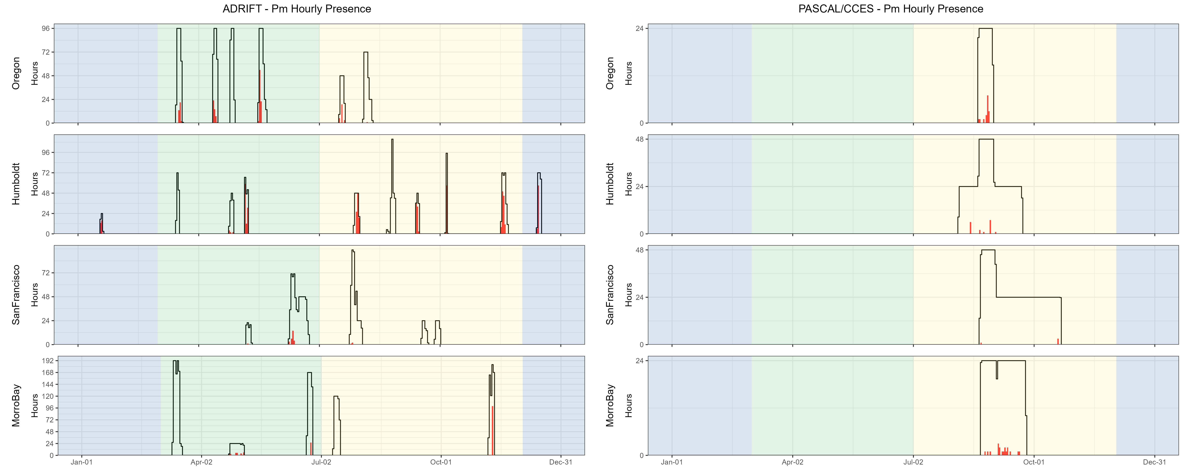

Figure 5.1. Hourly sperm whale events by month, region for Adrift and combined PASCAL, CCES surveys.

Hourly sperm whale events (y axis) for different months for combined years (x axis) and for each region (Oregon, Humboldt, San Francisco, and Morro Bay) for Adrift (left) and combined PASCAL and CCES (right). Hourly presence for duty-cycled data relates to the portion of the hour included in the duty cycled data. Black lines represent total available hours (effort) and red lines represent hours with detections. Blue shading represents winter, green represents upwelling, and yellow represents the post-upwelling oceanographic season.

A pilot study examining the potential estimation of body size based on inter-pulse and inter-click intervals found that sperm whale groups detected during November deployments in Morro Bay were comprised of females and juvenile males (see Appendix: Sperm Whales Demographic Composition). Sperm whales are protected under the endangered species act, and we recommend applying these methods to archived and future acoustic data to improve our understanding of sperm whale demographics within the regional WEAs as well as the greater California Current.

Table 5.1. Summary of sperm whale detections for regular and slow clicks in hourly bins for Adrift data.

|  |  |  |  |
| --- | --- | --- | --- |
|  | **Upwelling** | **Post-Upwelling** | **Winter** |
| **Regular Clicks** |  |  |  |
| Oregon | 0.11 (1419) | 0.06 (493) | – |
| Humboldt | 0.25 (452) | 0.37 (935) | 0.35 (264) |
| San Francisco | 0.03 (769) | 0.00 (626) | – |
| Morro Bay | 0.03 (1909) | 0.08 (1245) | – |
| **Slow Clicks** |  |  |  |
| Oregon | 0.00 (1419) | 0.00 (493) | – |
| Humboldt | 0.00 (452) | 0.00 (935) | 0.00 (264) |
| San Francisco | 0.01 (769) | 0.00 (626) | – |
| Morro Bay | 0.00 (1909) | 0.00 (1245) | – |

Note: Mean hourly probability of sperm whale detection for that call type/region/season; total hourly bins are shown in parenthesis.

## Beaked Whales

***Methods***

Multiple click detectors were run on 288 kHz decimated data using PAMGuard[9] (v.2.02.09f). The Click Template Classification module in PAMGuard was used to assign correlation scores to click templates from the following click types: goose-beaked whales (Zc), Baird's beaked whales (Bb, *Berardius bairdii*), Blainville's beaked whales (Md, *Mesoplodon densirostris*), Stejneger's beaked whales (Ms, *M. stejnegeri*), Hubb's beaked whales (Mc, *M. carlhubbsi*, formerly BW37V), Cross Seamount Beaked Whale (BWC), and unidentified beaked whale BW43 (BW43, recently identified as *M. ginkgodens*, Mc, (Henderson et al., *in prep.*)). All potential beaked whale events and species identifications were manually corrected by an analyst by reviewing detection and event features in PAMGuard. Detailed methods are provided in our GitHub online analysis methods.[10]

A protocol for estimating the density of goose-beaked whales from acoustic detections using drifting hydrophone recorders was established by Barlow et al. (2022). We developed an open-source R package RoboJ[11] (Robotic Jay) for these methods (see Appendix: Open Science). We explored automated event definition based on MTC (matched template classifier) scores and developed a process that identified every manually labeled event, but ultimately included an unacceptable number of false detections. The inclusion of a computer vision model was helpful for separating false detections; however, data processing times and classification rates were not acceptable. Current ideas to improve performance of automated event definition are discussed in Appendix: Open Science. Data were prepared for future density estimation, but density estimates were not completed for Adrift or CCES survey data.

***Results***

Beaked whales were detected in all regions (Figure 5.2), and species detected in Adrift data included Baird's beaked whales (Bb), Hubb's beaked whales (Mc), Stejneger's beaked whales (Ms), and goose-beaked whales (Zc) (Table 5.2). Detection of beaked whales was higher in low latitude regions than in higher latitudes for the combined CCES and PASCAL surveys (Figure 5.2).

All beaked whale species were detected in Morro Bay, with relatively high probability of detection for goose-beaked whales (Figure 5.3, Table 5.2). While goose-beaked whales were the most common species detected overall, there were no detections of this species in either Humboldt or Oregon study areas.

There had been no visual detection of beaked whales during the 30 years of annual ACCESS surveys offshore San Francisco (J. Roletto, pers. comm.). The drifting recorders deployed during the ACCESS surveys detected both Baird's and goose-beaked whales, suggesting that beaked whales do occur in and near the shipping lanes and the combined Greater Farallones and Cordell Bank National Marine Sanctuaries (Figure 5.3). The discrepancy in these detections is likely due to the typically poor sighting conditions in this region and the cryptic surfacing behavior of beaked whales. Future surveys in this region should consider passive acoustic monitoring with sufficient bandwidth to detect echolocating beaked whales.

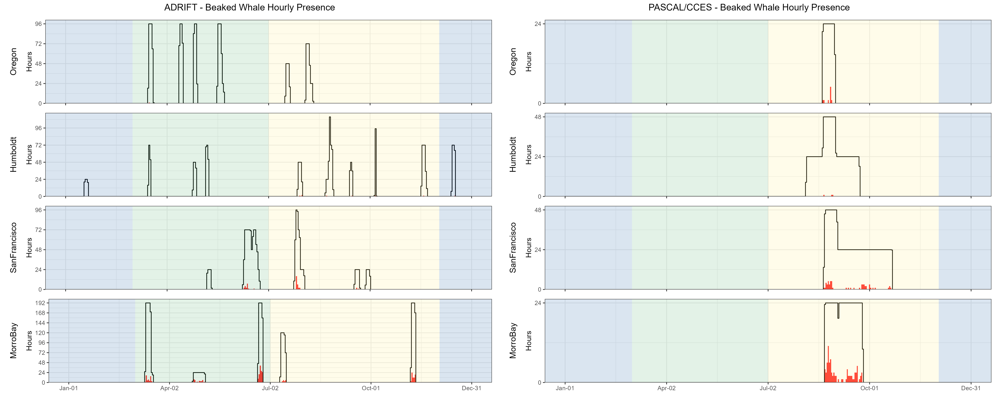

Figure 5.2. Hourly beaked whale events by month, region for Adrift and combined PASCAL, CCES surveys.

Hourly presence of beaked whales (combined species) (y axis) for different months for combined years (x axis) and for each region (Oregon, Humboldt, San Francisco, and Morro Bay) for Adrift (left) and combined PASCAL and CCES (right). Hourly presence for duty-cycled data relates to the portion of the hour included in the duty cycled data. Black lines represent total available hours (effort) and red lines represent hours with detections. Blue shading represents winter, green represents upwelling, and yellow represents the post-upwelling oceanographic season.

Many of the beaked whale detections in Morro Bay occurred during times with large numbers of dolphin detections (see Figure 6.10, Figure 6.11 for a visualization of this co-occurrence). Dolphins frequently occur in large schools with many animals echolocating simultaneously. It can be very difficult to identify beaked whales (smaller group sizes where fewer clicks are detected from each group) in these situations. The vertical hydrophone array allows for the estimation of bearing angles of incoming echolocation clicks. Beaked whales echolocate at depths below the vertical array, providing bearing angles > 90⁰ on the hydrophone array, while dolphins are typically above the array (bearing angles < 90⁰). By segregating the data based on bearing angle, we were able to identify groups of echolocating beaked whales during times where there were large numbers of echolocating dolphins. The co-occurrence of dolphins and beaked whales has not been previously reported, and it is unclear what may bring these species together. The likelihood of detecting beaked whales in these mixed species encounters would have been very low if recordings were collected from a single, seafloor sensor or from towed hydrophone arrays.

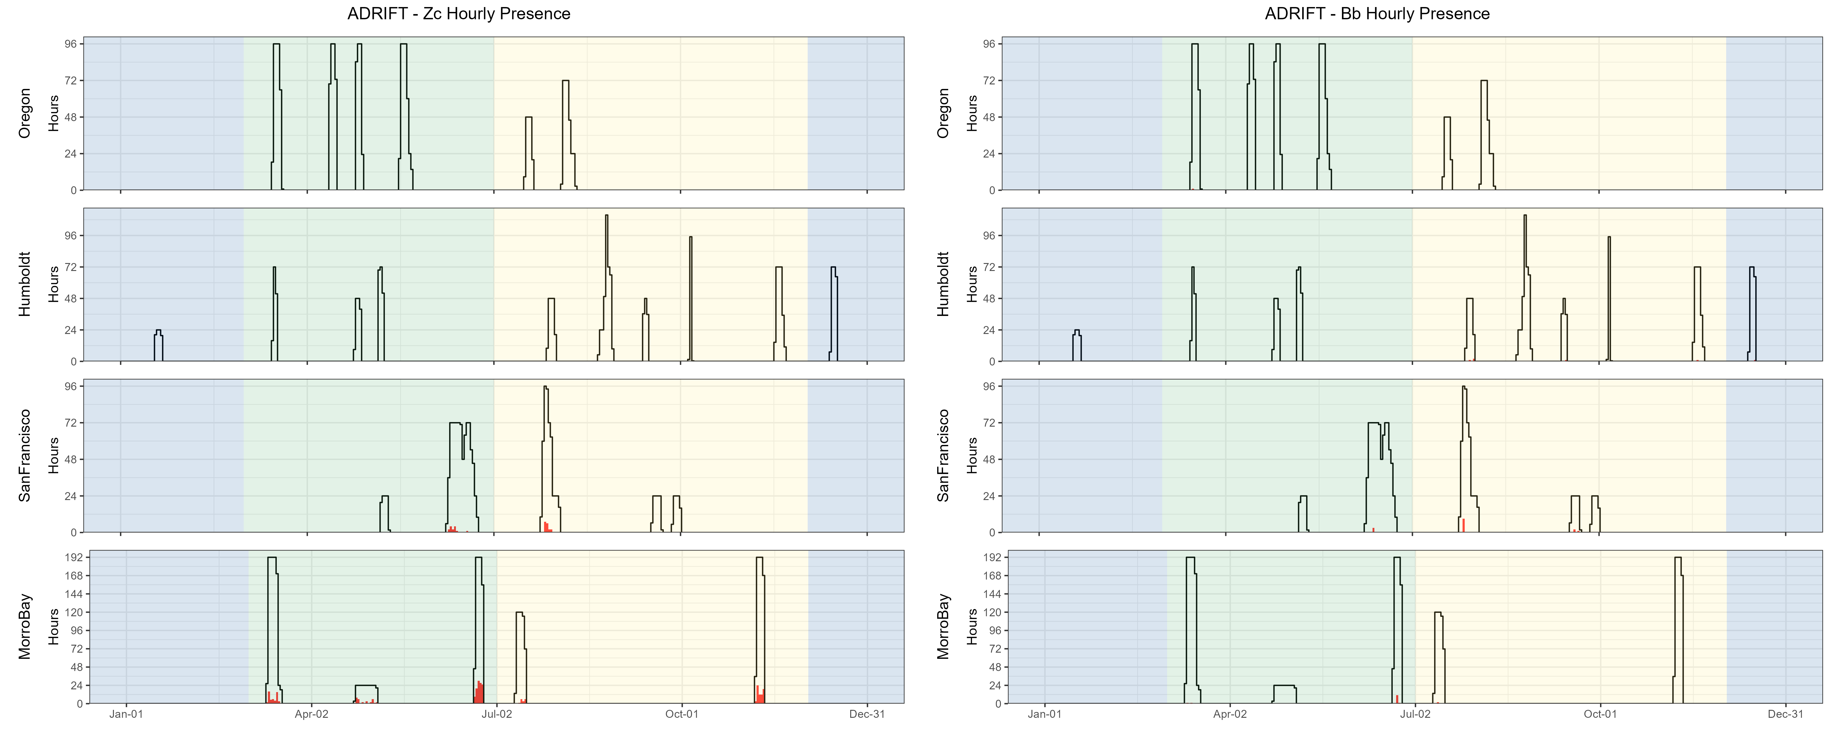

Figure 5.3. Hourly goose-beaked whales and Baird's beaked whales by month, region.

Hourly presence of goose-beaked whales (Zc-left) and Baird's beaked whales (Bb-right) (y axis) for different months for combined years (x axis) and for each region (Oregon, Humboldt, San Francisco, and Morro Bay). Adrifts 001-012 were duty cycled and hourly presence relates to the portion of the hour included in the duty cycled data (6 min of 12 min). Black lines represent total available hours (effort) and red lines represent hours with detections. Blue shading represents winter, green represents upwelling, and yellow represents the post-upwelling oceanographic season.

Table 5.2. Summary of beaked whale detections for Hubb’s beaked whales, Baird’s beaked whales, Stejneger’s beaked whales, and goose-beaked whales in hourly bins for Adrift data.

|  |  |  |  |
| --- | --- | --- | --- |
|  | **Upwelling** | **Post-Upwelling** | **Winter** |
| **Hubb's beaked whale** |  |  |  |
| Oregon | 0.0000 (1430) | 0.0000 (493) | – |
| Humboldt | 0.0000 (489) | 0.0010 (1048) | 0.0000 (308) |
| San Francisco | 0.0000 (960) | 0.0000 (688) | – |
| Morro Bay | 0.0010 (2034) | 0.0000 (1353) | – |
| **Baird's beaked whale** |  |  |  |
| Oregon | 0.0007 (1430) | 0.0000 (493) | – |
| Humboldt | 0.0000 (489) | 0.0049 (1048) | 0.0033 (308) |
| San Francisco | 0.0031 (960) | 0.0176 (688) | – |
| Morro Bay | 0.0069 (2034) | 0.0015 (1353) | – |
| **Stejneger's beaked whale** |  |  |  |
| Oregon | 0.0000 (1430) | 0.0000 (493) | – |
| Humboldt | 0.0000 (489) | 0.0010 (1048) | 0.0000 (308) |
| San Francisco | 0.0000 (960) | 0.0000 (688) | – |
| Morro Bay | 0.0015 (2034) | 0.0000 (1353) | – |
| **Goose-beaked whale** |  |  |  |
| Oregon | 0.0000 (1430) | 0.0000 (493) | – |
| Humboldt | 0.0000 (489) | 0.0000 (1048) | 0.0000 (308) |
| San Francisco | 0.0147 (960) | 0.0250 (688) | – |
| Morro Bay | 0.0947 (2034) | 0.0642 (1353) | – |

Note: Summary of beaked whale detections for Hubb’s beaked whales, Baird’s beaked whales, Stejneger’s beaked whales, and goose-beaked whales in hourly bins for Adrift data. Mean hourly probability of detection for that species/region/season; total hourly bins are shown in parenthesis.

## Dolphins

***Methods***

An experienced analyst manually scanned 1 hr LTSA windows (Triton software in MATLAB, 200 Hz and 5 s resolution) to identify the start and end times of dolphin acoustic events. The analyst noted the presence of different click types to identify Risso's dolphins (Gg) and Pacific white-sided dolphins (Lo) within these events (Soldevilla et al. 2008). Some dolphin species produce echolocation clicks which cannot currently be classified from the LTSA; those species are not included in this analysis, but their presence may be identified by the detection of dolphin whistle events. Dolphin whistles appear in the LTSA as scattered, yet distinct pockets of energy between 2 and 20 kHz. There are no established methods to identify dolphin species by their whistles in the LTSA alone; therefore, dolphin whistle events are all attributed to "Unidentified Odontocetes". Detailed methods are provided in our GitHub online analysis methods.[12]

***Results***

Dolphins were detected during most Adrift deployments (Table 5.3), as well as during the combined PASCAL and CCES survey (Table 5.3, Figure 5.4). While dolphins were detected in all regions during the PASCAL and CCES surveys, they were more frequently detected in the San Francisco and Morro Bay regions during the Adrift study. Dolphin detections included detections that could be positively attributed to Risso's dolphins (Gg) and Pacific white-sided Dolphins (Lo), and detections that remained unidentified (UO) (Table 5.3). Dolphin acoustic events attributed to Unidentified Odontocetes (UO) were uncommon relative to the number of detections of Risso's and/or Pacific white-sided dolphins.

Dolphin schools in central and northern California are frequently encountered in large, dispersed mixed species groups (S.Rankin, pers. comm.), and here we do not distinguish mixed species from single-species groups. So, attribution of an acoustic event to Risso's dolphins does not preclude the presence of other species. We currently lack a comprehensive acoustic classification routine that includes all dolphin schools in the region. Future research should develop a publicly available acoustic classifier for dolphins that considers mixed species groups and can be applied to different passive acoustic platforms.

Previous research identified different click types for Pacific white-sided dolphins (Soldevilla et al. 2010). The dominant click type in Adrift acoustic encounters of Pacific white-sided dolphins was 'Type A'; however, there were some encounters with 'Type B'. Most of these Type A encounters were at night, similar to Soldevilla et al. (2010), and our research identified a co-occurrence of Click Type A with goose-beaked whale (see Beaked Whales). Future research could investigate this relationship between Pacific white-sided dolphins and goose-beaked whales by taking advantage of the vertical array for separating animals echolocating at the surface and at depth. Soldevilla et al. (2010) suggested Type B echolocation clicks might be attributed to a nearshore population in the southern California Current (Southern California Bight and Baja Mexico); however, our results show that Click Type B can be found in other regions. Future investigation in the geographic variation in click types for Pacific white-sided dolphins is merited.

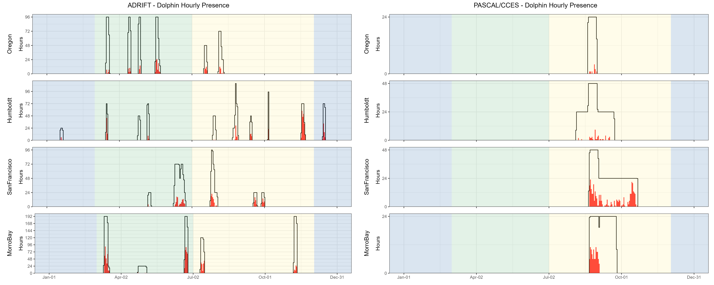

Figure 5.4. Hourly dolphin events by month, region for Adrift and combined PASCAL, CCES surveys.

Hourly presence of dolphins (combined species) (y axis) for different months for combined years (x axis) and for each region (Oregon, Humboldt, San Francisco, and Morro Bay) for Adrift (left) and combined PASCAL and CCES (right). Hourly presence for duty-cycled data relates to the portion of the hour included in the duty cycled data. Black lines represent total available hours (effort) and red lines represent hours with detections. Blue shading represents winter, green represents upwelling, and yellow represents the post-upwelling oceanographic season.

Multiple click types have been described for Risso’s dolphins (Soldevilla et al. 2017). The dominant click type in all acoustic encounters of Risso’s dolphins in our analysis was the “Pelagic Pacific” (PPac) click type. Previous models had limited sample sizes from Risso’s dolphins in open ocean waters, and future investigations should incorporate the acoustic detections from Adrift, PASCAL, and CCES to improve the definition of geographic variation in click types throughout the North Pacific Ocean.

Opportunistic acoustic recordings were collected in the presence of dolphin groups with visually confirmed species, including single and mixed assemblages of Pacific white-sided, North Pacific right whale, Risso’s, and common dolphins. The sample sizes are currently too low to be used to develop classification models, but these recordings will be useful contributions to training datasets in the future.

Table 5.3. Summary of dolphin detections (by species) in hourly bins for Adrift data.

|  |  |  |  |
| --- | --- | --- | --- |
|  | **Upwelling** | **Post-Upwelling** | **Winter** |
| **Risso's dolphins** |  |  |  |
| Oregon | 0.00 (1430) | 0.00 (493) | – |
| Humboldt | 0.09 (489) | 0.01 (1048) | 0.03 (308) |
| San Francisco | 0.01 (960) | 0.01 (688) | – |
| Morro Bay | 0.00 (2034) | 0.01 (1353) | – |
| **Pacific white-sided dolphins** |  |  |  |
| Oregon | 0.10 (1430) | 0.11 (493) | – |
| Humboldt | 0.06 (489) | 0.29 (1051) | 0.18 (308) |
| San Francisco | 0.10 (960) | 0.23 (688) | – |
| Morro Bay | 0.31 (2035) | 0.12 (1353) | – |
| **Unidentified odontocetes** |  |  |  |
| Oregon | 0.00 (1430) | 0.01 (493) | – |
| Humboldt | 0.00 (489) | 0.00 (1048) | 0.00 (308) |
| San Francisco | 0.00 (960) | 0.00 (688) | – |
| Morro Bay | 0.00 (2034) | 0.05 (1357) | – |

Note: Summary of dolphin detections for Risso’s dolphins, Pacific white-sided dolphins, and unidentified odontocetes for hourly bins for Adrift data. Mean hourly probability of detection for that species/region/season; total hourly bins are shown in parenthesis.

## Narrow Band High Frequency Species (*Kogia* spp., porpoise)

***Methods***

A NBHF click detector was run on full bandwidth data using PAMGuard (v2.02.09). The matched template classifier module evaluated the similarity of each detection to templates from known click types, including Harbor porpoise, Dall's porpoise, and *Kogia* spp. Potential NBHF acoustic events are automatically defined based on the presence of 3 or more clicks that exceed matched-template thresholds that occur within a 2-minute period. All NBHF events are confirmed by an analyst by reviewing detection and event features in the Click Display window of PAMGuard Viewer. Detailed methods are provided in our GitHub online analysis methods.[13]

***Results***

Calls associated with NBHF species (porpoise and *Kogia* spp.) were detected in all regions in all seasons (Figure 5.5), and the hourly probability of detection was higher for the post-upwelling season than for the upwelling season in all regions (Table 5.4). Detections were made during most drifts; however, there were no NBHF detected during the April deployments in any region (there was no effort in San Francisco during this month, Figure 5.5). During the PASCAL and CCES Surveys, most NBHF detections were in the Humboldt region (Figure 5.5).

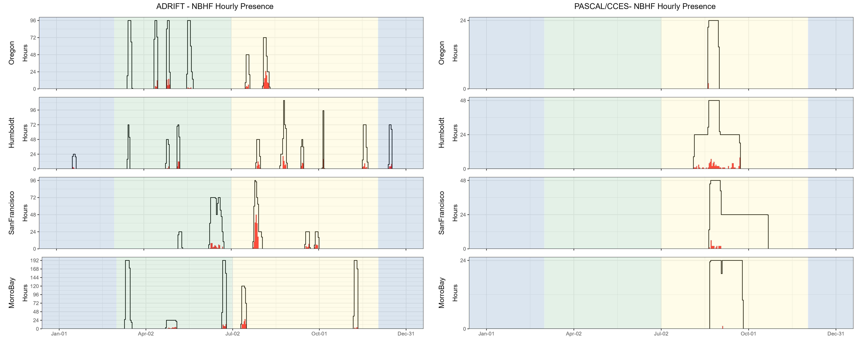

Figure 5.5. Hourly NBHF events by month, region for Adrift and combined PASCAL, CCES surveys.

Hourly presence of NBHF events (y axis) for different months for different months for combined years (x axis) and for each region (Oregon, Humboldt, San Francisco, and Morro Bay) for Adrift (left) and combined PASCAL and CCES (right). Hourly presence for duty-cycled data relates to the portion of the hour included in the duty cycled data. Black lines represent total available hours (effort) and red lines represent hours with detections. Blue shading represents winter, green represents upwelling, and yellow represents the post-upwelling oceanographic season.

The California Current is home to 4 different species that produce NBHF echolocation clicks: harbor porpoise, Dall’s porpoise, pygmy sperm whales, and dwarf sperm whales. Despite the similarities in their echolocation clicks, these species inhabit different habitats and have different behaviors and life histories. Harbor porpoise inhabit the nearshore waters north of Point Conception, and are very sensitive to noise and other anthropogenic impacts. Dall’s porpoise are fast moving and are often found in mixed species aggregations with dolphins. Both the pygmy and dwarf sperm whales are cryptic deep diving species. Lumping these very different species into one ‘acoustic’ group is problematic, and acoustic classification to species (or at least genus) is needed.

Preliminary efforts at developing a genus-level species classifier for NBHF species in the California Current have shown positive results, and future research will further develop this classifier (see Appendix: Acoustics Classification of NBHF Species). With some improvement, this classifier can be applied towards existing archived data to improve our understanding of the distribution of these species in the greater California Current.

Table 5.4 Summary of NBHF detections in hourly bins for Adrift data.

|  |  |  |  |
| --- | --- | --- | --- |
|  | **Upwelling** | **Post-Upwelling** | **Winter** |
| Oregon | 0.04 (1430) | 0.20 (493) | – |
| Humboldt | 0.07 (489) | 0.13 (1048) | 0.07 (308) |
| San Francisco | 0.05 (960) | 0.27 (688) | – |
| Morro Bay | 0.03 (2065) | 0.08 (1353) | – |

Note: Summary of NBHF detections for Adrift data. Mean hourly probability of NBHF detection for that region/season; total hourly bins are shown in parenthesis.

## Blue Whales

***Methods***

Detection of blue whale A, B, and D calls were identified by an experienced analyst scanning hourly LTSA windows created using custom MATLAB software, Triton (500 Hz decimated data and 1 Hz, 5 s resolution). Detection of at least one call of any call type (A, B, or D) was required to determine presence of blue whales in hourly bins. Deployments with excessive self-noise (such as strumming) that consistently impacted our ability to detect blue whales were eliminated from this analysis. Detailed methods are provided in our GitHub online analysis methods.[14]

***Results***

Blue whales were detected in all regions except Oregon (Figure 5.6), with most detections during the post-upwelling season (Table 5.5). Similar to the overall Adrift project, blue whales were detected in all regions during the combined PASCAL/CCES surveys, with low detections of blue whales off Oregon (Figure 5.6).

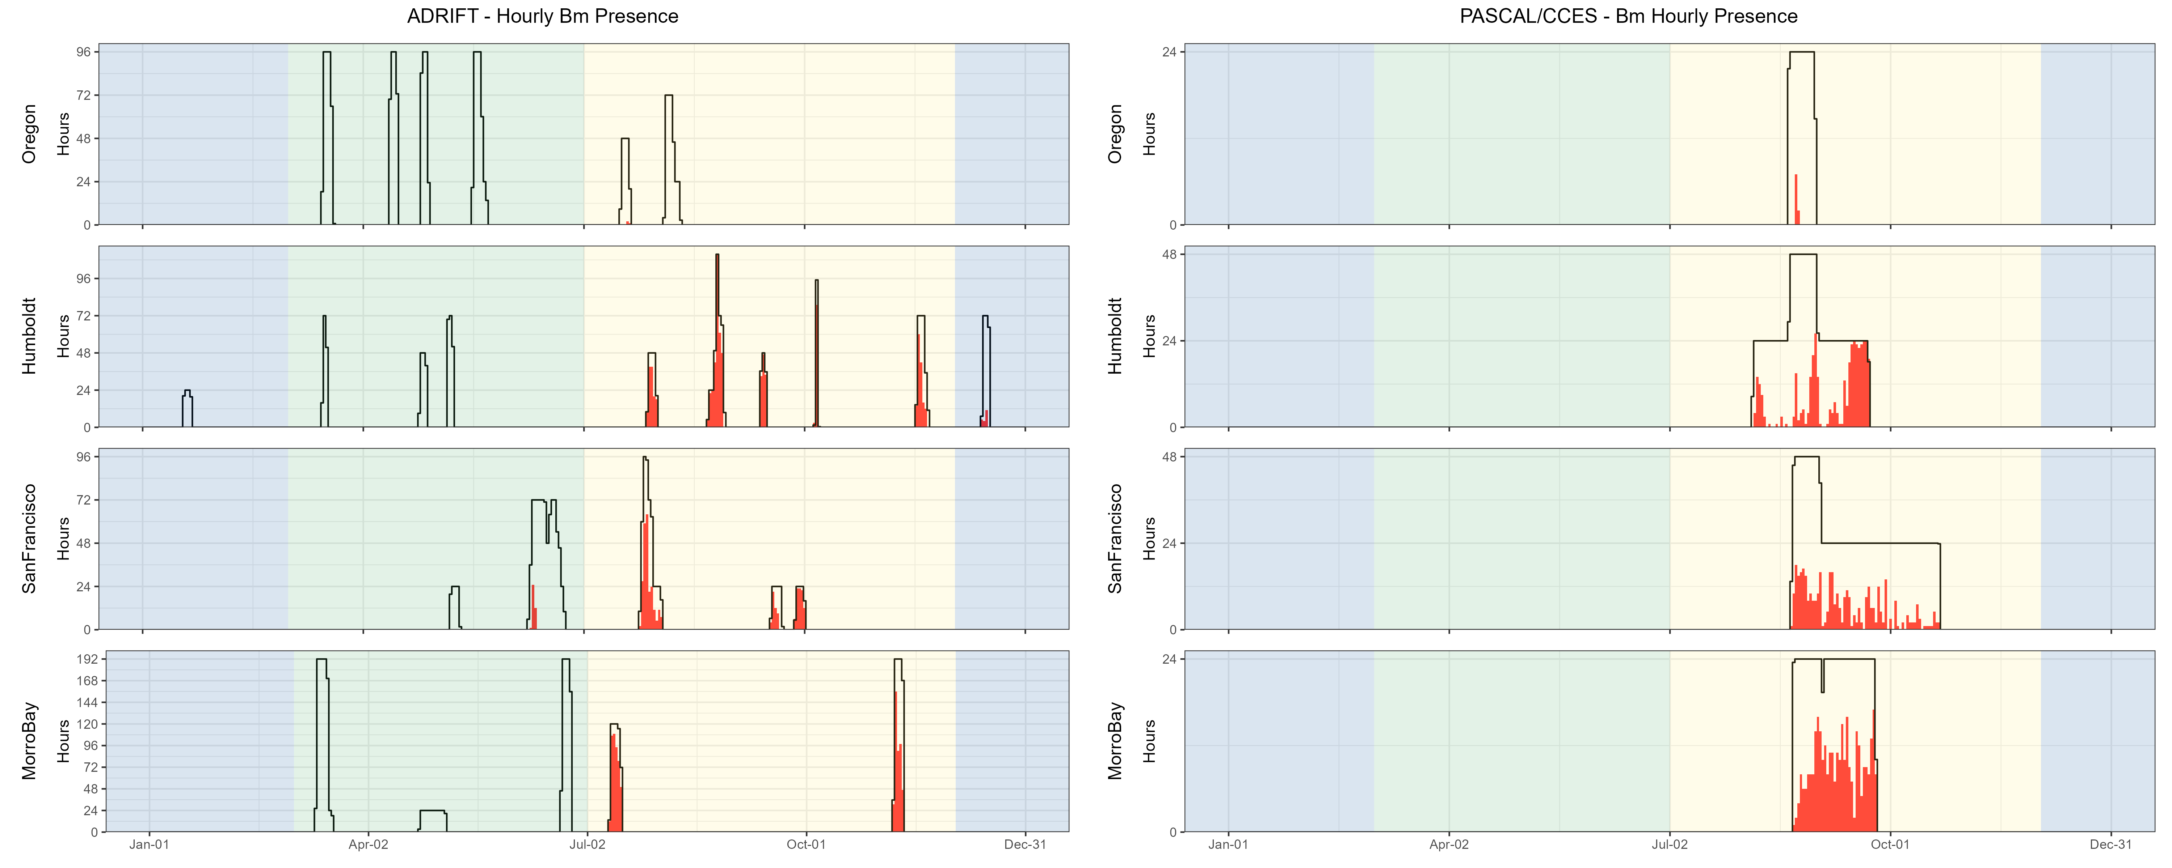

Figure 5.6. Hourly blue whale events by month, region for Adrift and combined PASCAL, CCES surveys.

Hourly presence of blue whale calls (A, B, and D types, combined) (y axis) for different months for combined years (x axis) and for each region (Oregon, Humboldt, San Francisco, and Morro Bay) for Adrift (left) and combined PASCAL and CCES (right). Hourly presence for duty-cycled data relates to the portion of the hour included in the duty cycled data. Black lines represent total available hours (effort) and red lines represent hours with detections. Blue shading represents winter, green represents upwelling, and yellow represents the post-upwelling oceanographic season.

Detection of blue whale calls were primarily A and B calls associated with song, with few detections of D calls during the summer months (Figure 5.7).

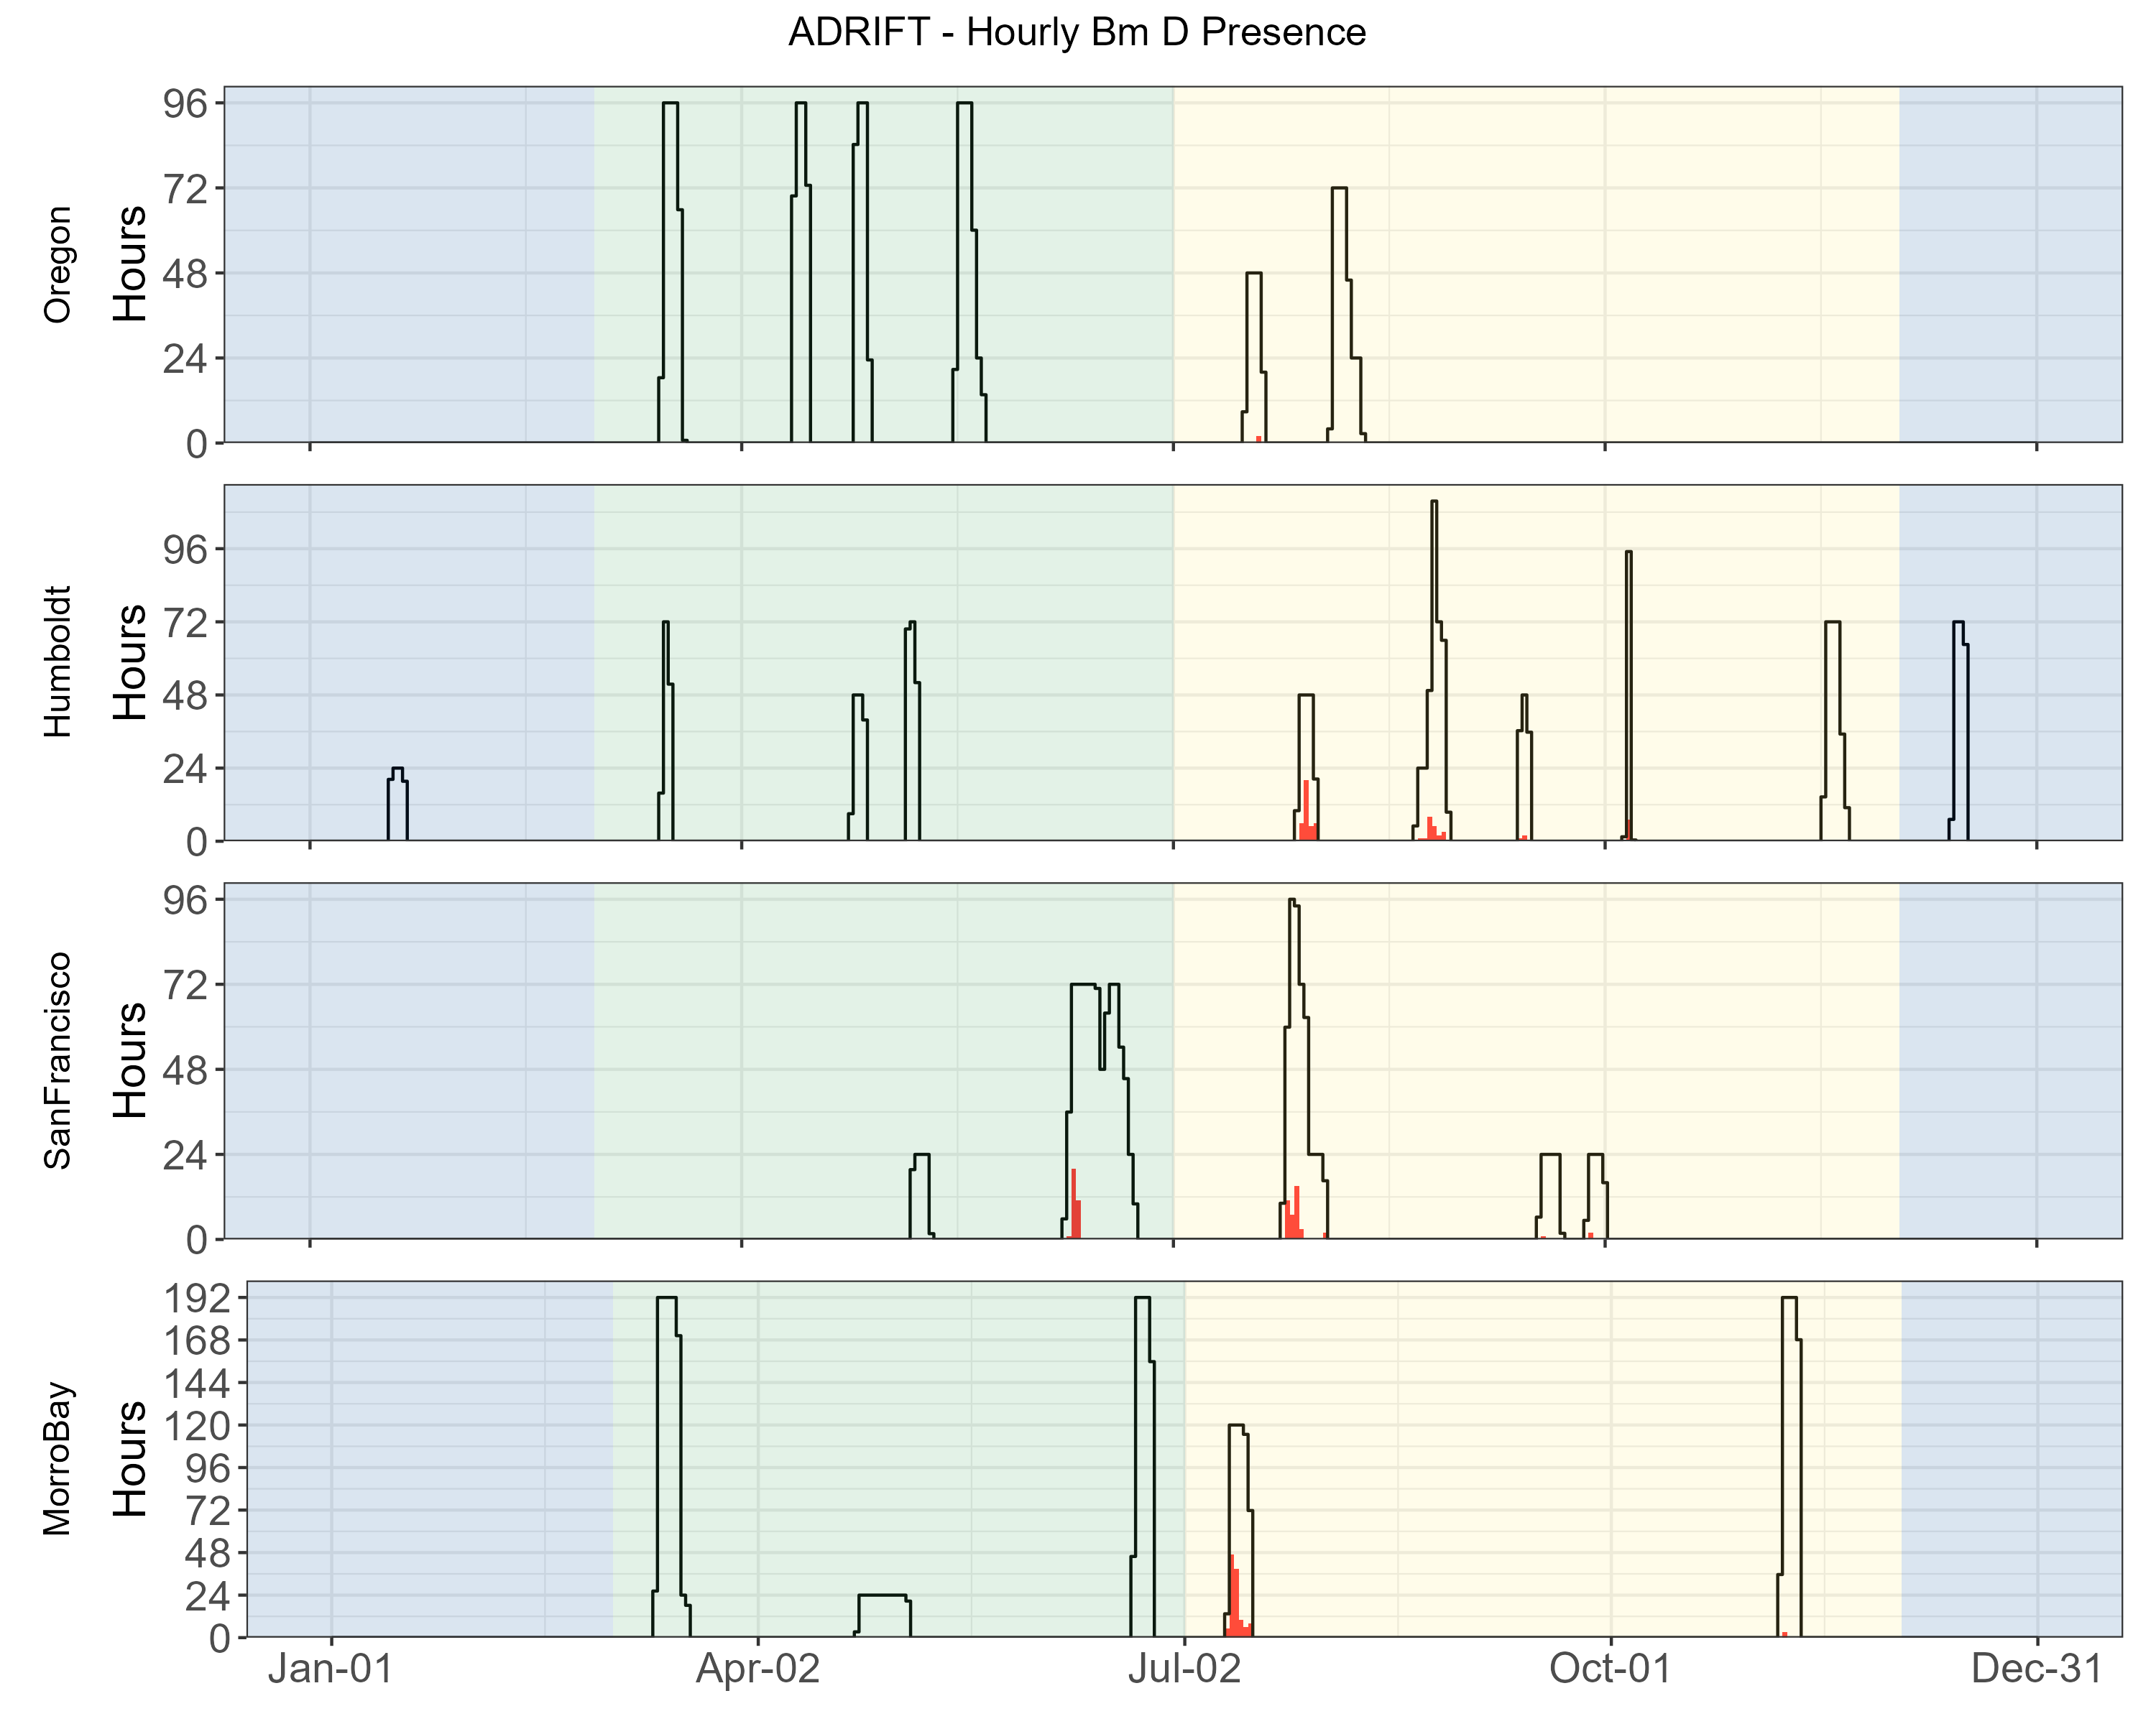

Figure 5.7. Hourly presence of blue whale D calls by month, region for Adrift.

Hourly presence of blue whale D calls (y axis) for different months for combined years (x axis) and for each region (Oregon, Humboldt, San Francisco, and Morro Bay). Adrifts 001-012 were duty cycled and hourly presence relates to the portion of the hour included in the duty cycled data (6 min of 12 min). Black lines represent total available hours (effort) and red lines represent hours with detections. Blue shading represents winter, green represents upwelling, and yellow represents the post-upwelling oceanographic season.

Blue whale ‘song’ consists of both A and B calls, which can occur individually or in A-B pairs. Detection of both A and B calls were higher during the post-upwelling seasons in all areas (Table 5.5). The hourly probability of detecting blue whale A and B calls during the limited data off Humboldt in the winter were higher than during the upwelling season, but lower than the post-upwelling season. There were only a few blue whale B calls detected during the upwelling season off San Francisco; no other calls associated with song were detected during the upwelling season in any region. The probability of detecting blue whale B calls was consistently higher than A calls for all regions (and seasons), which reflects research showing that blue whale B calls can be detected at greater ranges than blue whale A calls (McDonald et al. 2001). Blue whale B calls can be readily classified by an experienced analyst when the SNR (signal to noise ratio) is low.

Blue whale D calls have been associated with feeding behavior (Oleson et al. 2007), and detection of D calls were primarily during the post-upwelling season (Figure 5.7). The probability of detecting D calls was much lower than detecting A and/or B calls, and there were no detection of D calls off Oregon (Table 5.5). Low SNR D calls are more readily confused with low frequency downsweep calls produced by other species, reducing the overall effective detection range for these calls.

There were an additional 227 ad hoc detections of blue whales during the OSA analysis of other low-frequency baleen whale species.[15] The majority of those detections were either low SNR calls or were masked by noise while scanning the LTSAs.

Table 5.5. Summary of blue whale detections in hourly bins for Adrift data.

|  |  |  |  |
| --- | --- | --- | --- |
|  | **Upwelling** | **Post-Upwelling** | **Winter** |
| **A Calls** |  |  |  |
| Oregon | 0.00 (1430) | 0.00 (493) | – |
| Humboldt | 0.00 (489) | 0.50 (1048) | 0.01 (308) |
| San Francisco | 0.00 (960) | 0.31 (688) | – |
| Morro Bay | 0.00 (2034) | 0.31 (1353) | – |
| **B Calls** |  |  |  |
| Oregon | 0.00 (1430) | 0.00 (493) | – |
| Humboldt | 0.00 (489) | 0.74 (1048) | 0.07 (308) |
| San Francisco | 0.02 (960) | 0.50 (688) | – |
| Morro Bay | 0.00 (2034) | 0.63 (1353) | – |
| **D Calls** |  |  |  |
| Oregon | 0.00 (1430) | 0.00 (493) | – |
| Humboldt | 0.00 (489) | 0.07 (1048) | 0.00 (308) |
| San Francisco | 0.03 (960) | 0.06 (688) | – |
| Morro Bay | 0.00 (2034) | 0.09 (1353) | – |

Note: Summary of blue whale detections for A, B, and D calls in hourly bins for Adrift data. Mean hourly probability of blue whale detection for that call type/region/season; total hourly bins are shown in parenthesis.

## Fin Whales

***Methods***

Due to complications associated with fin whale call structure, we implemented multiple methods to detect fin whale 20 and 40 Hz calls. Fin whale 20 Hz calls consist of low frequency pulses; we used both a tonal and click detector to identify fin whale 20 Hz pulses in our datasets. Tonal detectors are commonly used for detecting tonal baleen whale call, whereas click detectors are typically used for echolocation clicks, but are suitable for detecting short duration fin whale 20 Hz pulses. Fin whale 40 Hz calls were detected using a tonal detector.

For all datasets, fin whale 20 and 40 Hz calls were analyzed by our research partner OSA using a PAMGuard whistle and moan detector (v2.02.09) and reviewed by an experienced analyst in PAMGuard's Viewer Mode. Detections were grouped into acoustic events using the Detection Group Localiser module. Acoustic events were then binned into hourly presence for the 40 Hz fin whale call type. Due to the variability in sampling rates and duty cycles during the CCES and PASCAL datasets, presence of fin whale 20 Hz calls were detected by manual scanning of LTSAs using Triton (500 Hz decimated data and 1 Hz, 5 s resolution). Identification of at least three fin whale 20 Hz calls by an experienced analyst were required to consider this species 'present' during any given hour.

Fin whale 20 Hz calls were also detected using the click detector in PAMGuard (v2.02.09). A stratified sub-sampling method was used to validate 20% of the wav files in each drift. A random forest model was developed using validated data from 14 drifts from three different geographic areas between 2021-2023. This model was used to predict the presence of fin whales in hourly bins. For each hourly bin, if there were less than 3 predictions with scores over 0.5, these classifications were automatically rejected to eliminate false positives. Hourly bins with at least 3 predictions with scores greater than 0.5 were manually reviewed by an experienced analyst for final classification.

Deployments with excessive self-noise (such as strumming) that consistently impacted our ability to detect fin whales were eliminated from this analysis. Detailed methods are provided in our GitHub online analysis methods[16], in a report provided by OSA and archived on our GitHub Repository.[17]

A pilot study to develop a deep learning network to detect and classify fin whale 20 and 40 Hz calls was initiated by Ocean Science Analytics and preliminary results can be found in Appendix: Deep Learning to Detect Fin Whales.

***Results***

Fin whales were detected throughout the study area and at different times of year (Figure 5.8). Detection of fin whales during the combined PASCAL/CCES surveys showed strong presence in the Morro Bay and San Francisco regions, with low detections in Humboldt and Oregon (Figure 5.8).

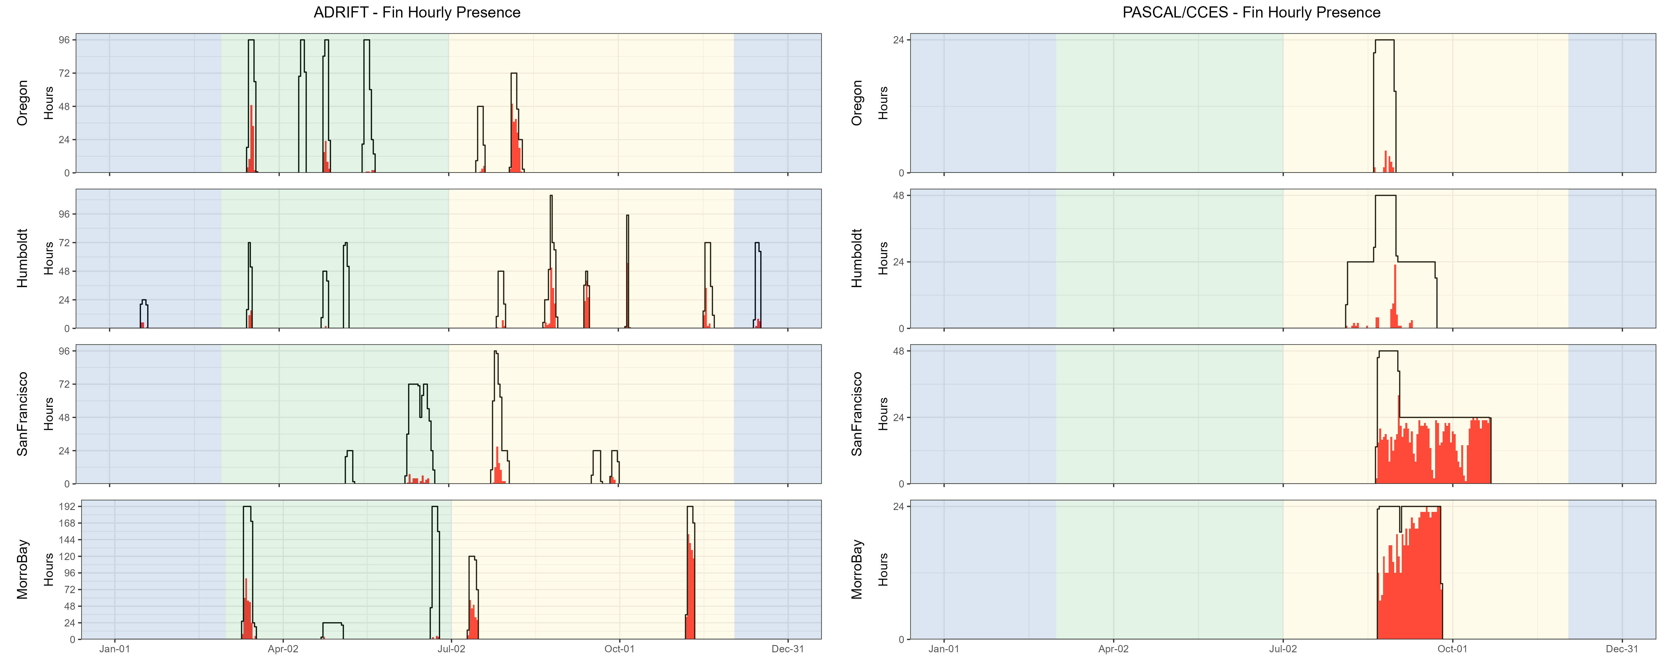

Figure 5.8. Hourly fin whale events by month, region for Adrift and combined PASCAL, CCES surveys.

Hourly presence of fin whales (combined call types) (y axis) for different months for combined years (x axis) and for each region (Oregon, Humboldt, San Francisco, and Morro Bay) for ADRIFT (left) and combined Pascal and CCES (right). Hourly presence for duty-cycled data relates to the portion of the hour included in the duty cycled data. Black lines represent total available hours (effort) and red lines represent hours with detections. Blue shading represents winter, green represents upwelling, and yellow represents the post-upwelling oceanographic season.

Fin whale 20 Hz pulses had higher detection probabilities in the post-upwelling seasons for all locations (Figure 5.9, Table 5.6). This detection probability dropped during the (limited) winter data for Humboldt. Fin whale 20 Hz detections were lower off San Francisco than other areas, though detection of low frequency fin whale calls in this area may be compromised by low frequency noise associated with high levels of low frequency noise associated with large shipping traffic (container ships). The fin whale 20 Hz call is the most commonly reported and is thought to be used as a social call to establish and maintain contact when produced in irregular sequences (Edds-Walton 1997) and it may serve a reproductive function when produced by males in a regular sequence forming song (Croll et al. 2002). Here we did not differentiate between irregular and regular sequencing.

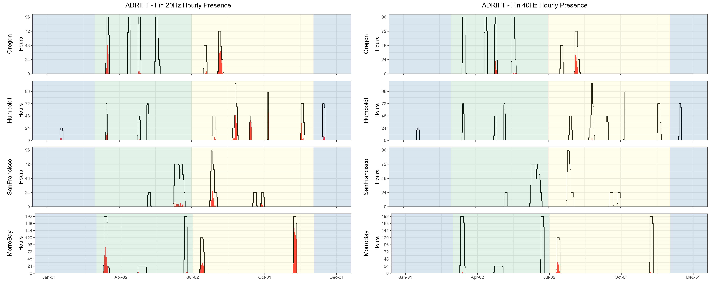

Figure 5.9. Hourly presence of fin whale 20, 40 Hz calls by month, region for Adrift.

Hourly presence of fin 20 Hz calls (left) and fin 40 Hz calls (right) (y axis) for different months for combined years (x axis) and for each region (Oregon, Humboldt, San Francisco, and Morro Bay). Adrifts 001-012 were duty cycled and hourly presence relates to the portion of the hour included in the duty cycled data (6 min of 12 min). Black lines represent total available hours (effort) and red lines represent hours with detections. Blue shading represents winter, green represents upwelling, and yellow represents the post-upwelling oceanographic season.

The 40 Hz call has a more irregular pattern and has been positively associated with prey biomass, providing evidence that it is associated with a foraging function (Romagosa et al. 2021). Most 40 Hz fin whale detections occurred off Oregon, with a few detections off Morro Bay. Detection probability was highest during the post-upwelling season for both Oregon and Morro Bay (there were no detections during the upwelling season off Morro Bay).

Table 5.6. Summary of fin whale detections in hourly bins for Adrift data.

|  |  |  |  |
| --- | --- | --- | --- |
|  | **Upwelling** | **Post-Upwelling** | **Winter** |
| **20 Hz** |  |  |  |
| Oregon | 0.08 (1430) | 0.37 (493) | – |
| Humboldt | 0.06 (489) | 0.31 (1048) | 0.09 (308) |
| San Francisco | 0.04 (960) | 0.12 (688) | – |
| Morro Bay | 0.15 (2034) | 0.54 (1353) | – |
| **40 Hz** |  |  |  |
| Oregon | 0.04 (1430) | 0.20 (493) | – |
| Humboldt | 0.00 (489) | 0.00 (1048) | 0.00 (308) |
| San Francisco | 0.00 (960) | 0.00 (688) | – |
| Morro Bay | 0.00 (2034) | 0.09 (1353) | – |

Note: Summary of fin whale 20 Hz and 40 Hz detections in hourly bins for Adrift data. Mean hourly probability of fin whale detection for that call type/region/season; total hourly bins are shown in parenthesis.

## Humpback Whales

***Methods***

An experienced analyst manually scanned spectrograms of 12 kHz decimated data using Raven Pro v. 1.6.4[18] (4096pt FFT length, Hann window, 90% overlap resulting in a resolution of 341 ms and 4.21 Hz) to detect the presence of humpback whale calls. Humpback whale calls were categorized as song, social, or undetermined calls. Cross validation of a portion of calls was completed with Dr. Alison Stimpert to ensure consistency with expert annotations. Detailed methods are provided in our GitHub online analysis methods.[19]

***Results***

Humpback whales were detected during most deployments (Figure 5.10), with higher probability of detection in the post-upwelling season in Humboldt and San Francisco (Table 5.7). Hourly detection rates were lower for the PASCAL and CCES surveys (Table 5.7); these deployments were further offshore (west) of the Adrift study areas (see Appendices: PASCAL Expanded Datasets, CCES Expanded Datasets). Historical sighting data shows fewer humpback whales in these offshore waters (see Ocean Biodiversity Information System Seamap[20]). Humpback whales were not detected in Oregon during the PASCAL and CCES Surveys (Figure 5.10).

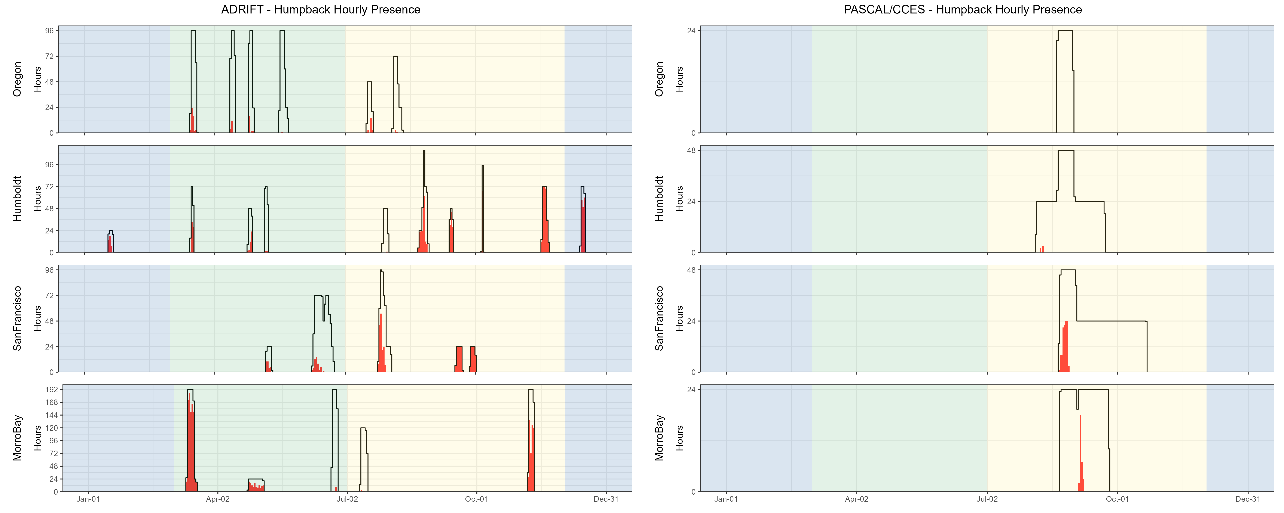

Figure 5.10. Hourly humpback whale events by month, region for Adrift and combined PASCAL, CCES surveys.

Hourly presence of combined humpback whales call types (y axis) for different months for combined years (x axis) and for each region (Oregon, Humboldt, San Francisco, and Morro Bay) for Adrift (left) and combined PASCAL and CCES (right). Hourly presence for duty-cycled data relates to the portion of the hour included in the duty cycled data. Black lines represent total available hours (effort) and red lines represent hours with detections. Blue shading represents winter, green represents upwelling, and yellow represents the post-upwelling oceanographic season.

There were few acoustic detections of humpback whales during the late June/early July surveys off Morro Bay (Figure 5.10). Multiple humpback whales were visually sighted during the June 2022 and July 2023 CCC surveys in Morro Bay; however, the bulk of the visual survey effort (and sightings) were south of the area acoustically surveyed. The disconnect between the visual sightings and acoustic detections could be due to local differences in the sampling areas or that the animals were not particularly vocal during this sampling period.

Hourly probability of detecting song was higher in the post-upwelling than the upwelling season for Humboldt and San Francisco, but the opposite was true for Morro Bay (Table 5.7). Deployments were limited in winter, but high probability of detecting humpback song aligns with the production of song during the southern winter migration (Clapham and Mattila 1990). There were several drifts in which humpback song dominated the recordings (Figure 5.11). The acoustic features of humpback whale song, including high source level and series of calls produced over long time spans, naturally lead to high detection rates (Au et al. 2006). While recordings dominated by song may be attributed to one or a few animals, social sounds may be attributed to larger numbers of animals (Ryan et al. 2019). There were few detections of humpback song in Oregon.

Humpback whales produce many non-song (social) calls that may be associated with feeding or social behaviors. Humpback whale social sounds most frequently detected in these analyses included the grunts, 'wops' and 'thwops' (Dunlop et al. 2008). We were unable to dedicate the time required to differentiate these sounds during this study. Highly annotated datasets exist, and we recommend development of machine learning models to classify humpback non-song, which may allow for an improved understanding of spatial and temporal variation in habitat use in the California Current, allowing us to identify potential critical habitat.

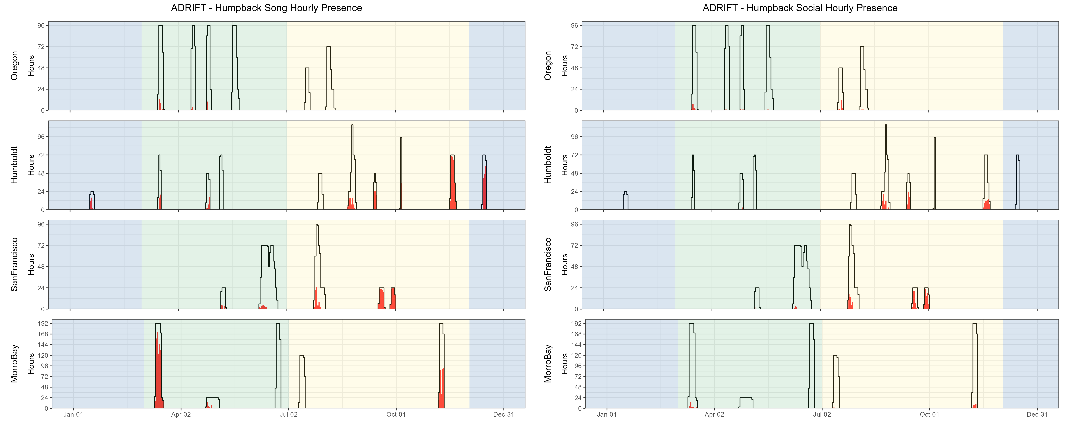

Figure 5.11. Hourly presence of humpback song, social calls by month, region for Adrift.

Hourly presence of humpback song (left) and humpback social calls (right)(y axis) for different months for combined years (x axis) and for each region (Oregon, Humboldt, San Francisco, and Morro Bay). Adrifts 001-012 were duty cycled and hourly presence relates to the portion of the hour included in the duty cycled data (6 min of 12 min). Black lines represent total available hours (effort) and red lines represent hours with detections. Blue shading represents winter, green represents upwelling, and yellow represents the post-upwelling oceanographic season.

Table 5.7. Summary of humpback whale detections in hourly bins for Adrift data.

|  |  |  |  |
| --- | --- | --- | --- |
|  | **Upwelling** | **Post-Upwelling** | **Winter** |
| **Song** |  |  |  |
| Oregon | 0.03 (1430) | 0.00 (493) | – |
| Humboldt | 0.13 (489) | 0.42 (1048) | 0.58 (308) |
| San Francisco | 0.03 (960) | 0.36 (688) | – |
| Morro Bay | 0.40 (2034) | 0.24 (1353) | – |
| **Social Calls** |  |  |  |
| Oregon | 0.01 (1430) | 0.04 (493) | – |
| Humboldt | 0.01 (489) | 0.16 (1048) | 0.00 (308) |
| San Francisco | 0.01 (960) | 0.24 (688) | – |
| Morro Bay | 0.02 (2034) | 0.02 (1353) | – |
| **Undetermined Humpback Calls** |  |  |  |
| Oregon | 0.03 (1430) | 0.01 (493) | – |
| Humboldt | 0.15 (489) | 0.26 (1048) | 0.18 (308) |
| San Francisco | 0.06 (960) | 0.28 (688) | – |
| Morro Bay | 0.16 (2034) | 0.21 (1353) | – |

Note: Summary of humpback whale detections for Song, Social sounds, and Unidentified calls in hourly bins for Adrift data. Mean hourly probability of humpback whale detection for that call type/region/season; total hourly bins are shown in parenthesis.

## Bryde’s and Sei Whales

***Methods***

Detection of calls associated with Bryde’s and sei whales was conducted by our partners at OSA. PAMGuard's (v2.02.09) whistle and moan detector was used to detect calls associated with Bryde's (Be4) and sei whales (frequency modulated downsweep calls identified in Rankin and Barlow (2007)). Potential calls were reviewed by an experienced OSA analyst in PAMGuard's Viewer Mode. Detections were grouped into acoustic events using the Detection Group Localiser module. Acoustic events were then binned into hourly presence for the presence of Bryde's and sei whales. Deployments with excessive self-noise (such as strumming) that consistently impacted our ability to detect Bryde's and sei whales were eliminated from this analysis. Detailed methods are provided in our GitHub online analysis methods[21] and an OSA Report archived on our GitHub repository.[22]

***Results***

There were no confirmed detections of calls associated with Bryde's or sei whales during Adrift, and a single possible sei whale encounter was detected during PASCAL (see spectrogram of possible sei whale in GitHub Repository).[23]

Bryde’s whale distribution is in the tropical and subtropical waters, with occasional northward incursion into the Southern California Bight (Kerosky et al. 2012). The Adrift deployments were north of Point Conception (and the Southern California Bight), and it is not unexpected to fail to detect animals on our recordings. Warming oceans associated with climate change may lead to more consistent detection of these species in the California Current, and these detections may occur in increasingly northern latitudes over time. We recommend that future acoustic studies in the California Current include detection of Bryde’s whales.

Little is known about sei whales in the North Pacific, and to our knowledge there is only one confirmed recording of sei whales in the North Pacific, near Hawaii (Rankin and Barlow 2007). Future research should take advantage of opportunities to understand the vocal repertoire of sei whales in the North Pacific Ocean.

## Gray Whales

***Methods***

An experienced analyst manually scanned spectrograms of 12 kHz decimated data using Raven Pro v. 1.6.4 (4096pt FFT length, Hann window with 90% overlap resulting in a resolution of 341 ms and 4.21 Hz) to detect calls associated with gray whales. Presence of gray whales were indicated, but call classes were not specified. Cross validation of a portion of calls was verified by Dr. Alison Stimpert to ensure consistency with expert annotations. Detailed methods are provided in our GitHub online analysis methods.[24]

***Results***

Sounds associated with gray whales were only detected on a few recordings in the upwelling and post-upwelling seasons in Oregon and San Francisco regions (Table 5.8), and only during a few hours on the combined PASCAL and CCES surveys (Figure 5.12). There is a significant overlap in spectral content for humpback and gray whale calls and most drifts were outside primary gray whale migration routes; care should be taken when inferring gray whale presence from data with concurrent humpback whale presence.

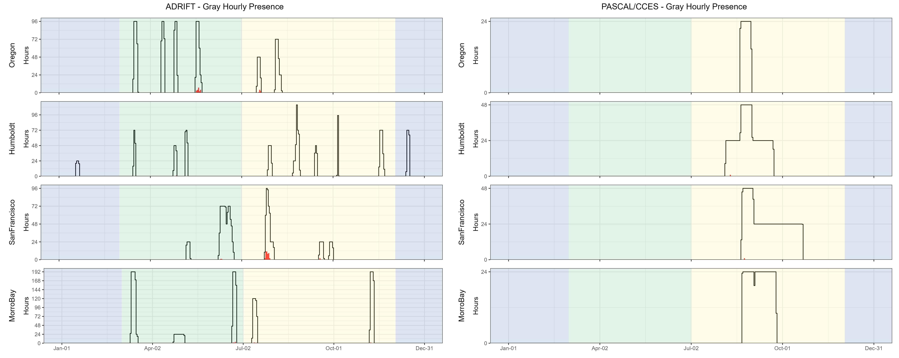

Figure 5.12. Hourly gray whale events by month, region for Adrift and combined PASCAL, CCES surveys.

Hourly presence of gray whale calls (y axis) for different months for combined years (x axis) and for each region (Oregon, Humboldt, San Francisco, and Morro Bay) for Adrift (left) and combined PASCAL and CCES (right). Hourly presence for duty-cycled data relates to the portion of the hour included in the duty cycled data. Black lines represent total available hours (effort) and red lines represent hours with detections. Blue shading represents winter, green represents upwelling, and yellow represents the post-upwelling oceanographic season.

Most Eastern North Pacific gray whales use the California Current to migrate between their feeding grounds in the north and their winter breeding grounds in Baja California. A subpopulation of these whales known as the ‘Pacific Coast Feeding Group’ feed in the California Current off Northern California, Oregon, and Washington during the upwelling and post-upwelling seasons (Barlow et al. 2024). Gray whales are typically found in the nearshore waters, but do occur in offshore waters.[25]

Table 5.8. Summary of gray whale detections in hourly bins for Adrift data.

|  |  |  |  |
| --- | --- | --- | --- |
|  | **Upwelling** | **Post-Upwelling** | **Winter** |
| Oregon | 0.01 (1430) | 0.01 (493) | – |
| Humboldt | 0.00 (489) | 0.00 (1048) | 0.00 (308) |
| San Francisco | 0.00 (960) | 0.07 (688) | – |
| Morro Bay | 0.00 (2065) | 0.01 (1353) | – |

Note: Summary of gray whale detections for Adrift data. Mean hourly probability of gray whale detection for that region/season; total hourly bins are shown in parenthesis.

## Minke Whales

***Methods***

Minke whale ‘boing’ calls were detected using PAMGuard’s Generalized Power Law (GPL) detector on 10 kHz decimated data (Butterworth low pass filter at 5 kHz). GPL settings were modified from a template tuned to fit our data (Helble, pers. comm). The GPL detector returned a low number of detections, and all detections were manually validated using the PAMGuard spectrogram annotation tool. A stratified sub-sampling method was then used to randomly sample 20% of all data void of detections to verify the GPL was not missing boings. Detailed methods are provided in our GitHub online analysis methods.[26]

***Results***

There were no detections of minke whale boings during the Adrift study, and only a few minke whale detections in the CCES and PASCAL datasets (Figure 5.13). Minke whale boing calls are considered 'song' and typically detected during the winter and early spring months where our study has limited effort (Rankin and Barlow 2005). In November 2023 there was a minke whale sighting near Morro Bay; however, there were no boings detected from our offshore drifts. The lack of detections could be due to low population densities or that minkes use coastal waters. Research is needed to improve our knowledge of the minke whale vocal repertoire.

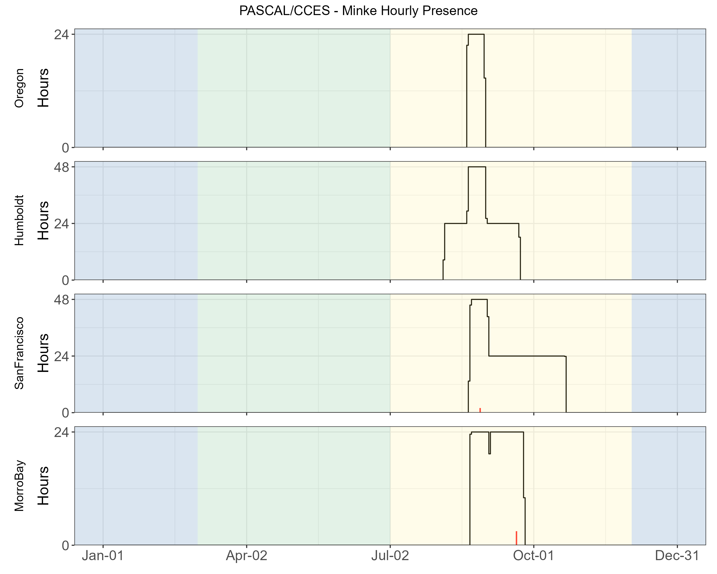

Figure 5.13. Hourly minke whale events by month, region for Adrift and combined PASCAL, CCES surveys.

Hourly presence for minke whale boing calls (y axis) for different months for combined PASCAL 2016 and CCES 2018 survey (x axis) for each region (Oregon, Humboldt, San Francisco, and Morro Bay). There were no detections of minke whale boings during the Adrift study. Buoys were duty cycled and hourly presence relates to the portion of the hour included in the duty cycled data. Black lines represent total available hours (effort), and red lines represent hours with detections. Blue shading represents winter, green represents upwelling, and yellow represents the post-upwelling oceanographic season.

# Soundscape

## Soundscape

The purpose of soundscape monitoring was to describe the ambient noise level(s) in the California Current Ecosystem (including the Morro Bay and Humboldt Wind Energy Areas) and to identify the major contributors to the soundscape. To that end, we measured soundscape metrics and identified two primary sources of noise: self-noise and ship noise. Weather (wind, rain) is a significant contributor to soundscape and varies by season/region. Although we did not quantify this in our analysis, we recommend that future research include weather as a contributor to the soundscape. These data were combined with the detection of biological sounds from marine mammals to examine the biological and anthropogenic contributors to the soundscape.

Soundscape metrics aligned with SanctSound protocols[27] and were measured using Triton (Wiggins and Hildebrand 2007) with the Soundscape Remora. Data were decimated to 48 kHz, and LTSAs were calculated with a 1 Hz, 1 s resolution. The full system calibration value was calculated from the combined hydrophone and SoundTrap sensitivity. Soundscape LTSAs were used to calculate sound levels in 2-minute windows from 100 - 24,000 Hz, including broadband sound pressure levels, third-octave levels, and power spectral densities. Median (50th percentile), mean, and various statistical sound levels (1st, 5th, 10th, 25th, 75th, 90th, and 95th percentiles) are calculated for each metric. Soundscape metrics were archived to NCEI and linked with the original raw data.

The SanctSound methods were initially adopted to provide data consistent with previously analyzed data. Soundscape methods have changed significantly in the last three years, and the most recent recommendation is to report sound levels in hybrid millidecade bands. While there is now open-source software that can produce these metrics, it was not available for our analysis. All of our data is publicly available and the LTSAs were retained so that the data can be converted in the future. We recommend that data be reanalyzed to report sound levels in hybrid millidecade bands to align with current standards.

Periods of low frequency self-noise (strumming, knocking sounds resulting from movement of buoy components) were identified by scanning the 1- or 2-hour LTSA windows created with 500 Hz decimated files (5 Hz and 1 s resolution). Start and end times of noisy data were logged with the highest frequency affected (up to the 250 Hz maximum provided by the 500 Hz decimated data). Noisy data with energy above the 100 Hz lower bounds of the soundscape methods were removed from analysis. Additional details are provided in online analysis methods.[28]

The Power Spectral Density (PSD) is the measure of the signal's power as a function of frequency, and the PSD plots provide a visualization of the ambient noise for each region and season (Figure 6.1). Contributing sounds include biological sounds (marine mammals, fish, invertebrates), environmental noise (wind, rain), and anthropogenic noise (vessel noise, depth sounders, seal bombs). While Figure 6.1 includes all contributors to the soundscape, seasonal and regional differences can be informative and provide valuable pre-development information regarding the general soundscape. In general, noise levels ranged from 50 dB re 1uPa to nearly 150 dB re 1uPa, with the highest density of sound in the 75 - 100 dB range (Figure 6.1).

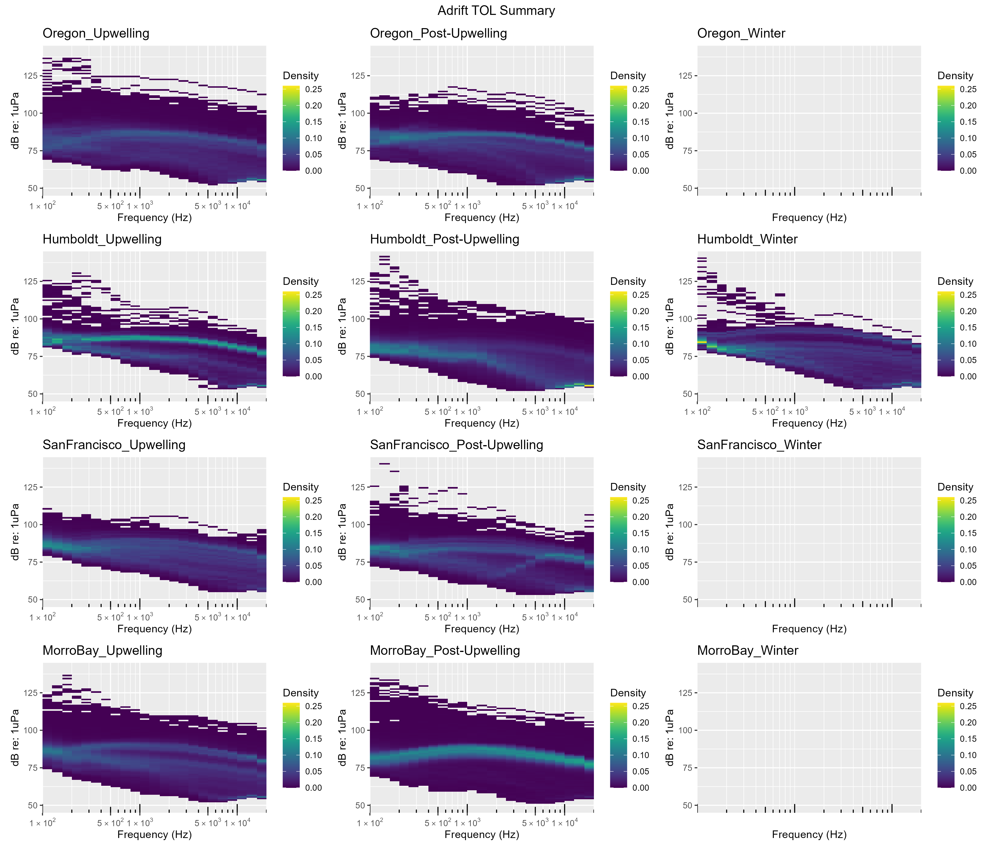

Figure 6.1. Power spectral density for Adrift deployments by season and region.

Other researchers have developed models to separate the distinct contributions of ship and wind noise to soundscapes (Erbe et al. 2021; ZoBell et al. 2024). These models have been validated with empirical data and can be in close agreement in certain times and places, but validation has been very limited to small spatiotemporal scales. The data collected in offshore waters throughout the California Current by drifting recorders during PASCAL, CCES, and Adrift surveys can be used to validate models which separate wind and shipping contributions to sound levels. This will be an important next step for evaluating changes in the soundscape associated with offshore wind development areas.

Low frequency noise associated with strumming precluded consistent analysis of soundscape below 100Hz. Future drifting recorder studies should consider alternative configurations that eliminate strumming and other self-noise to allow for broadband soundscape analysis.

## Ship Noise

Ships produce different sounds while operating, such as impulsive signals from ship propeller cavitation or echosounder signals that can be easily identified in the LTSA and confirmed with a spectrogram. Vessel noise was identified by a trained analyst scanning 1-hour LTSA windows using the Logger Remora in Triton (100 Hz and 5 s resolution). Once a ship was identified, 10 s spectrograms were used to confirm identification (2000 point FFT, 75% overlap). Ships were either logged as being broadband (high amplitude with frequency content above 5 kHz) or narrowband/low frequency (lower amplitude). Ship noise was assessed in full for the Adrift study and in part for CCES (not analyzed for PASCAL). Additional details are provided in online analysis methods.[29] The manual methods used in this study were time consuming, but our initial efforts to analyze data with an existing ship detector found that the detector was unreliable on identifying ship tracks with our dataset. We recommend development of an open-source approach to vessel detection that includes classification of vessels to vessel type, and integration of this data into a systematic approach to quantifying the contribution of ship noise to the soundscape.

The percent of recording hours with vessel presence varied across region, season, and time of day (Figure 6.2). Vessel presence was higher in Oregon and Humboldt than in San Francisco or Morro Bay. Vessel presence in Humboldt shifted from night-time during the upwelling season to daytime during the post-upwelling season (summer), with winter variability likely relating to low effort. Morro Bay region experienced the lowest amount of vessel traffic, with extremely low levels of vessel traffic (<20%) detected in the post-upwelling season.

Hourly presence of ships in San Francisco appears to be lower than other regions (Figure 6.2). Overall sound levels were much higher in this region (Figure 6.1), and may have masked some individual ship passages. Future work can include an Automatic Identification System metric such as the number of unique large vessels with relatively close approaches.

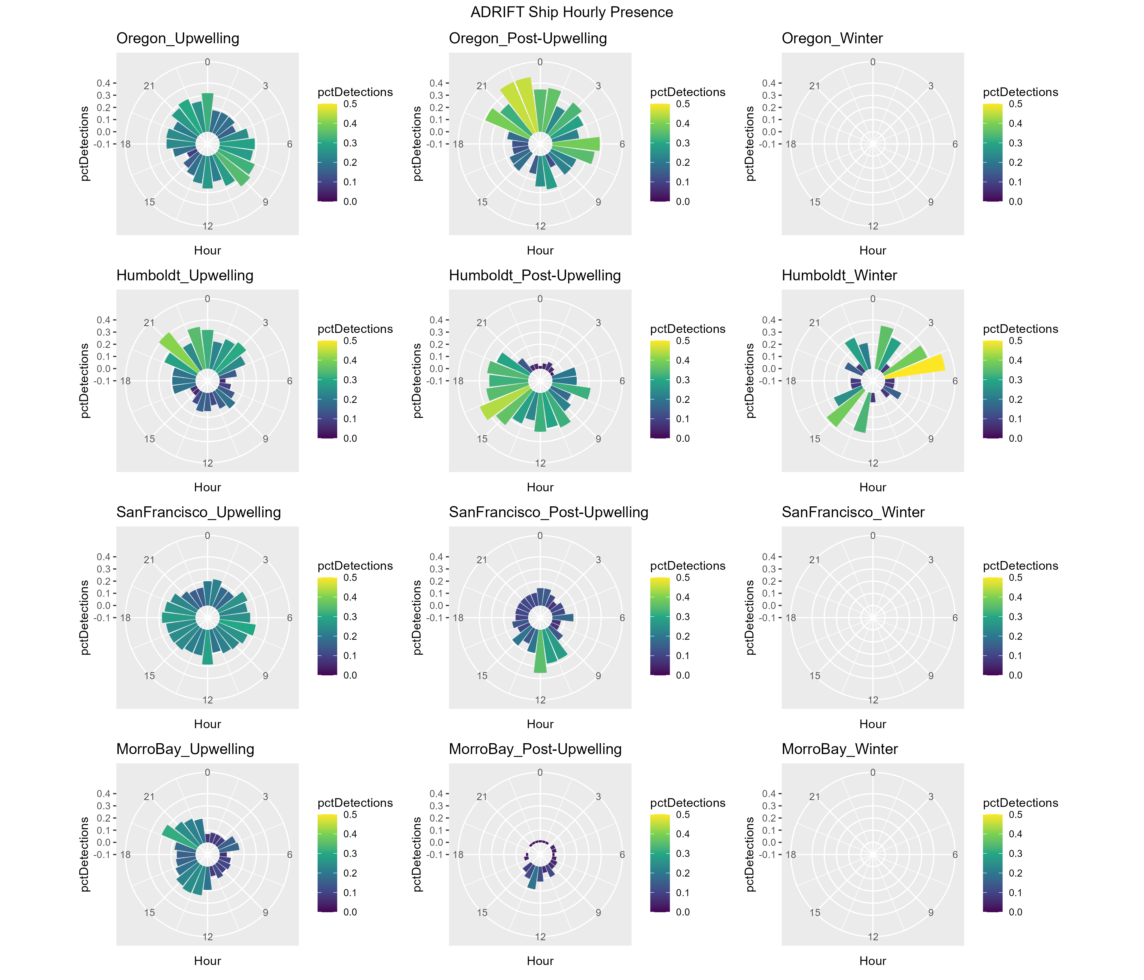

Figure 6.2. Polar plots of seasonal detection of ship noise in Oregon, Humboldt, San Francisco, and Morro Bay regions.

The hourly percent of effort with vessel detections is shown in color ranging from dark blue (0%) to yellow (50%). The diurnal variation in vessel noise is shown by detection in bins on polar plot ranging from 0 to 24 hr of the day (UTC, Universal Time Coordinated).

## Contributors to the Soundscape

The marine soundscape includes sounds associated with physical drivers (rain, waves, earthquakes), biological sources (sounds produced by marine mammals, fish, and invertebrates), as well as anthropogenic sounds. In this study we examined sounds attributed to a number of marine mammal species as well as ship noise. Temporal variation (marked in hourly bins) in the contribution of these sounds to the overall soundscape are provided by the acoustic scene. An acoustic scene provides a visualization of the spectral variation in the contributors to the soundscape, where detection of various species classes is noted by the approximate frequency of their sounds. For this visualization, we used the following frequency range for these detections: blue whale (15 - 25 Hz), fin whale (20 - 50 Hz), humpback whale (50 - 2,000 Hz), sei whale (50 - 500 Hz), gray whale (100 - 2,000 Hz), minke whale (1,000 -2,000 Hz), sperm whale (1,000 - 20,000 Hz), dolphins (1,000 - 25,000 Hz), beaked whales (25,000 - 60,000 Hz), NBHF species (80,000 - 120,000 Hz) and ship noise (100 - 1,000 Hz).

### Oregon

The 2023 Oregon Pilot study consisted of multiple deployments during the upwelling and post-upwelling season (Figure 6.3). NBHF and sperm whales were detected during both the upwelling and post-upwelling seasons, but they were not detected during all deployments. Dolphins were detected during all deployments during both seasons, with variable occurrence. There was a single detection of beaked whales during the upwelling season.

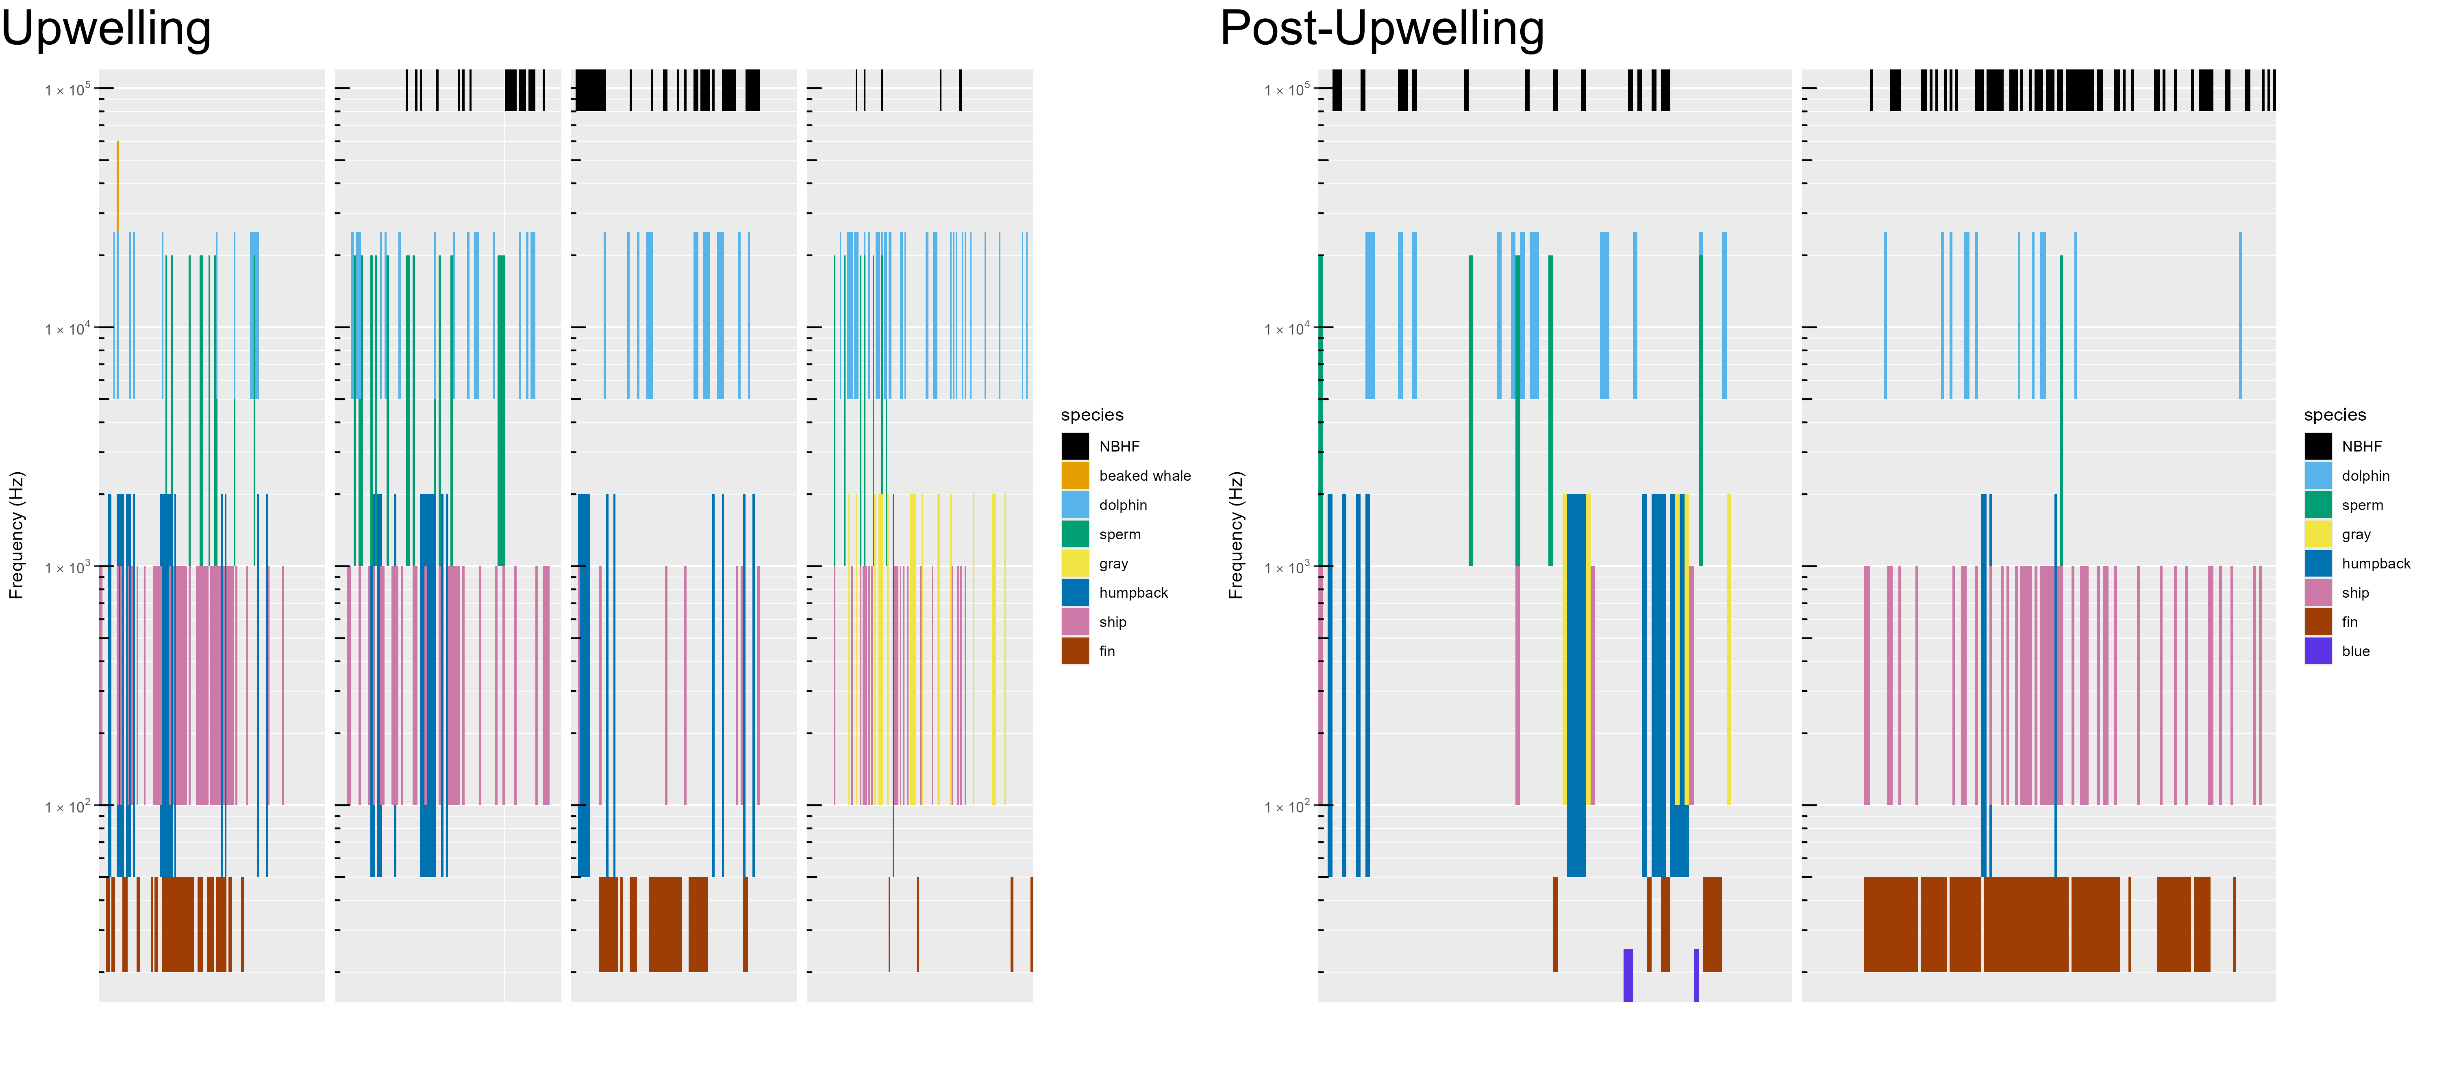

Figure 6.3. Acoustic scene for Oregon, 2023.

Acoustic scene showing detections of various contributors to the soundscape for the 2023 Oregon pilot study deployments in the upwelling and post-upwelling oceanographic seasons.

Fin, humpback, and gray whales were detected during both the upwelling and post-upwelling seasons off Oregon, with a few detections of blue whales during the post-upwelling season (Figure 6.3). While ship noise was detected during both seasons, detection of vessel noise varied by deployment.

There were no deployments during the winter oceanographic season in Oregon, and the single year study did not allow us to assess annual variation.

### Humboldt

In Humboldt, NBHF, dolphins, and sperm whales were detected during all seasons, but not during all deployments (Figure 6.4, Figure 6.5, Figure 6.6). There were fewer dolphins detected in 2021 (Figure 6.4) than in subsequent years. Similar to Oregon, there were few detections of beaked whales in this region.

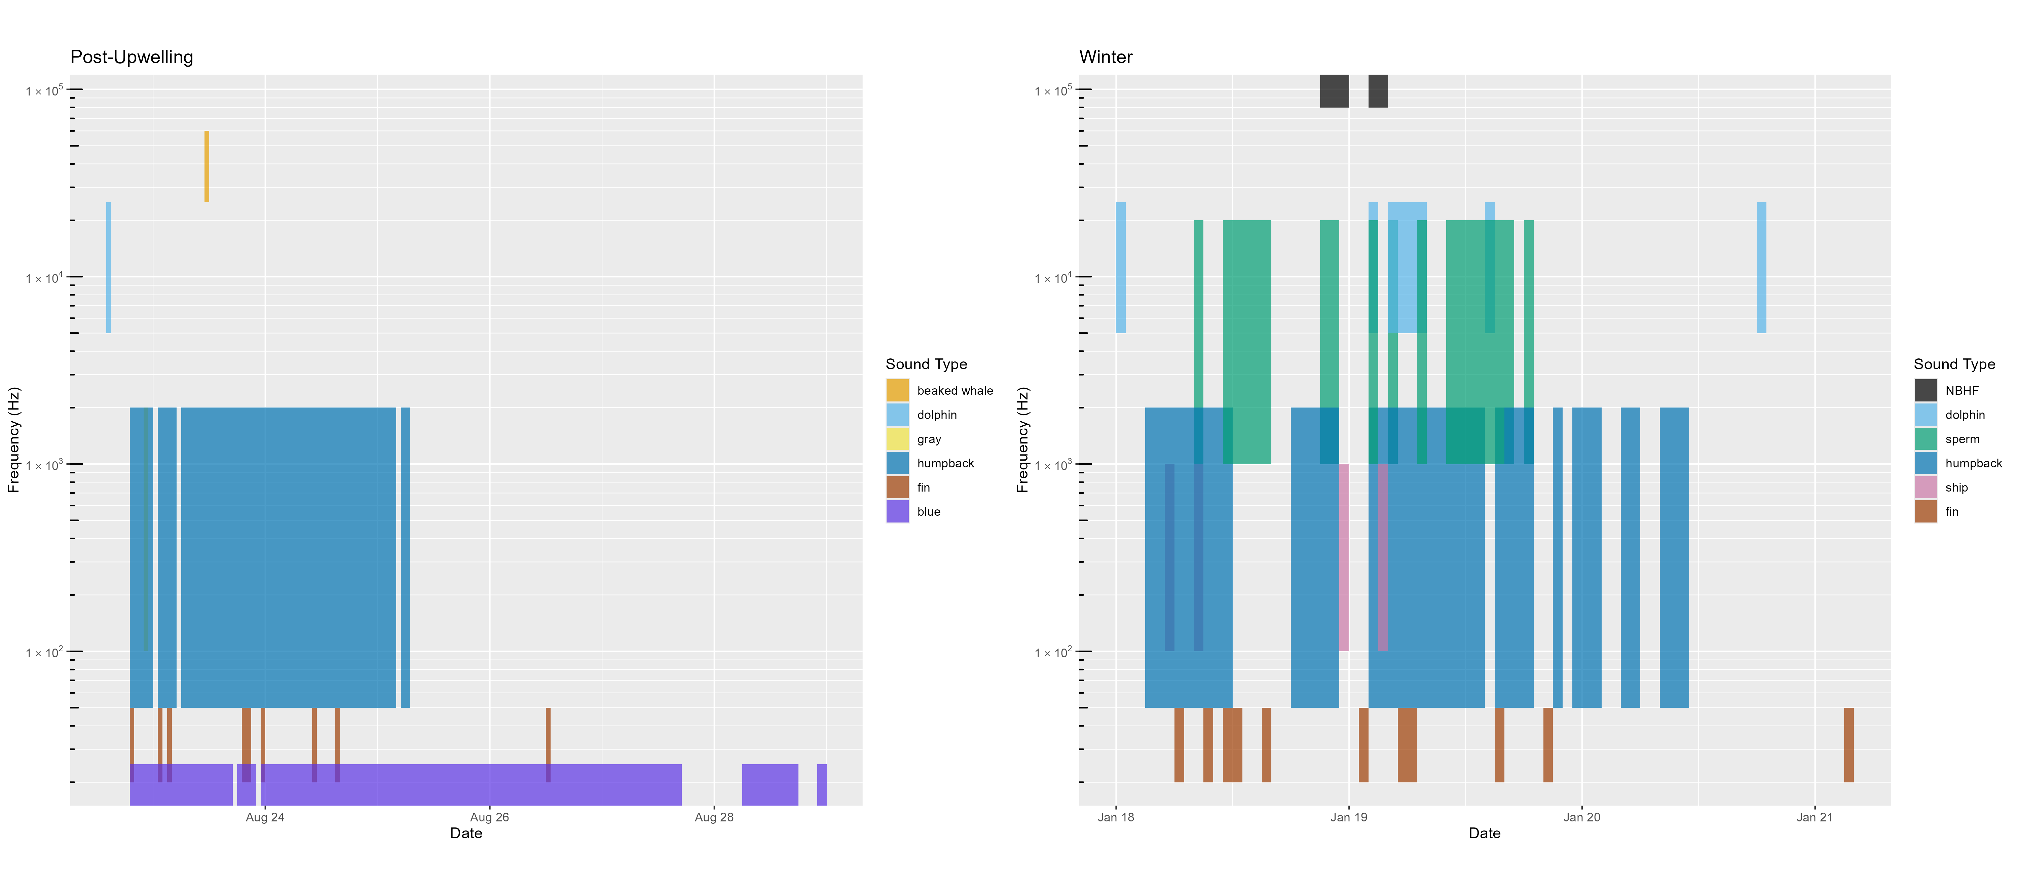

Figure 6.4. Acoustic scene for Humboldt, 2021.

Acoustic scene showing detections of various contributors to the soundscape for the 2021 Humboldt deployments in the post-upwelling and winter oceanographic seasons. No data was collected during the 2021 upwelling season.

Blue whales were consistently detected during the post-upwelling season in all years (Figure 6.4, Figure 6.5, Figure 6.6). While fin whales were detected in all seasons, they were most consistently detected in the post-upwelling season. Humpback whales were frequently detected across seasons and years.

There was little ship noise detected during 2021 (Figure 6.4), which may be due to the ongoing pandemic; ship noise was more consistent during the 2022 and 2023 deployments (Figure 6.5, Figure 6.6).

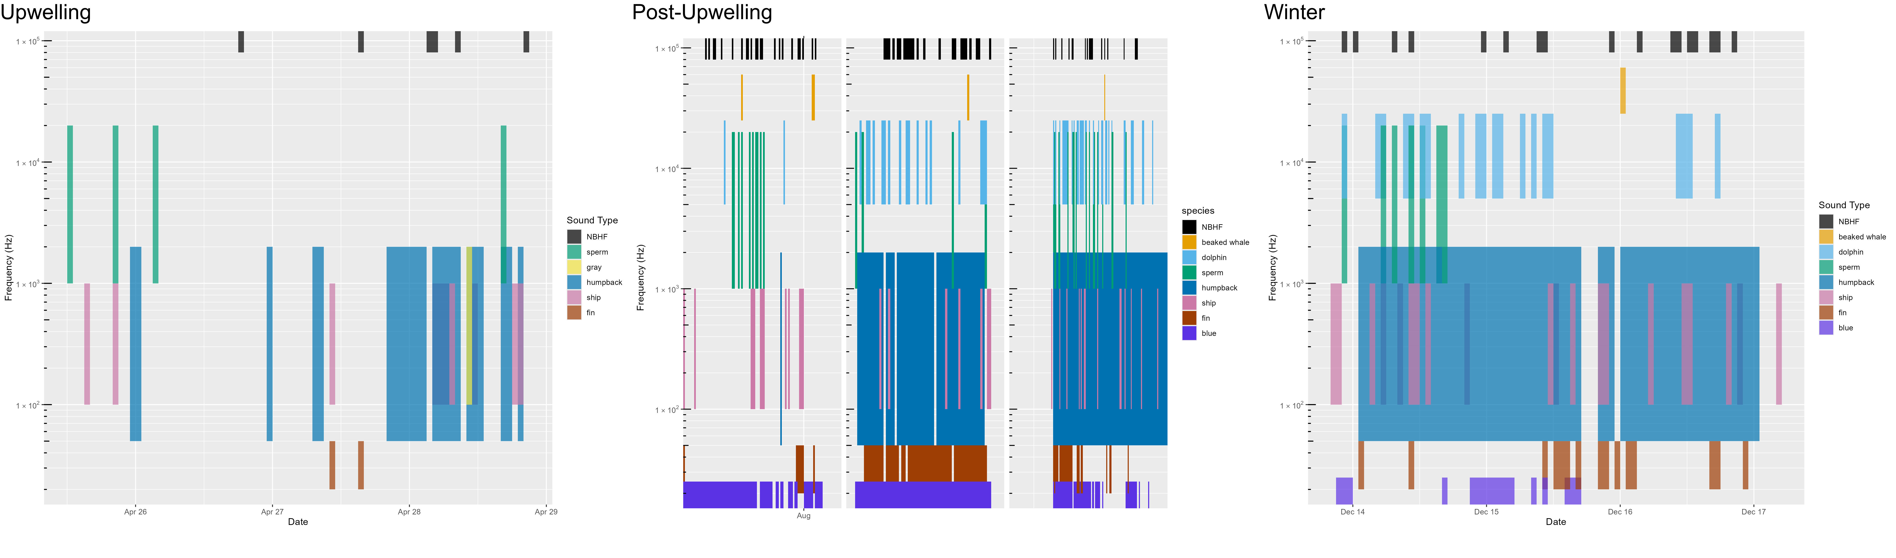

Figure 6.5. Acoustic scene for Humboldt, 2022.

Acoustic scene showing detections of various contributors to the soundscape for the 2022 Humboldt deployments in the upwelling, post-upwelling, and winter oceanographic seasons.

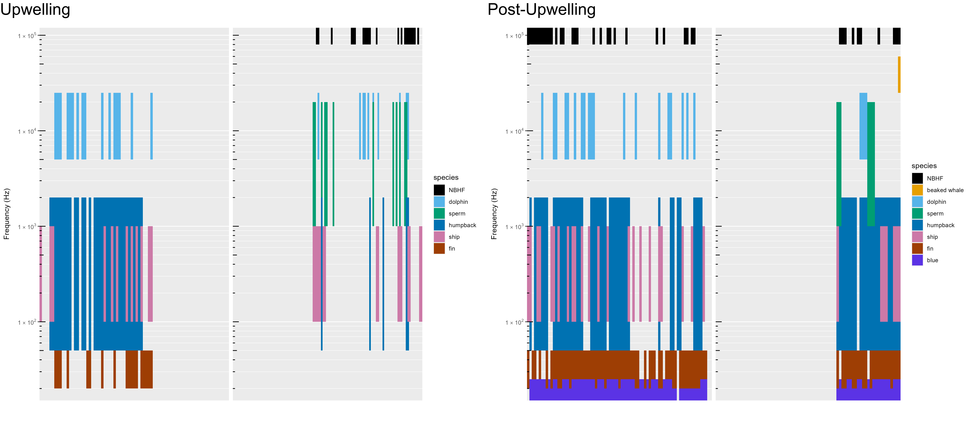

Figure 6.6. Acoustic scene for Humboldt, 2023.

Acoustic scene showing detections of various contributors to the soundscape for the 2023 Humboldt deployments in the upwelling and post-upwelling oceanographic seasons.

### San Francisco

Deployments offshore San Francisco were coordinated with NOAA Sanctuaries' ACCESS Surveys during the upwelling and post-upwelling oceanographic seasons (Figure 6.7, Figure 6.8, Figure 6.9). Contrary to other deployments, buoys were not deployed in clusters as part of the ACCESS survey (to broaden survey area), and therefore data represent data from 1 or 2 buoys at greater distance from each other. Differences in geographic location of deployments in the upwelling and post-upwelling seasons may complicate interpretation of seasonal differences in marine mammal detections (see Figure 3.5).

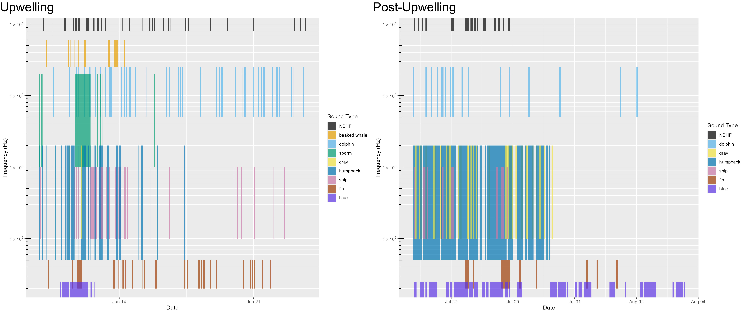

Figure 6.7. Acoustic scene for San Francisco, 2021.

Acoustic scene showing detections of various contributors to the soundscape for the 2021 San Francisco deployments in the upwelling and post-upwelling oceanographic seasons.

Detection of odontocetes (including NBHF, beaked whales, sperm whales, and dolphins) varied by drift (Figure 6.7, Figure 6.8, Figure 6.9). Detection of baleen whales (humpback, gray, fin, and blue whales) varied by drift, with a general increase in detections of many baleen whale species during the post-upwelling season.

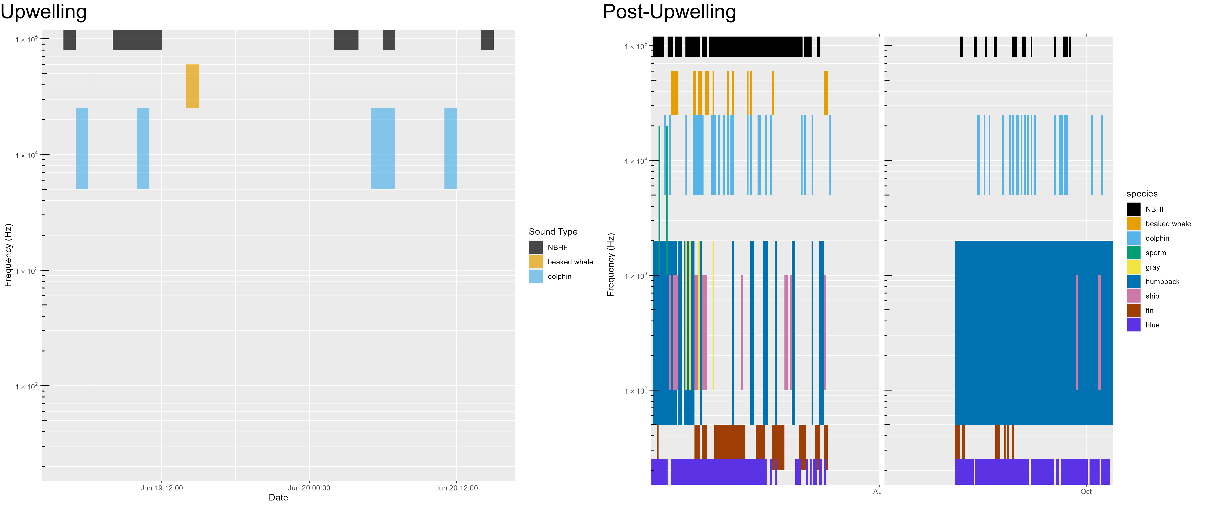

Figure 6.8. Acoustic scene for San Francisco, 2022.

Acoustic scene showing detections of various contributors to the soundscape for the 2022 San Francisco deployments in the upwelling and post-upwelling oceanographic seasons.

Despite the drift locations being near a convergence of shipping lanes entering San Francisco Bay, detection of specific vessels was relatively modest. Analysts noted an overall high level of ambient noise associated with background ship noise (Figure 6.1) and a reduced ability to detect individual vessels. Detection of vessels used manual detection methods (existing automated vessel detectors were not reliable for this dataset); development of a standardized vessel detector that works across datasets could be used to determine if individual ship tracks are difficult to detect in high traffic areas.

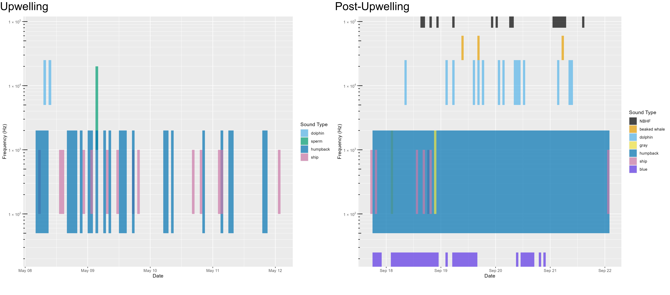

Figure 6.9. Acoustic scene for San Francisco, 2023.

Acoustic scene showing detections of various contributors to the soundscape for the 2023 San Francisco deployments in the upwelling and post-upwelling oceanographic seasons.

### Morro Bay

Morro Bay deployments included between 7 and 8 drifting recorders deployed over a larger area, which allowed for improved geographic sampling during the limited time for each deployment. Detection of NBHF, beaked whales, and dolphins were much lower during the initial upwelling deployments in 2022 (Figure 6.10), but high during the second upwelling deployments in 2022 and in the 2023 deployments. Detection of high numbers of beaked whales during times with dolphin echolocation was possible due to the vertical hydrophone configuration that allows for differentiating deep diving beaked whale species (echolocating below the hydrophones) from dolphins echolocating near the surface. Sperm whales were detected on some, but not all, drifts during both the upwelling and post-upwelling surveys (Figure 6.10, Figure 6.11).

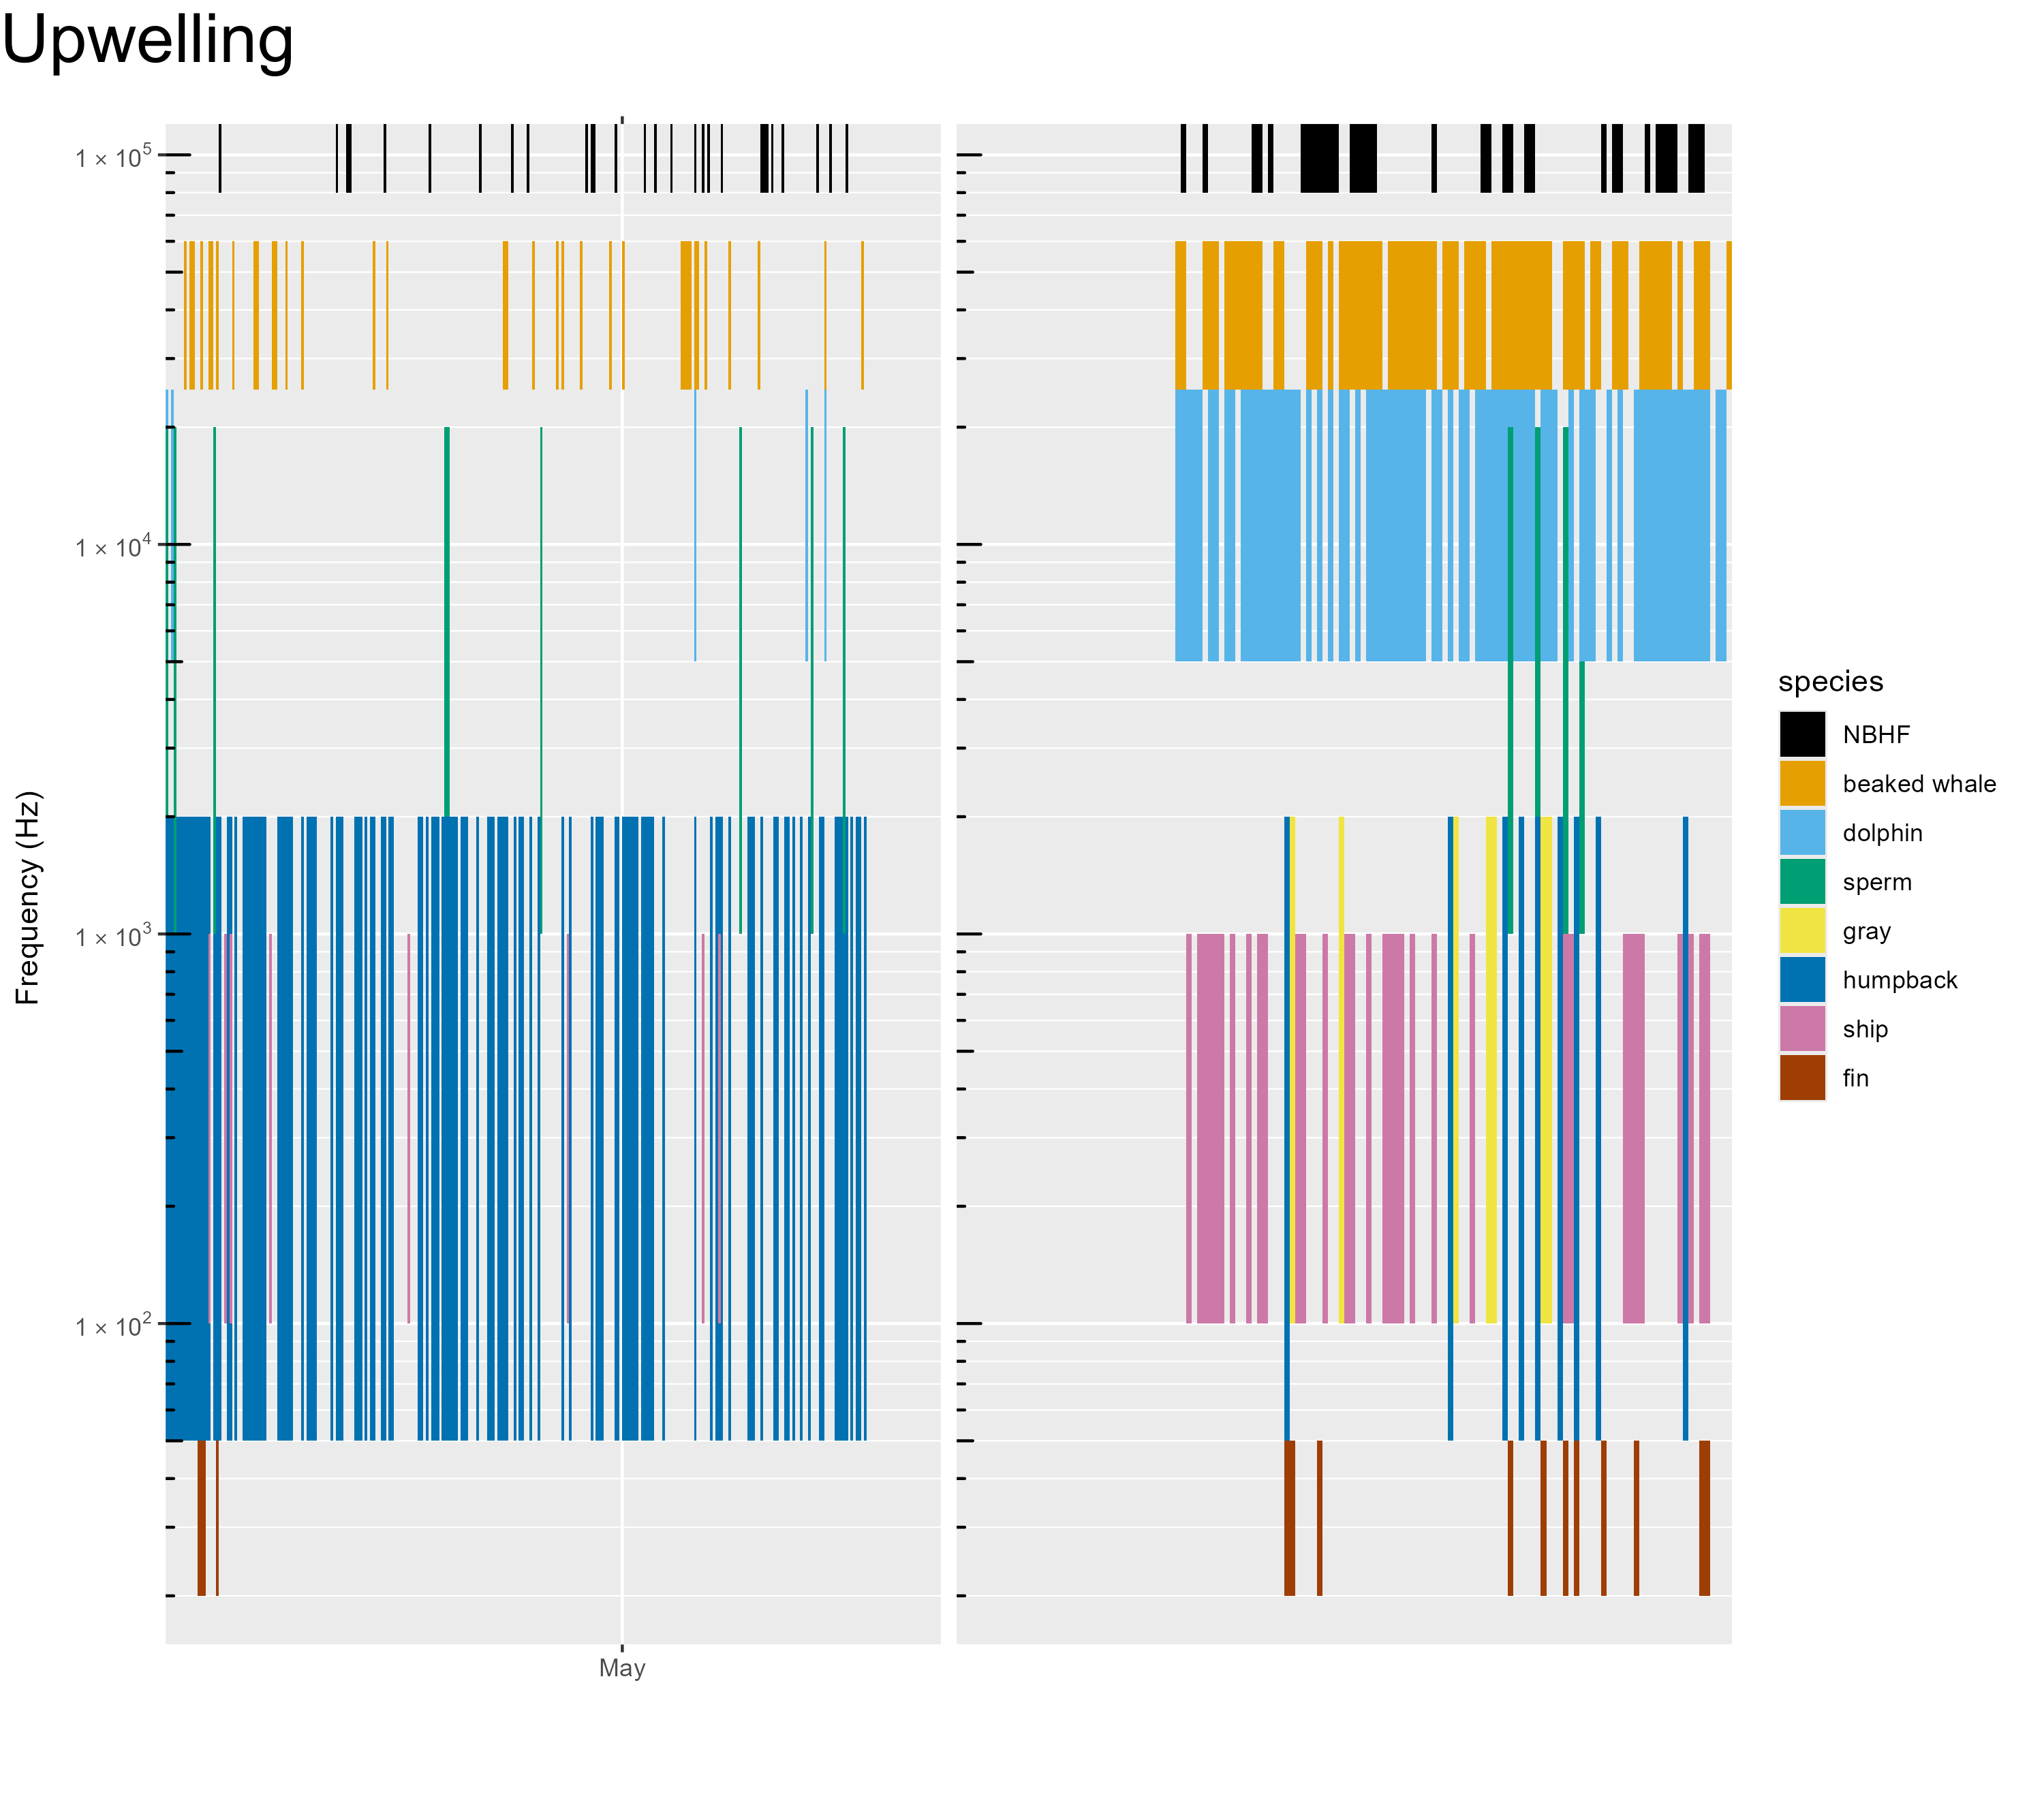

Figure 6.10. Acoustic scene for Morro Bay, 2022.

Acoustic scene showing detections of various contributors to the soundscape for the 2022 Morro Bay deployments in the upwelling oceanographic season.

Fin and humpback whales were detected during all surveys. Blue whales dominated the post-upwelling deployments in 2023 (Figure 6.11), but there were no blue whale detections during either of the upwelling deployments. Periodic vessel noise was detected during all deployments.

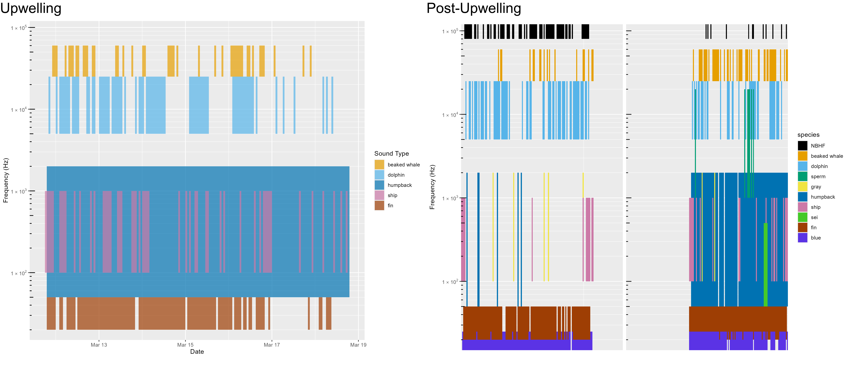

Figure 6.11. Acoustic scene for Morro Bay, 2023.

Acoustic scene showing detections of various contributors to the soundscape for the 2023 Morro Bay deployments in the upwelling and post-upwelling oceanographic seasons.

# Data Sharing

NOAA is committed to increasing the accessibility of publications and digital data produced by federal researchers through the Public Access to Research Results. Publications (including reports) can be accessed at the NOAA Institutional Repository. Raw acoustic data (wav files) are stored at the NCEI and can be accessed after an initial waiting period required as part of the NOAA Fisheries agreement with the U.S. Navy. Metadata include information related to data collection (hardware characteristics, geopositions, recording specifications), soundscape metrics, and species acoustic detection data. Recording metadata associated with data collection and Soundscape metrics will be stored at NCEI. Acoustic detection of species will be accessible via PACM[30]. Details on data archive and sharing methods are provided in our analysis methods.[31]

In addition to public sharing of our research results, the Southwest Acoustic Ecology Lab firmly believes that analysis methods should be publicly accessible. We dedicated time to develop a streamlined approach to data analysis, data visualization, and archival processes to create a reproducible product. These include developing methods in open-source software and publishing analytical methods as R packages, available on CRAN[32] (Comprehensive R Archive Network). This approach requires substantial initial investment, but ultimately provides improved efficiency and reproducible research results. Development of open-source analytical methods for detecting baleen whales required additional research and development investment; complications that arose due to the COVID-19 pandemic thwarted these efforts. Many of these data methods and data products are being adopted by other researchers and across NOAA Fisheries more broadly, providing future cost savings to NOAA and BOEM into the future.

Additional details regarding open Science efforts can be found in Appendix: Open Science.

# Education and Outreach

The study of ocean sound is interdisciplinary and provides a natural opportunity for community engagement in formal education (K-12), informal science learning (museums), and online crowd-source citizen science participation. Our team engaged with students, journalists, and educators to develop materials and tools to make our science accessible to the public. Education and Outreach efforts included mentoring students and interns on authentic research projects, inviting journalists to participate in fieldwork, collaborating with educators to develop lesson plans for many age groups, and developing a preliminary crowd-sourced Zooniverse platform for community involvement in our research.

The interdisciplinary nature of passive acoustics along with the natural appeal of whales and dolphins provides an opportunity for engaging the public in science and the scientific process. To that end, we developed a series of education and outreach materials to reach a diverse populace.

In 2020 we collaborated with San Diego Unified School District (SDUSD) to host a teachers' workshop to develop a series of phenomena-based instructional curricula. Lessons aligned with Next Generation Science Standards and included instructional units for elementary schools (Dolphins have Needs[33]), Middle School (You can recognize different species by the sounds they make[34]) and High School (Ocean noise impacts marine mammals[35]). Lessons plans are publicly available on the Project Phenomena Database[36] website.

Data Nuggets are free classroom activities designed to bring contemporary research and authentic data into the classroom. Data Nuggets were recommended by our teacher collaborators during the SDUSD workshop as a highly useful format for Science Technology Engineering Mathematics in the classroom. We collaborated with Data Nuggets to create 'Eavesdropping on the Ocean’[37]. This Data Nugget provides background on the research question, authentic data to allow classrooms to work with real data to apply to the research question, as well as links for additional information. This has been made publicly available for teachers at no cost.

In addition, we initiated a Zooniverse Project, Ocean Voices[38]. The initial intention of this effort was to use citizen scientists to label datasets as either humpback whales or ship noise; these annotations would then be used to develop an improved machine learning classifier. This required significant effort to automate development of paired spectrograms and acoustic recordings for the platform. The citizen scientist portion of this project will be delayed until future continuation of the work done during the Adrift study, however, the platform can currently function as an education learning tool. The software tools designed to manipulate acoustic data for input to Zooniverse are available on GitHub.[39]

Our periodic 'Sound Bytes' blog provides a general audience with insight into the day-to-day work behind the science. Topics range from 'Lessons learned from Fishermen'[40] to how we ‘Gear up for Fieldwork’[41] to how we ‘Hook young scientists on Research’.[42] We have had a host of guest bloggers, including students, interns, and collaborators. These blogs are shared on NOAA's website[43] and they have been promoted through numerous NOAA newsletters. Cory Hom-Weaver led these efforts and was recognized for an Award by NOAA's Southwest Fisheries Science Center for the excellent education and outreach provided by the Sound Bytes blog.

Additional details regarding our education and outreach efforts can be found in Appendix: Education and Outreach Details.

# Conclusions and Future Directions

The Adrift in the California Current survey was intended to provide additional baseline data on marine mammals and the marine soundscape to inform management of offshore renewable resource development in the California Current. In addition to conducting data collection efforts in and around the Morro Bay, Humboldt, and Oregon WEAs, we also analyzed archived data from previous large scale acoustic surveys.

The first phase of Adrift was initiated in June 2020 off Northern California, with a special focus on the Humboldt WEA. We partnered with NOAA Sanctuaries to provide additional sampling off San Francisco between late Spring and late Summer. Initial deployments were delayed until August 2021 due to the COVID-19 pandemic. The second phase extended this effort to the Morro Bay WEA offshore Central California in 2021. In 2022 we initiated a pilot study to examine the potential for extending this study northward to include offshore Oregon. Data collection efforts were severely limited due to the COVID-19 pandemic as well as inclement weather and oceanographic conditions aggravated by La Niña. Despite these limitations, we deployed 90 drifting recorders in our four study areas for a total of 8,736 recording hours.

Prior to this study, NOAA had successfully deployed drifting acoustic recorders during two large-scale surveys and developed methods to estimate beaked whale density for the larger California Current region. Southwest Fisheries Science Center in partnership with BOEM’s Pacific Region is currently conducting an additional large-scale survey with drifting acoustic recorders (Pacific Marine Assessment Partnership for Protected Species – PacMAPPS II/CalCurCEAS).

While we have been successful using drifting recorders during these large-scale surveys during the late post-upwelling season, we encountered significant challenges in using them during other oceanographic seasons. There were multiple cases of equipment and data loss, especially during the initial deployments. Losses were due to a variety of reasons, including inclement weather, strong currents, and recorder failures. We mitigated these problems through modifying components and altering survey methods. A number of gear modifications were made to improve robustness and to decrease self-noise that interfered with recording quality.

Drifting acoustic recorders provide a low-cost alternative to traditional PAM systems and they can provide additional geographic and temporal resolution in remote offshore areas. Clustered drifting recorders provide an opportunity to improve our understanding of the spatial and temporal variability of the contributors to the soundscape. Preliminary results suggest that clustered drifting recorders can be used to reduce the possible range of possible source location for sound sources (see Appendix: Modeling Habitat Use) and can provide information on the spatial variation in soundscape (see Appendix: Spatial Variation in Noise). Drifting recorders were deployed in clusters of 4 drifting recorders in Humboldt and Oregon study areas, and in clusters of 8 in the Morro Bay Study area. In some cases, drifting recorders in close proximity to each other followed dramatically different drift trajectories.

Below we present a summary of our results and a summary of recommendations for future work.

## Summary of Results

Drifting acoustic recorders can provide high quality PAM for some offshore regions, especially when deployed in clusters to enhance spatial monitoring. Pilot studies are recommended for new regions, to ensure that environmental conditions and local resources support effective sampling. Hardware continues to evolve to allow for improved data collection, and newly developed sub-surface drifting recorders may prove preferable to existing drifting recorders with surface buoys. Our experience suggests that deployment of clustered drifting recorders seasonally in areas of interest could provide additional spatial context to co-located seafloor recorders. Seasonal sampling of these clustered deployments during collaborative cruises, such as our Morro Bay fieldwork, promotes collaborative science and reduces vessel costs.

This dataset provides additional (publicly available) data to support management needs as well as new information on several species. Data analysis included most cetacean species found within the California Current; though several rare species (north Pacific right whales, pilot whales) were not included, nor were pinnipeds. The data are publicly available for future expansion of analysis to include these species.

**Sperm whales** are listed as endangered and their consistent, stereotyped vocalizations make them ideal candidates for PAM. Sperm whales were detected in all study areas, with high detection probabilities in Humboldt during all seasons. PAM data can also be used to determine the demographic composition of sperm whales, and a pilot study of a Morro Bay dataset found that all animals were social groups consisting of females and their young, or juvenile males. There was insufficient time to complete this analysis for our entire archived data, but future research should include acoustic estimations of demographic composition for sperm whales.

**Beaked whales** are difficult to detect, and even harder to classify to species, based on traditional visual observation methods. As with sperm whales, beaked whales are ideal candidates for PAM, and most species can be acoustically classified to species. As an example, there were no detections of beaked whales in 30 years of ACCESS surveys; however, during our limited Adrift deployments, there were numerous detections of both Baird’s beaked whales and goose-beaked whales. Beaked whales were found in all regions, with goose-beaked whales the most common species overall (though none of these species were detected in either Humboldt or Oregon). During the Adrift study, methods to estimate beaked whale density using drifting recorders were automated (to improve efficiency), and data were prepared for analysis, but we were unable to complete this analysis during the time available.

Many of the beaked whales detected in Morro Bay co-occurred with echolocating dolphins. The vertical hydrophone array of the drifting recorders allows for estimation of bearing angles for incoming echolocation clicks, and subsequent differentiation between echolocating beaked whales at depth from echolocating dolphins near the surface. By segregating the echolocation clicks based on bearing angle, we were able to identify the small numbers of beaked whale clicks within thousands (or even millions) of echolocating dolphins. The co-occurrence of dolphins and beaked whales has not been previously reported, and it is unclear what may bring these species together. The likelihood of detecting beaked whales in these mixed species encounters would have been very low if recordings were collected from a single, seafloor sensor or from towed hydrophone arrays.

The California Current has a high diversity of **dolphin species**, and species classification is difficult. While there are several potential approaches to species classification, they have either been developed for towed arrays at the surface (Rankin et al. 2017) or for seafloor hydrophones (Frasier et al. 2017). Currently, there is insufficient validated data for drifting recorders to test the efficacy of existing classifiers on these data, or to develop a drifting-recorder specific classifier. That said, there are robust methods to identify echolocation clicks from Pacific white-sided dolphins and Risso’s dolphins. Dolphin schools in central and northern California are frequently encountered in large, dispersed mixed species groups, and here we do not distinguish mixed species from single-species groups.

Risso’s dolphins were detected in all regions except Oregon, and had the highest probability of detection during the upwelling season in Humboldt. The dominant click type detected was the ‘Pelagic Pacific’ type identified by Soldevilla 2017. Pacific white-sided dolphins were detected in all regions, with higher detection probabilities in the post-upwelling season for Humboldt and San Francisco, and during the upwelling season in Morro Bay. The dominant click type for Pacific white-sided dolphins was ‘Type A’, though ‘Type B’ click types were detected northward of the range identified in Soldevilla 2010. There were relatively few detections of ‘Unidentified odontocetes’ during the post-upwelling season in Oregon and Morro Bay.

The California Current is home to four different species that produce **NBHF** echolocation clicks: harbor porpoise, Dall’s porpoise, pygmy sperm whales, and dwarf sperm whales. Despite the similarities in their echolocation clicks, these species inhabit different habitats and have different behaviors and life histories. Student work to develop a NBHF classifier for this study (see Appendix: Acoustics Classification of NBHF Species) will be further developed in the near future and applied to these data to expand our understanding of the distribution of these species in the California Current as well as the regional WEAs.

**Blue whales** were detected in all regions except Oregon, and the probability of detecting blue whales was higher during the post-upwelling season. Blue whale acoustic detections were dominated by the A/B song call types produced by males. Foraging associated ‘D’ calls were primarily detected during the post-upwelling season, and at much lower detection probabilities than A/B call types. Blue whale calls, especially the ‘B’ call type, can be detected at great ranges and the range of potential sound source locations can be large. Preliminary methods to localize low frequency sounds on clustered drifting recorders shows promise (see Appendix: Modeling Habitat Use), and adoption of these methods may improve our understanding of the habitat use of these species in the greater area.

**Fin whales** were detected throughout the study area at different times of year. Fin whale 20 Hz pulses had a higher detection probability during the post-upwelling season for all regions. Here we did not differentiate between irregular and stereotyped patterns of 20 Hz calls. The 40 Hz call associated with foraging were detected off Oregon and during the post-upwelling season off Morro Bay. These data were used to improve and test a fin whale classifier with excellent results (Appendix: Deep Learning to Detect Fin Whales), and future adoption of these methods may allow for an improved approach of classifying variability in fin whale call patterns.

**Humpback whales** were detected during most deployments, though detection off Oregon was relatively low. The probability of detecting humpbacks was higher for the upwelling season for Morro Bay, while the probability of detecting humpbacks was lower during the upwelling season for both San Francisco and Humboldt. While there were few detections of humpback whales during the late June/early July surveys off Morro Bay, these animals were frequently sighted nearshore, highlighting the variability of their distribution within these greater regions.

Humpback whales are notoriously difficult PAM subjects due to their very active vocal behavior (in quantity and variability). Many recordings can be dominated by humpback song, and this song may be the result of a single individual. There is significant research on many of the non-song vocalizations, but detection and classification of these sounds require expertise and manual classification. There are significant numbers of annotated datasets, and development of a machine learning method to detect and classify these sounds would allow researchers to better understand how the detection of humpback sounds can inform the demographic composition and habitat use of these species throughout the California Current.

**Bryde’s whales** occur in the tropical and sub-tropical Pacific Ocean, with occasional incursions into the Southern California Bight. We did not detect sounds associated with Bryde’s whales in this analysis, but we do expect these species may become more common with global ocean warming.

Little is known of the vocal repertoire of **sei whales**, and our research only found one potential sei whale acoustic detection. Future research should take advantage of opportunities to understand the vocal repertoire of sei whales in the North Pacific Ocean.

Most **gray whales** use more shallow, coastal waters for their migration between their feeding grounds in the north and their winter breeding grounds in Baja California. Gray whales were detected off Oregon, where there is a resident population, and during the post-upwelling season in the San Francisco and Morro Bay areas. There is a significant overlap in spectral content for humpback and gray whale calls and care should be taken when inferring gray whale presence from data with concurrent humpback whale presence.

There were no detections of **minke whale** ‘boings’ during our Adrift study, and only a few during the combined PASCAL/CCES surveys. There was one visual sighting of a minke whale in coastal waters near Morro Bay harbor in November 2023; however, there were no recordings during our offshore drifts during this same survey. The lack of detections could be related to low seasonal population densities or that calling animals use coastal waters.

In addition to detecting marine mammal species, we manually detected **ship tracks** in these data (existing ship noise detectors were not reliable on our data). The percent of recording hours with vessel presence varied across region, season, and time of day, and vessel presence was generally higher in Oregon and Humboldt than in San Francisco or Morro Bay. Vessel presence in Humboldt shifted from night-time during the upwelling season to daytime during the post-upwelling season (summer), with winter variability likely relating to low effort. Morro Bay region experienced the lowest amount of vessel traffic, with extremely low levels of vessel traffic (<20%) detected in the post-upwelling season. The relatively low detection of ships off San Francisco may be related to masking of individual ship passages due to the overall higher sound levels in this region. Development of a standardized approach to detecting vessels that works across platforms and compensates for elevated ambient noise due to high vessel track is warranted.

These biological and anthropogenic sounds contribute to the overall soundscape, and measurement of sound levels allows us to examine variation in the soundscape over time. **Soundscape metrics** aligned with previously analyzed SanctSound data for consistency, but preferred methods recommend reporting sound levels in hybrid millidecade bands. Our soundscape data will be publicly accessible to allow for this conversion. Our results show variability in sound levels over time and space, with general noise levels ranging from 50 dB re 1µPa to nearly 150 dB re 1 µPa (and the highest density of sound in the 75 – 100 dB range).

The marine soundscape includes sounds associated with physical drivers (rain, waves, earthquakes), biological sources (sounds produced by marine mammals, fish, and invertebrates), as well as anthropogenic sounds. In this study we examined sounds attributed to a number of marine mammal species as well as ship noise. We also developed automated methods to integrate these data to better understand these various contributors to the soundscape, and how they change over time. While we had limited time to conduct advanced analyses, our research efforts took a significant step forward so that future researchers can more readily integrate these methods into their analyses. These methods will be adopted and expanded by NOAA PAM researchers at a national scale as part of a new PAM strategic initiative.

All data have been publicly archived to NCEI[44] and detection data archived to PACM[45].

## Recommendations

We believe that drifting recorders provide high quality data to address certain research questions, and that they complement additional PAM studies using traditional methods. Here we provide a list of recommendations that may serve to guide future research efforts.

### Data Collection Recommendations

* **Clustered deployments** provide improved spatial and temporal data to understand variability in contributors to the soundscape and should be considered for surveys.
* **Conduct regional pilot studies** to determine region-specific environmental conditions and to identify local partners prior to initiating full scale surveys, as drifting recorders are not appropriate for all geographic regions.
* **Collaborative field surveys** should be considered in all regions (including Humboldt) to share vessel resources, improve scientific collaborations, and provide opportunities for scientists to share and learn from other community members.
* **Alternative buoy designs** to reduce strumming should be considered; design developed by Pacific Islands Fisheries Science Center may reduce strumming and associated self-noise. New sub-surface drifting recorders (in development and testing) may be an alternative approach that reduces risk of ship strike or data loss due to self-noise.
* **Seafloor recorders are the preferred platform for depths < 300 m**. depth. Drifting recorders are suitable for monitoring offshore, deep water habitats.

### Data Analysis and Archive Recommendations

* **Expand beaked whale density estimation methods** to include (1) further development of an automated approach to acoustic event delineation to improve standardization of methods and reduce manual workload, and (2) expansion of this analysis to species beyond goose-beaked whales.
* **Expand analytical methods to localize sound sources from clustered recorders** based on pilot study (Appendix: Modeling Habitat Use) to apply these data to population assessment, if future work with clustered buoys will be adopted.
* **Expand methods to assess the spatial and temporal variability in soundscape from clustered recorders** based on preliminary methods outlined in (Appendix: Spatial Variation in Noise) if future work with clustered buoys will be adopted.
* **Develop a comprehensive machine learning acoustic classifier for dolphins in California Current** using existing archived datasets, including these data.
* **Develop an open-source platform to share bioacoustics annotations** to make annotations of publicly available datasets available for developing deep learning classifiers.
* **Encourage Open Science methods**, including the development of analytical methods using open-source software, open sharing of data and metadata in accessible environments, and public sharing of research methods to accommodate reproduction of methods.
* **Develop machine learning methods for humpback whale calls**, including differentiation of specific social sounds and song. Detection of humpback whales was dominated by humpback whale song; however, detection of specific social calls may be more appropriate for identifying larger aggregations of humpback whales.
* **Exclude gray whale analysis from offshore data** collection efforts if these efforts are outside their primary migration routes.
* **Assess demographic composition of sperm whales in California Current** from new and archived datasets by applying methods outlined in (Appendix: Sperm Whales Demographic Composition).
* **Estimate beaked whale density for the Adrift dataset**; data were prepared but we were unable to complete this analysis due to delays caused by the COVID-19 pandemic.
* **Encourage research on sei whale vocal repertoire in the Pacific Ocean** to allow for PAM description of this little-known species.
* **Examine the co-occurrence of beaked whales with echolocating dolphins** and how this may impact studies based on single sensors.
* **Examine geographic variation in acoustic characteristics of Pacific white-sided and Risso's dolphins** to better understand the geographic variation in these two species and potential underlying environmental variables.
* **Reanalyze Adrift sound levels** in hybrid millidecade bands to conform to recently developed standards.
* **Develop vessel noise detectors** that provide standardized output for different platforms for a systematic approach to quantifying the contribution of ship noise to the soundscape.

# References

Au WWL, Pack AA, Lammers MO, Herman LM, Deakos MH, Andrews K. 2006. Acoustic properties of humpback whale songs. The Journal of the Acoustical Society of America. 120(2):1103–1110. <doi:10.1121/1.2211547>.

Barlow DR, Strong CS, Torres LG. 2024. Three decades of nearshore surveys reveal long-term patterns in gray whale habitat use, distribution, and abundance in the Northern California Current. Sci Rep. 14(1):9352. <doi:10.1038/s41598-024-59552-z>.

Barlow J, Fregosi S, Thomas L, Harris D, Griffiths ET. 2021. Acoustic detection range and population density of Cuvier’s beaked whales estimated from near-surface hydrophones. The Journal of the Acoustical Society of America. 149(1):111–125. <doi:10.1121/10.0002881>.

Barlow J, Moore JE, McCullough JLK, Griffiths ET. 2022. Acoustic-based estimates of Cuvier’s beaked whale (*Ziphius cavirostris*) density and abundance along the U.S. West Coast from drifting hydrophone recorders. Marine Mammal Science. 38(2):517–538. <doi:10.1111/mms.12872>.

Becker EA, Forney KA, Miller DL, Barlow J, Moore JE. 2020. Habitat-based density estimates for cetaceans in the California Current Ecosystem based on 1991–2018 survey data. <doi:https://doi.org/10.25923/3znq-yx13>.

Beslin WAM, Whitehead H, Gero S. 2018. Automatic acoustic estimation of sperm whale size distributions achieved through machine recognition of on-axis clicks. The Journal of the Acoustical Society of America. 144(6):3485–3495. <doi:10.1121/1.5082291>.

Carretta JV. 2023. U.S. Pacific marine mammal stock assessments: 2022. <doi:10.25923/5YSF-GT95>. https://repository.library.noaa.gov/view/noaa/51022.

Clapham PJ hillip, Mattila DK. 1990. Humpback Whale Songs as Indicators of Migration Routes. Marine Mammal Science. 6(2):155–160. <doi:10.1111/j.1748-7692.1990.tb00238.x>.

Croll DA, Clark CW, Acevedo A, Tershy B, Flores S, Gedamke J, Urban J. 2002. Only male fin whales sing loud songs. Nature. 417(6891):809–809. <doi:10.1038/417809a>.

Dunlop RA, Cato DH, Noad MJ. 2008. Non-song acoustic communication in migrating humpback whales (*Megaptera novaeangliae*). Marine Mammal Science. 24(3):613–629. <doi:10.1111/j.1748-7692.2008.00208.x>.

Edds-Walton PL. 1997. Acoustic Communication Signals of Mysticete Whales. Bioacoustics. 8(1–2):47–60. <doi:10.1080/09524622.1997.9753353>.

Erbe C, Schoeman RP, Peel D, Smith JN. 2021. It Often Howls More than It Chugs: Wind versus Ship Noise Under Water in Australia’s Maritime Regions. Journal of Marine Science and Engineering. 9(5):472. <doi:10.3390/jmse9050472>.

Frasier KE, Roch MA, Soldevilla MS, Wiggins SM, Garrison LP, Hildebrand JA. 2017. Automated classification of dolphin echolocation click types from the Gulf of Mexico. PLOS Computational Biology. 13(12):e1005823. <doi:10.1371/journal.pcbi.1005823>.

Griffiths ET, Archer F, Rankin S, Keating JL, Keen E, Barlow J, Moore JE. 2020. Detection and classification of narrow-band high frequency echolocation clicks from drifting recorders. The Journal of the Acoustical Society of America. 147(5):3511–3522. <doi:10.1121/10.0001229>.

Henderson EE, Ballance L, Cárdenas-Hinojosa G, Barlow J, DeAngelis AI, Martinez S, Hayslip C, Pusser T, Márquez Segovia M, Baker S, et al. *In Preparation.* First at-sea identifications of gingko-toothed beaked whale (*Mesoplodon gingkodens*): acoustics, genetics, and biological observations off Baja California, Mexico. Marine Mammal Science.

Hildebrand JA, Frasier KE, Baumann-Pickering S, Wiggins SM. 2021. An empirical model for wind-generated ocean noise. Journal Acoustical Society America. 149(6):4516–4533. <doi:https://doi.org/10.1121/10.0005430>.

Keating J, Barlow J, Griffiths ET, Moore JE. 2018. Passive acoustics survey of cetacean abundance levels (PASCAL-2016) final report. US Department of the Interior, Bureau of Ocean Energy Management Report No.: 25. <https://www.boem.gov/sites/default/files/environmental-stewardship/Environmental-Studies/Pacific-Region/Studies/BOEM-2018-025.pdf>.

Kerosky SM, Širović A, Roche L, Baumann-Pickering S, Wiggins SM, Hildebrand JA. 2012. Bryde’s whale seasonal range expansion and increasing presence in the Southern California Bight from 2000 to 2010. Deep Sea Research. 65:125–132. <doi:https://doi.org/10.1016/j.dsr.2012.03.013>.

Largier JL, Magnell BA, Winant CD. 1993. Subtidal circulation over the northern California shelf. Journal of Geophysical Research: Oceans. 98(C10):18147–18179. <doi:10.1029/93JC01074>.

McDonald MA, Calambokidis J, Teranishi AM, Hildebrand JA. 2001. The acoustic calls of blue whales off California with gender data. The Journal of the Acoustical Society of America. 109(4):1728–1735. <doi:10.1121/1.1353593>.

Møhl B, Wahlberg M, Madsen PT, Miller LA, Surlykke A. 2000. Sperm whale clicks: Directionality and source level revisited. The Journal of the Acoustical Society of America. 107(1):638–648. <doi:10.1121/1.428329>.

Oleson EM, Wiggins SM, Hildebrand JA. 2007. Temporal separation of blue whale call types on a southern California feeding ground. Animal Behaviour. 74(4):881–894. <doi:10.1016/j.anbehav.2007.01.022>.

Posdaljian N, Solsona-Berga A, Hildebrand JA, Soderstjerna C, Wiggins SM, Lenssen K, Baumann-Pickering S. 2023. Sperm Whales Demographics in the Gulf of Alaska and Bering Sea/Aleutian Islands: An Overlooked Female Habitat. <doi:10.1101/2023.04.16.537097>. http://biorxiv.org/lookup/doi/10.1101/2023.04.16.537097.

Rankin S, Archer F, Keating JL, Oswald JN, Oswald M, Curtis A, Barlow J. 2017. Acoustic classification of dolphins in the California Current using whistles, echolocation clicks, and burst pulses. Marine Mammal Science. 2(33):520–540. <doi:10.1111/mms.12381>.

Rankin S, Barlow J. 2005. Source of the North Pacific “boing” sound attributed to minke whales. The Journal of the Acoustical Society of America. 118(5):3346–3351. <doi:10.1121/1.2046747>.

Rankin S, Barlow J. 2007. Vocalizations of the sei whale Balaenoptera borealis off the Hawaiian Islands. Bioacoustics. 16(2):137–145. <doi:10.1080/09524622.2007.9753572>.

Romagosa M, Pérez-Jorge S, Cascão I, Mouriño H, Lehodey P, Pereira A, Marques TA, Matias L, Silva MA. 2021. Food talk: 40-Hz fin whale calls are associated with prey biomass. Proceedings of the Royal Society B: Biological Sciences. 288(1954):20211156. <doi:10.1098/rspb.2021.1156>.

Ryan JP, Cline DE, Joseph JE, Margolina T, Santora JA, Kudela RM, Chavez FP, Pennington JT, Wahl C, Michisaki R, et al. 2019. Humpback whale song occurrence reflects ecosystem variability in feeding and migratory habitat of the northeast Pacific. PLOS ONE. 14(9):e0222456. <doi:10.1371/journal.pone.0222456>.

Simonis AE. 2020. Passive Acoustic Survey Of Deep-Diving Odontocetes in the California Current Ecosystem 2018: Final Report. NOAA-TM-NMFS-SWFSC-630. <doi:10.25923/W5XX-JZ73>. https://repository.library.noaa.gov/view/noaa/27223.

Soldevilla M, Wiggins S, Hildebrand J. 2010. Spatio-temporal comparison of Pacific white-sided dolphin echolocation click types. Aquat Biol. 9:49–62. <doi:10.3354/ab00224>.

Soldevilla MS, Baumann-Pickering S, Cholewiak D, Hodge LEW, Oleson EM, Rankin S. 2017. Geographic variation in Risso’s dolphin echolocation click spectra. The Journal of the Acoustical Society of America. 142(2):599–617. <doi:10.1121/1.4996002>.

Soldevilla MS, Henderson EE, Campbell GS, Wiggins SM, Hildebrand JA, Roch MA. 2008. Classification of Risso’s and Pacific white-sided dolphins using spectral properties of echolocation clicks. The Journal of the Acoustical Society of America. 124(1):609–624.<doi:10.1121/1.2932059>.

Solsona-Berga A, Posdaljian N, Hildebrand JA, Baumann-Pickering S. 2022. Echolocation repetition rate as a proxy to monitor population structure and dynamics of sperm whales. Remote Sensing in Ecology and Conservation. 8(6):827–840. <doi:10.1002/rse2.278>.

Southall B, Mazurek R, Eriksen R. 2023. Vulnerability Index to Scale Effects of Offshore Renewable Energy on Marine Mammals and Sea Turtles Off the U.S. West Coast (VIMMS). Aptos, CA: Southall Environmental Associates, Inc. Report No.: BOEM-2023-057. <https://espis.boem.gov/Final%20Reports/BOEM_2023-057.pdf>.

Thompson AR, Swalethorp R, Alksne M, Santora JA, Hazen EL, Leising A, Satterthwaite E, Sydeman WJ, Anderson CR, Auth TD, et al. 2024. State of the California Current Ecosystem report in 2022: a tale of two La Niñas. Front Mar Sci. 11. <doi:10.3389/fmars.2024.1294011>. https://www.frontiersin.org/articles/10.3389/fmars.2024.1294011.

Westell A, Rowell TJ, Posdaljian N, Solsona-Berga A, Van Parijs SM, DeAngelis AI. 2024 Feb 19. Acoustic presence and demographics of sperm whales (*Physeter macrocephalus*) off southern New England and near a US offshore wind energy area. ICES Journal of Marine Science. <doi:10.1093/icesjms/fsae012>.

Wiggins SM, Hildebrand JA. 2007. High-frequency Acoustic Recording Package (HARP) for broad-band, long-term marine mammal monitoring. In: 2007 Symposium on Underwater Technology and Workshop on Scientific Use of Submarine Cables and Related Technologies. Tokyo, Japan: IEEE. p. 551–557. . <http://ieeexplore.ieee.org/document/4231090/>.

Zahn M, Ladegaard M, Simon M, Stafford K, Sakai T, Laidre K. 2024. Accurate species classification of Arctic toothed whale echolocation clicks using one-third octave ratios. The Journal of the Acoustical Society of America. 155:2359–2370. <doi:10.1121/10.0025460>.

ZoBell VM, Hildebrand JA, Frasier KE. 2024. Comparing pre-industrial and modern ocean noise levels in the Santa Barbara Channel. Marine Pollution Bulletin. 202:116379. <doi:10.1016/j.marpolbul.2024.116379>.

1. Adrift Expanded Datasets

Complete list of drifting acoustic recorder deployments (Table A‑1) during the Adrift in the California Current Survey. Sites include Oregon (ORE), Humboldt (HUM), San Francisco Bay (SFB), Half Moon Bay (HMB), Monterey Bay (MBY) and Morro Bay (MOB). See Figure 3.1 for more information on regions.

Table A‑1. Summary of Adrift deployments.

|  |  |  |  |  |  |  |  |  |  |  |  |  |  |  |  |  |  |  |  |  |  |  |  |  |  |  |  |  |  |  |  |  |  |  |  |  |  |  |  |  |  |  |
| --- | --- | --- | --- | --- | --- | --- | --- | --- | --- | --- | --- | --- | --- | --- | --- | --- | --- | --- | --- | --- | --- | --- | --- | --- | --- | --- | --- | --- | --- | --- | --- | --- | --- | --- | --- | --- | --- | --- | --- | --- | --- | --- |
| **Drift ID** | **Site** | **Status** | **Deploy Date** | **Deploy Lat** | **Deploy Long** | | **Recover Date** | | | | | | **Recover Lat** | | | | | | | | | | **Recover Long** | | | | | | | **Recorder** | | | | | | | | **SR (kHz)** | **Duty Cycle** | **HP Depth (m)** | **Data Start Date** | **Data End Date** |
| ADRIFT_001 | HUM | Complete | 8/22/2021 | 41.07 | −124.35 | | 9/4/2021 | | | | | | 41.2 | | | | | | | | | | −124.35 | | | | | | | ST4300HF | | | | | | | | 384 | 6 min per 12 | 100 | 8/22/2021 | 8/29/2021 |
| ADRIFT_002 | HMB | Complete | 6/9/2021 | 37.38 | −122.39 | | 6/29/2021 | | | | | | 36.98 | | | | | | | | | | −124.25 | | | | | | | ST4300HF | | | | | | | | 384 | 6 min per 6 | 100 | 6/9/2021 | 6/16/2021 |
| ADRIFT_003 | SFB | Complete | 7/25/2021 | 37.97 | −123.50 | | 8/3/2021 | | | | | | 38.03 | | | | | | | | | | −123.48 | | | | | | | ST4300HF | | | | | | | | 384 | 6 min per 12 | 100 | 7/25/2021 | 8/3/2021 |
| ADRIFT_004 | HUM | Failed | 7/31/2021 | 41.84 | −125.09 | | – | | | | | | – | | | | | | | | | | – | | | | | | | ST4300HF | | | | | | | | 384 | 6 min per 12 | 100 | – | – |
| ADRIFT_005 | SFB | Complete | 6/10/2021 | 37.64 | −123.32 | | 6/24/2021 | | | | | | 37.36 | | | | | | | | | | −123.40 | | | | | | | ST4300HF | | | | | | | | 384 | 6 min per 12 | 100 | 6/10/2021 | 6/22/2021 |
| ADRIFT_006 | SFB | Complete | 7/25/2021 | 38.13 | −123.54 | | 7/28/2021 | | | | | | 38.12 | | | | | | | | | | −123.32 | | | | | | | ST4300HF | | | | | | | | 384 | 6 min per 12 | 100 | 7/25/2021 | 7/28/2021 |
| ADRIFT_007 | SFB | Complete | 6/10/2021 | 37.84 | −123.42 | | 6/24/2021 | | | | | | 37.7 | | | | | | | | | | −123.36 | | | | | | | ST4300HF | | | | | | | | 384 | 6 min per 12 | 100 | 6/10/2021 | 6/24/2021 |
| ADRIFT_008 | HMB | Failed | 6/9/2021 | 37.14 | −122.96 | | – | | | | | | – | | | | | | | | | | – | | | | | | | ST4300HF | | | | | | | | 384 | 6 min per 12 | 100 | – | – |
| ADRIFT_009 | HUM | Failed | 9/8/2021 | 41.03 | −124.30 | | – | | | | | | – | | | | | | | | | | – | | | | | | | ST4300HF | | | | | | | | 384 | 6 min per 12 | 100 | – | – |
| ADRIFT_010 | SFB | Failed | 9/25/2021 | 37.8 | −123.39 | | 10/14/2021 | | | | | | 35.94 | | | | | | | | | | −123.40 | | | | | | | ST4300HF | | | | | | | | 384 | 6 min per 12 | 50 | – | – |
| ADRIFT_011 | SFB | Failed | 9/25/2021 | 37.64 | −123.13 | | 10/15/2021 | | | | | | 36.66 | | | | | | | | | | −123.52 | | | | | | | ST4300HF | | | | | | | | 384 | 6 min per 12 | 50 | – | – |
| ADRIFT_012 | HUM | Complete | 1/18/2022 | 41.03 | −124.43 | | 1/23/2022 | | | | | | 40.87 | | | | | | | | | | −124.86 | | | | | | | ST4300HF | | | | | | | | 384 | Continuous | 100 | 1/18/2022 | 1/21/2022 |
| ADRIFT_013 | MOB | Complete | 4/23/2022 | 36.05 | −122.03 | | 5/5/2022 | | | | | | 35 | | | | | | | | | | −122.27 | | | | | | | ST640 | | | | | | | | 384 | Continuous | 100 | 4/23/2022 | 5/4/2022 |
| ADRIFT_014 | MOB | Failed | 4/22/2022 | 36.06 | −122.01 | | – | | | | | | – | | | | | | | | | | – | | | | | | | ST640 | | | | | | | | 384 | Continuous | 100 | – | – |
| ADRIFT_015 | SFB | Complete | 6/18/2022 | 37.96 | −123.50 | | 6/21/2022 | | | | | | 37.68 | | | | | | | | | | −123.35 | | | | | | | ST640 | | | | | | | | 384 | Continuous | 100 | 6/18/2022 | 6/21/2022 |
| ADRIFT_016 | SFB | Unusable | 6/16/2022 | 37.8 | −123.38 | | 6/21/2022 | | | | | | 37.37 | | | | | | | | | | −123.27 | | | | | | | ST640 | | | | | | | | 288 | Continuous | 100 | – | – |
| ADRIFT_017 | HUM | Complete | 4/25/2022 | 41.06 | −124.48 | | 4/28/2022 | | | | | | 40.7 | | | | | | | | | | −124.53 | | | | | | | ST4300HF | | | | | | | | 384 | Continuous | 100 | 4/25/2022 | 4/28/2022 |
| ADRIFT_018 | HUM | Complete | 4/25/2022 | 41.05 | −124.55 | | 4/28/2022 | | | | | | 40.58 | | | | | | | | | | −124.87 | | | | | | | ST4300HF | | | | | | | | 384 | Continuous | 100 | 4/25/2022 | 4/28/2022 |
|  |  |  |  |  |  | |  | | | | | |  | | | | | | | | | |  | | | | | | |  | | | | | | | |  |  |  |  |  |
| **Table A-1. Summary of Adrift deployments, con’t.** | | | | | | | | | | | | | | | |  | | |  | | |  | | |  | |  | |  | | | |  |  | |  | |  |  |  |  |  |
| **Drift ID** | **Site** | **Status** | **Deploy Date** | **Deploy Lat** | **Deploy Long** | | **Recover Date** | | | | | | **Recover Lat** | | | | | | | | | | **Recover Long** | | | | | | | **Recorder** | | | | | | | | **SR (kHz)** | **Duty Cycle** | **HP Depth (m)** | **Data Start Date** | **Data End Date** |
| ADRIFT_019 | MBY | Complete | 6/21/2022 | 35.8 | −122.19 | | 6/25/2022 | | | | | | 35.98 | | | | | | | | | | −122.05 | | | | | | | ST640 | | | | | | | | 384 | Continuous | 100 | 6/21/2022 | 6/25/2022 |
| ADRIFT_020 | MBY | Complete | 6/21/2022 | 35.8 | −122.09 | | 6/25/2022 | | | | | | 35.61 | | | | | | | | | | −121.92 | | | | | | | ST640 | | | | | | | | 384 | Continuous | 100 | 6/21/2022 | 6/25/2022 |
| ADRIFT_021 | MBY | Complete | 6/21/2022 | 35.8 | −121.98 | | 6/25/2022 | | | | | | 35.62 | | | | | | | | | | −121.82 | | | | | | | ST640 | | | | | | | | 384 | Continuous | 100 | 6/21/2022 | 6/25/2022 |
| ADRIFT_022 | MBY | Complete | 6/21/2022 | 35.8 | −121.88 | | 6/25/2022 | | | | | | 35.5 | | | | | | | | | | −122.02 | | | | | | | ST640 | | | | | | | | 384 | Continuous | 100 | 6/21/2022 | 6/25/2022 |
| ADRIFT_023 | MBY | Complete | 6/21/2022 | 35.71 | −122.19 | | 6/25/2022 | | | | | | 35.84 | | | | | | | | | | −121.88 | | | | | | | ST640 | | | | | | | | 384 | Continuous | 100 | 6/21/2022 | 6/25/2022 |
| ADRIFT_024 | MBY | Complete | 6/21/2022 | 35.72 | −122.09 | | 6/25/2022 | | | | | | 35.72 | | | | | | | | | | −122.11 | | | | | | | ST640 | | | | | | | | 384 | Continuous | 100 | 6/21/2022 | 6/25/2022 |
| ADRIFT_025 | MBY | Complete | 6/21/2022 | 35.72 | −121.98 | | 6/25/2022 | | | | | | 35.54 | | | | | | | | | | −122.03 | | | | | | | ST640 | | | | | | | | 384 | Continuous | 100 | 6/21/2022 | 6/25/2022 |
| ADRIFT_026 | MBY | Complete | 6/21/2022 | 35.72 | −121.88 | | 6/25/2022 | | | | | | 35.75 | | | | | | | | | | −122.01 | | | | | | | ST640 | | | | | | | | 384 | Continuous | 100 | 6/21/2022 | 6/25/2022 |
| ADRIFT_027 | SFB | Complete | 7/26/2022 | 37.9 | −123.44 | | 7/30/2022 | | | | | | 37.68 | | | | | | | | | | −123.78 | | | | | | | ST640 | | | | | | | | 384 | Continuous | 100 | 7/26/2022 | 7/30/2022 |
| ADRIFT_028 | SFB | Complete | 7/26/2022 | 37.89 | −123.38 | | 7/30/2022 | | | | | | 37.72 | | | | | | | | | | −123.80 | | | | | | | ST640 | | | | | | | | 384 | Continuous | 100 | 7/26/2022 | 7/30/2022 |
| ADRIFT_029 | HUM | Failed | 7/28/2022 | 41.13 | −124.44 | | 8/1/2022 | | | | | | 40.95 | | | | | | | | | | −124.32 | | | | | | | ST4300HF | | | | | | | | 384 | Continuous | 100 | – | – |
| ADRIFT_030 | HUM | Complete | 7/28/2022 | 41.13 | −124.54 | | 8/1/2022 | | | | | | 41.05 | | | | | | | | | | −125.03 | | | | | | | ST4300HF | | | | | | | | 384 | Continuous | 100 | 7/28/2022 | 8/1/2022 |
| ADRIFT_031 | HUM | Complete | 7/28/2022 | 41.13 | −124.64 | | 8/1/2022 | | | | | | 41.08 | | | | | | | | | | −125.02 | | | | | | | ST4300HF | | | | | | | | 384 | Continuous | 100 | 7/28/2022 | 8/1/2022 |
| ADRIFT_032 | HUM | Complete | 9/13/2022 | 41.05 | −124.53 | | 9/15/2022 | | | | | | 41.35 | | | | | | | | | | −124.54 | | | | | | | ST4300HF | | | | | | | | 384 | Continuous | 100 | 9/13/2022 | 9/15/2022 |
| ADRIFT_033 | HUM | Complete | 9/13/2022 | 41.05 | −124.43 | | 9/15/2022 | | | | | | 41.46 | | | | | | | | | | −124.45 | | | | | | | ST4300HF | | | | | | | | 384 | Continuous | 100 | 9/13/2022 | 9/15/2022 |
| ADRIFT_034 | SFB | Complete | 9/27/2022 | 38.05 | −123.56 | | 10/1/2022 | | | | | | 38.33 | | | | | | | | | | −123.45 | | | | | | | ST640 | | | | | | | | 384 | Continuous | 100 | 9/27/2022 | 10/1/2022 |
| ADRIFT_035 | SFB | Unusable | 9/26/2022 | 38.13 | −123.53 | | 10/1/2022 | | | | | | 38.05 | | | | | | | | | | −123.41 | | | | | | | ST640 | | | | | | | | 384 | Continuous | 100 | – | – |
| ADRIFT_036 | HUM | Complete | 11/16/2022 | 41.05 | −124.43 | | 11/21/2022 | | | | | | 40.93 | | | | | | | | | | −124.34 | | | | | | | ST4300HF | | | | | | | | 384 | Continuous | 100 | 11/16/2022 | 11/20/2022 |
| ADRIFT_037 | HUM | Complete | 11/16/2022 | 41.05 | −124.51 | | 11/21/2022 | | | | | | 41.01 | | | | | | | | | | −124.41 | | | | | | | ST4300STD | | | | | | | | 288 | Continuous | 100 | 11/16/2022 | 11/21/2022 |
| ADRIFT_038 | HUM | Complete | 11/16/2022 | 41.05 | −124.58 | | 11/21/2022 | | | | | | 40.99 | | | | | | | | | | −124.41 | | | | | | | ST4300HF | | | | | | | | 384 | Continuous | 100 | 11/16/2022 | 11/20/2022 |
| ADRIFT_039 | HUM | Complete | 12/13/2022 | 40.81 | −124.47 | | 12/16/2022 | | | | | | 40.7 | | | | | | | | | | −124.55 | | | | | | | ST4300HF | | | | | | | | 384 | Continuous | 100 | 12/13/2022 | 12/16/2022 |
| ADRIFT_040 | HUM | Complete | 12/13/2022 | 40.81 | −124.54 | | 12/16/2022 | | | | | | 40.82 | | | | | | | | | | −124.74 | | | | | | | ST4300STD | | | | | | | | 288 | Continuous | 100 | 12/13/2022 | 12/16/2022 |
| ADRIFT_041 | HUM | Complete | 12/13/2022 | 40.81 | −124.61 | | 12/16/2022 | | | | | | 41.04 | | | | | | | | | | −124.43 | | | | | | | ST4300HF | | | | | | | | 384 | Continuous | 100 | 12/13/2022 | 12/16/2022 |
| ADRIFT_042 | ORE | Complete | 3/16/2023 | 44.6 | −124.75 | | 3/21/2023 | | | | | | 44.6 | | | | | | | | | | −124.70 | | | | | | | ST4300HF | | | | | | | | 384 | Continuous | 100 | 3/16/2023 | 3/21/2023 |
| ADRIFT_043 | ORE | Complete | 3/16/2023 | 44.78 | −124.72 | | 3/20/2023 | | | | | | 44.7 | | | | | | | | | | −124.61 | | | | | | | ST4300HF | | | | | | | | 384 | Continuous | 100 | 3/16/2023 | 3/20/2023 |
| **Table A-1. Summary of Adrift deployments, con’t.** | | | | | | | | | | |  | | |  | | |  | | |  | | | |  | |  | |  | | | |  | | | |  | |  |  |  |  |  |
| **Drift ID** | **Site** | **Status** | **Deploy Date** | **Deploy Lat** | **Deploy Long** | | **Recover Date** | | | | | | **Recover Lat** | | | | | | | | | | **Recover Long** | | | | | | | **Recorder** | | | | | | | | **SR (kHz)** | **Duty Cycle** | **HP Depth (m)** | **Data Start Date** | **Data End Date** |
| ADRIFT_044 | ORE | Complete | 3/16/2023 | 44.54 | −124.66 | | 3/21/2023 | | | | | | 44.55 | | | | | | | | | | −124.51 | | | | | | | ST4300HF | | | | | | | | 384 | Continuous | 100 | 3/16/2023 | 3/20/2023 |
| ADRIFT_045 | ORE | Complete | 3/16/2023 | 44.62 | −124.62 | | 3/21/2023 | | | | | | 44.54 | | | | | | | | | | −124.58 | | | | | | | ST4300HF | | | | | | | | 384 | Continuous | 100 | 3/16/2023 | 3/20/2023 |
| ADRIFT_046 | MBY | Complete | 3/11/2023 | 35.62 | −121.85 | | 3/16/2023 | | | | | | 35.26 | | | | | | | | | | −121.61 | | | | | | | ST640 | | | | | | | | 384 | 6 min per 6 | 100 | 3/11/2023 | 3/16/2023 |
| ADRIFT_047 | MBY | Complete | 3/11/2023 | 35.63 | −121.98 | | 3/16/2023 | | | | | | 35.26 | | | | | | | | | | −121.69 | | | | | | | ST640 | | | | | | | | 384 | 6 min per 6 | 100 | 3/11/2023 | 3/16/2023 |
| ADRIFT_048 | MBY | Complete | 3/11/2023 | 35.63 | −122.08 | | 3/18/2023 | | | | | | 35.35 | | | | | | | | | | −120.94 | | | | | | | ST640 | | | | | | | | 384 | 6 min per 6 | 100 | 3/11/2023 | 3/18/2023 |
| ADRIFT_049 | MBY | Complete | 3/11/2023 | 35.63 | −122.18 | | 3/16/2023 | | | | | | 35.41 | | | | | | | | | | −120.80 | | | | | | | ST640 | | | | | | | | 384 | 6 min per 6 | 100 | 3/11/2023 | 3/16/2023 |
| ADRIFT_050 | MBY | Complete | 3/11/2023 | 35.54 | −122.18 | | 3/16/2023 | | | | | | 35.24 | | | | | | | | | | −121.91 | | | | | | | ST640 | | | | | | | | 384 | 6 min per 6 | 100 | 3/11/2023 | 3/16/2023 |
| ADRIFT_051 | MBY | Complete | 3/11/2023 | 35.55 | −122.08 | | 3/16/2023 | | | | | | 35.24 | | | | | | | | | | −121.91 | | | | | | | ST640 | | | | | | | | 384 | 6 min per 6 | 100 | 3/11/2023 | 3/16/2023 |
| ADRIFT_052 | MBY | Complete | 3/11/2023 | 35.55 | −121.98 | | 3/17/2023 | | | | | | 35.09 | | | | | | | | | | −121.74 | | | | | | | ST640 | | | | | | | | 384 | 6 min per 6 | 100 | 3/11/2023 | 3/16/2023 |
| ADRIFT_053 | MBY | Complete | 3/11/2023 | 35.54 | −121.87 | | 3/17/2023 | | | | | | 34.96 | | | | | | | | | | −121.70 | | | | | | | ST640 | | | | | | | | 384 | 6 min per 6 | 100 | 3/11/2023 | 3/16/2023 |
| ADRIFT_054 | HUM | Complete | 3/16/2023 | 40.84 | −124.54 | | 3/18/2023 | | | | | | 40.8 | | | | | | | | | | −124.53 | | | | | | | ST4300HF | | | | | | | | 384 | Continuous | 100 | 3/16/2023 | 3/18/2023 |
| ADRIFT_055 | HUM | Complete | 3/16/2023 | 40.84 | −124.63 | | 3/18/2023 | | | | | | 40.88 | | | | | | | | | | −124.45 | | | | | | | ST4300STD | | | | | | | | 288 | Continuous | 100 | 3/16/2023 | 3/18/2023 |
| ADRIFT_056 | HUM | Unusable | 3/16/2023 | 40.84 | −124.67 | | 3/18/2023 | | | | | | 40.94 | | | | | | | | | | −124.51 | | | | | | | ST4300HF | | | | | | | | 384 | Continuous | 100 | – | – |
| ADRIFT_057 | HUM | Complete | 3/16/2023 | 40.85 | −124.71 | | 3/18/2023 | | | | | | 41.09 | | | | | | | | | | −124.51 | | | | | | | ST4300HF | | | | | | | | 384 | Continuous | 100 | 3/16/2023 | 3/18/2023 |
| ADRIFT_058 | ORE | Complete | 4/13/2023 | 43.81 | −124.61 | | 4/16/2023 | | | | | | 43.27 | | | | | | | | | | −124.67 | | | | | | | ST4300HF | | | | | | | | 384 | Continuous | 100 | 4/13/2023 | 4/16/2023 |
| ADRIFT_059 | ORE | Complete | 4/13/2023 | 43.89 | −124.73 | | 4/16/2023 | | | | | | 43.69 | | | | | | | | | | −124.50 | | | | | | | ST4300HF | | | | | | | | 384 | Continuous | 100 | 4/13/2023 | 4/16/2023 |
| ADRIFT_060 | ORE | Complete | 4/13/2023 | 43.81 | −124.74 | | 4/16/2023 | | | | | | 43.35 | | | | | | | | | | −124.56 | | | | | | | ST4300HF | | | | | | | | 384 | Continuous | 100 | 4/13/2023 | 4/16/2023 |
| ADRIFT_061 | ORE | Complete | 4/13/2023 | 43.88 | −124.62 | | 4/16/2023 | | | | | | 43.39 | | | | | | | | | | −124.48 | | | | | | | ST4300HF | | | | | | | | 384 | Continuous | 100 | 4/13/2023 | 4/16/2023 |
| ADRIFT_062 | ORE | Complete | 4/26/2023 | 45.08 | −124.39 | | 4/29/2023 | | | | | | 45.16 | | | | | | | | | | −124.59 | | | | | | | ST4300HF | | | | | | | | 384 | Continuous | 100 | 4/26/2023 | 4/29/2023 |
| ADRIFT_063 | ORE | Complete | 4/26/2023 | 45.16 | −124.40 | | 4/29/2023 | | | | | | 45.38 | | | | | | | | | | −124.57 | | | | | | | ST4300HF | | | | | | | | 384 | Continuous | 100 | 4/26/2023 | 4/29/2023 |
| ADRIFT_064 | ORE | Complete | 4/26/2023 | 45.24 | −124.40 | | 4/29/2023 | | | | | | 45.41 | | | | | | | | | | −124.49 | | | | | | | ST4300HF | | | | | | | | 384 | Continuous | 100 | 4/26/2023 | 4/29/2023 |
| ADRIFT_065 | ORE | Complete | 4/26/2023 | 45.32 | −124.40 | | 4/29/2023 | | | | | | 45.2 | | | | | | | | | | −124.28 | | | | | | | ST4300HF | | | | | | | | 384 | Continuous | 100 | 4/26/2023 | 4/29/2023 |
| ADRIFT_066 | SFB | Unusable | 5/8/2023 | 37.72 | −123.23 | | 5/13/2023 | | | | | | 37.57 | | | | | | | | | | −123.54 | | | | | | | ST640 | | | | | | | | 384 | 6 min per 6 | 100 | – | – |
| ADRIFT_067 | SFB | Complete | 5/8/2023 | 37.8 | −123.38 | | 5/12/2023 | | | | | | 37.43 | | | | | | | | | | −123.47 | | | | | | | ST640 | | | | | | | | 384 | 6 min per 6 | 100 | 5/8/2023 | 5/12/2023 |
| ADRIFT_068 | HUM | Complete | 5/7/2023 | 40.83 | −124.54 | | 5/9/2023 | | | | | | 41.01 | | | | | | | | | | −124.57 | | | | | | | ST4300HF | | | | | | | | 384 | Continuous | 100 | 5/7/2023 | 5/9/2023 |
| **Table A-1. Summary of Adrift deployments, con’t.** | | | | | | | | | | | | | | |  | | |  | | |  | | |  | |  | |  | | |  | | | |  | |  |  |  |  |  |  |
| **Drift ID** | **Site** | **Status** | **Deploy Date** | **Deploy Lat** | **Deploy Long** | | **Recover Date** | | | | | | **Recover Lat** | | | | | | | | | | **Recover Long** | | | | | | | **Recorder** | | | | | | | | **SR (kHz)** | **Duty Cycle** | **HP Depth (m)** | **Data Start Date** | **Data End Date** |
| ADRIFT_069 | HUM | Unusable | 5/7/2023 | 40.83 | −124.59 | | 5/9/2023 | | | | | | 41.16 | | | | | | | | | | −124.42 | | | | | | | ST4300HF | | | | | | | | 384 | Continuous | 100 | – | – |
| ADRIFT_070 | HUM | Complete | 5/7/2023 | 40.83 | −124.64 | | 5/9/2023 | | | | | | 40.8 | | | | | | | | | | −125.03 | | | | | | | ST4300HF | | | | | | | | 384 | Continuous | 100 | 5/7/2023 | 5/9/2023 |
| ADRIFT_071 | HUM | Complete | 5/7/2023 | 40.83 | −124.70 | | 5/9/2023 | | | | | | 40.77 | | | | | | | | | | −125.10 | | | | | | | ST4300STD | | | | | | | | 288 | Continuous | 100 | 5/7/2023 | 5/9/2023 |
| ADRIFT_072 | ORE | Complete | 5/17/2023 | 44.61 | −124.75 | | 5/26/2023 | | | | | | 44.21 | | | | | | | | | | −124.82 | | | | | | | ST4300HF | | | | | | | | 384 | Continuous | 100 | 5/17/2023 | 5/23/2023 |
| ADRIFT_073 | ORE | Complete | 5/17/2023 | 44.64 | −124.78 | | 5/26/2023 | | | | | | 43.58 | | | | | | | | | | −124.97 | | | | | | | ST4300HF | | | | | | | | 384 | Continuous | 100 | 5/17/2023 | 5/21/2023 |
| ADRIFT_074 | ORE | Complete | 5/17/2023 | 44.61 | −124.81 | | 5/26/2023 | | | | | | 43.61 | | | | | | | | | | −125.02 | | | | | | | ST4300HF | | | | | | | | 384 | Continuous | 100 | 5/17/2023 | 5/21/2023 |
| ADRIFT_075 | ORE | Complete | 5/17/2023 | 44.58 | −124.78 | | 5/26/2023 | | | | | | 44.23 | | | | | | | | | | −124.84 | | | | | | | ST4300HF | | | | | | | | 384 | Continuous | 100 | 5/17/2023 | 5/21/2023 |
| ADRIFT_076 | ORE | Unusable | 7/17/2023 | 44.65 | −124.65 | | 7/21/2023 | | | | | | 44.46 | | | | | | | | | | −124.94 | | | | | | | ST4300HF | | | | | | | | 384 | 6 min per 6 | 100 | – | – |
| ADRIFT_077 | ORE | Complete | 7/17/2023 | 44.75 | −124.75 | | 7/21/2023 | | | | | | 44.43 | | | | | | | | | | −124.81 | | | | | | | ST4300HF | | | | | | | | 384 | 6 min per 6 | 100 | 7/17/2023 | 7/21/2023 |
| ADRIFT_078 | ORE | Complete | 7/17/2023 | 44.74 | −124.68 | | 7/21/2023 | | | | | | 44.45 | | | | | | | | | | −124.85 | | | | | | | ST4300HF | | | | | | | | 384 | 6 min per 6 | 100 | 7/17/2023 | 7/21/2023 |
| ADRIFT_079 | MBY | Complete | 7/11/2023 | 35.63 | −121.64 | | 7/16/2023 | | | | | | 35.4 | | | | | | | | | | −121.46 | | | | | | | ST640 | | | | | | | | 384 | 6 min per 6 | 100 | 7/11/2023 | 7/16/2023 |
| ADRIFT_080 | MBY | Complete | 7/11/2023 | 35.63 | −121.75 | | 7/16/2023 | | | | | | 35.88 | | | | | | | | | | −121.76 | | | | | | | ST640 | | | | | | | | 384 | 6 min per 6 | 100 | 7/11/2023 | 7/16/2023 |
| ADRIFT_081 | MBY | Complete | 7/11/2023 | 35.54 | −121.75 | | 7/16/2023 | | | | | | 35.66 | | | | | | | | | | −121.53 | | | | | | | ST640 | | | | | | | | 384 | 6 min per 6 | 100 | 7/11/2023 | 7/16/2023 |
| ADRIFT_082 | MBY | Complete | 7/11/2023 | 35.54 | −121.63 | | 7/15/2023 | | | | | | 35.63 | | | | | | | | | | −121.75 | | | | | | | ST640 | | | | | | | | 384 | 6 min per 6 | 100 | 7/11/2023 | 7/15/2023 |
| ADRIFT_083 | MBY | Complete | 7/11/2023 | 35.54 | −121.48 | | 7/16/2023 | | | | | | 35.64 | | | | | | | | | | −121.42 | | | | | | | ST640 | | | | | | | | 384 | 6 min per 6 | 100 | 7/11/2023 | 7/16/2023 |
| ADRIFT_084 | MBY | Failed | 7/11/2023 | 35.45 | −121.58 | | – | | | | | | – | | | | | | | | | | – | | | | | | | ST640 | | | | | | | | 384 | 6 min per 6 | 100 | – | – |
| ADRIFT_085 | ORE | Complete | 8/4/2023 | 45.38 | −124.41 | | 8/12/2023 | | | | | | 44.95 | | | | | | | | | | −124.45 | | | | | | | ST4300HF | | | | | | | | 384 | 6 min per 6 | 100 | 8/4/2023 | 8/11/2023 |
| ADRIFT_086 | ORE | Complete | 8/4/2023 | 45.32 | −124.41 | | 8/12/2023 | | | | | | 44.84 | | | | | | | | | | −124.47 | | | | | | | ST4300HF | | | | | | | | 384 | 6 min per 6 | 100 | 8/4/2023 | 8/8/2023 |
| ADRIFT_087 | ORE | Complete | 8/4/2023 | 45.34 | −124.47 | | 8/12/2023 | | | | | | 44.94 | | | | | | | | | | −124.54 | | | | | | | ST4300HF | | | | | | | | 384 | 6 min per 6 | 100 | 8/4/2023 | 8/8/2023 |
| ADRIFT_088 | HUM | Complete | 8/25/2023 | 41.83 | −124.64 | | 8/28/2023 | | | | | | 41.14 | | | | | | | | | | −124.42 | | | | | | | ST4300HF | | | | | | | | 384 | 6 min per 6 | 100 | 8/25/2023 | 8/28/2023 |
| ADRIFT_089 | HUM | Complete | 8/25/2023 | 41.83 | −124.69 | | 8/28/2023 | | | | | | 41.14 | | | | | | | | | | −124.42 | | | | | | | ST4300HF | | | | | | | | 384 | 6 min per 6 | 100 | 8/25/2023 | 8/26/2023 |
| ADRIFT_090 | HUM | Complete | 8/25/2023 | 41.83 | −124.54 | | 8/28/2023 | | | | | | 40.93 | | | | | | | | | | −124.43 | | | | | | | ST4300HF | | | | | | | | 384 | 6 min per 6 | 100 | 8/25/2023 | 8/26/2023 |
| ADRIFT_091 | HUM | Complete | 8/25/2023 | 41.83 | −124.59 | | 8/28/2023 | | | | | | 40.77 | | | | | | | | | | −124.53 | | | | | | | ST4300STD | | | | | | | | 288 | 6 min per 6 | 100 | 8/25/2023 | 8/28/2023 |
| ADRIFT_092 | SFB | Complete | 9/17/2023 | 37.72 | −123.23 | | 9/22/2023 | | | | | | 37.71 | | | | | | | | | | −123.67 | | | | | | | ST640 | | | | | | | | 384 | 6 min per 6 | 100 | 9/17/2023 | 9/22/2023 |
| ADRIFT_097 | HUM | Complete | 10/5/2023 | 40.83 | −124.55 | | 10/6/2023 | | | | | | 40.93 | | | | | | | | | | −124.89 | | | | | | | ST4300HF | | | | | | | | 384 | 6 min per 6 | 100 | 10/5/2023 | 10/6/2023 |
| **Table A-1. Summary of Adrift deployments, con’t.** | | | | | |  | |  |  |  | |  | | | |  | | |  | | | |  | | | | | | |  | | | | | | | |  |  |  |  |  |
| **Drift ID** | **Site** | **Status** | **Deploy Date** | **Deploy Lat** | **Deploy Long** | | **Recover Date** | | | | | | **Recover Lat** | | | | | | | | | | **Recover Long** | | | | | | | **Recorder** | | | | | | | | **SR (kHz)** | **Duty Cycle** | **HP Depth (m)** | **Data Start Date** | **Data End Date** |
| ADRIFT_098 | HUM | Complete | 10/5/2023 | 40.84 | −124.60 | | 10/6/2023 | | | | | | 40.96 | | | | | | | | | | −124.94 | | | | | | | ST4300HF | | | | | | | | 384 | 6 min per 6 | 100 | 10/5/2023 | 10/6/2023 |
| ADRIFT_099 | HUM | Complete | 10/5/2023 | 40.84 | −124.65 | | 10/6/2023 | | | | | | 40.97 | | | | | | | | | | −124.99 | | | | | | | ST4300HF | | | | | | | | 384 | 6 min per 6 | 100 | 10/5/2023 | 10/6/2023 |
| ADRIFT_100 | HUM | Complete | 10/5/2023 | 40.84 | −124.70 | | 10/7/2023 | | | | | | 40.98 | | | | | | | | | | −125.03 | | | | | | | ST4300STD | | | | | | | | 288 | 6 min per 6 | 100 | 10/5/2023 | 10/7/2023 |
| ADRIFT_101 | MBY | Complete | 11/6/2023 | 35.63 | −121.64 | | 11/10/2023 | | | | | | 35.37 | | | | | | | | | | −121.71 | | | | | | | ST640 | | | | | | | | 384 | 6 min per 6 | 100 | 11/6/2023 | 11/10/2023 |
| ADRIFT_102 | MBY | Complete | 11/6/2023 | 35.63 | −121.75 | | 11/10/2023 | | | | | | 35.81 | | | | | | | | | | −121.02 | | | | | | | ST640 | | | | | | | | 384 | 6 min per 6 | 100 | 11/6/2023 | 11/10/2023 |
| ADRIFT_103 | MBY | Complete | 11/6/2023 | 35.63 | −121.87 | | 11/10/2023 | | | | | | 35.81 | | | | | | | | | | −121.06 | | | | | | | ST640 | | | | | | | | 384 | 6 min per 6 | 100 | 11/6/2023 | 11/10/2023 |
| ADRIFT_104 | MBY | Complete | 11/6/2023 | 35.63 | −121.95 | | 11/10/2023 | | | | | | 35.54 | | | | | | | | | | −122.01 | | | | | | | ST640 | | | | | | | | 384 | 6 min per 6 | 100 | 11/6/2023 | 11/10/2023 |
| ADRIFT_105 | MBY | Complete | 11/6/2023 | 35.54 | −121.95 | | 11/10/2023 | | | | | | 35.56 | | | | | | | | | | −121.85 | | | | | | | ST640 | | | | | | | | 384 | 6 min per 6 | 100 | 11/6/2023 | 11/10/2023 |
| ADRIFT_106 | MBY | Complete | 11/6/2023 | 35.54 | −121.85 | | 11/10/2023 | | | | | | 35.54 | | | | | | | | | | −121.92 | | | | | | | ST640 | | | | | | | | 384 | 6 min per ca | 100 | 11/6/2023 | 11/10/2023 |
| ADRIFT_107 | MBY | Complete | 11/6/2023 | 35.54 | −121.75 | | 11/10/2023 | | | | | | 35.73 | | | | | | | | | | −122.03 | | | | | | | ST640 | | | | | | | | 384 | 6 min per 6 | 100 | 11/6/2023 | 11/10/2023 |
| ADRIFT_108 | MBY | Complete | 11/6/2023 | 35.54 | −121.63 | | 11/10/2023 | | | | | | 35.65 | | | | | | | | | | −121.93 | | | | | | | ST640 | | | | | | | | 384 | 6 min per 6 | 100 | 11/6/2023 | 11/10/2023 |

.

1. PASCAL Expanded Datasets

PASCAL was a dedicated cetacean acoustic survey in the California Current off the U.S. West Coast in August and September 2016. Background information on this survey as well as preliminary analysis are provided in Keating et al. (2018). A map of drift tracks is provided in Figure B‑1.

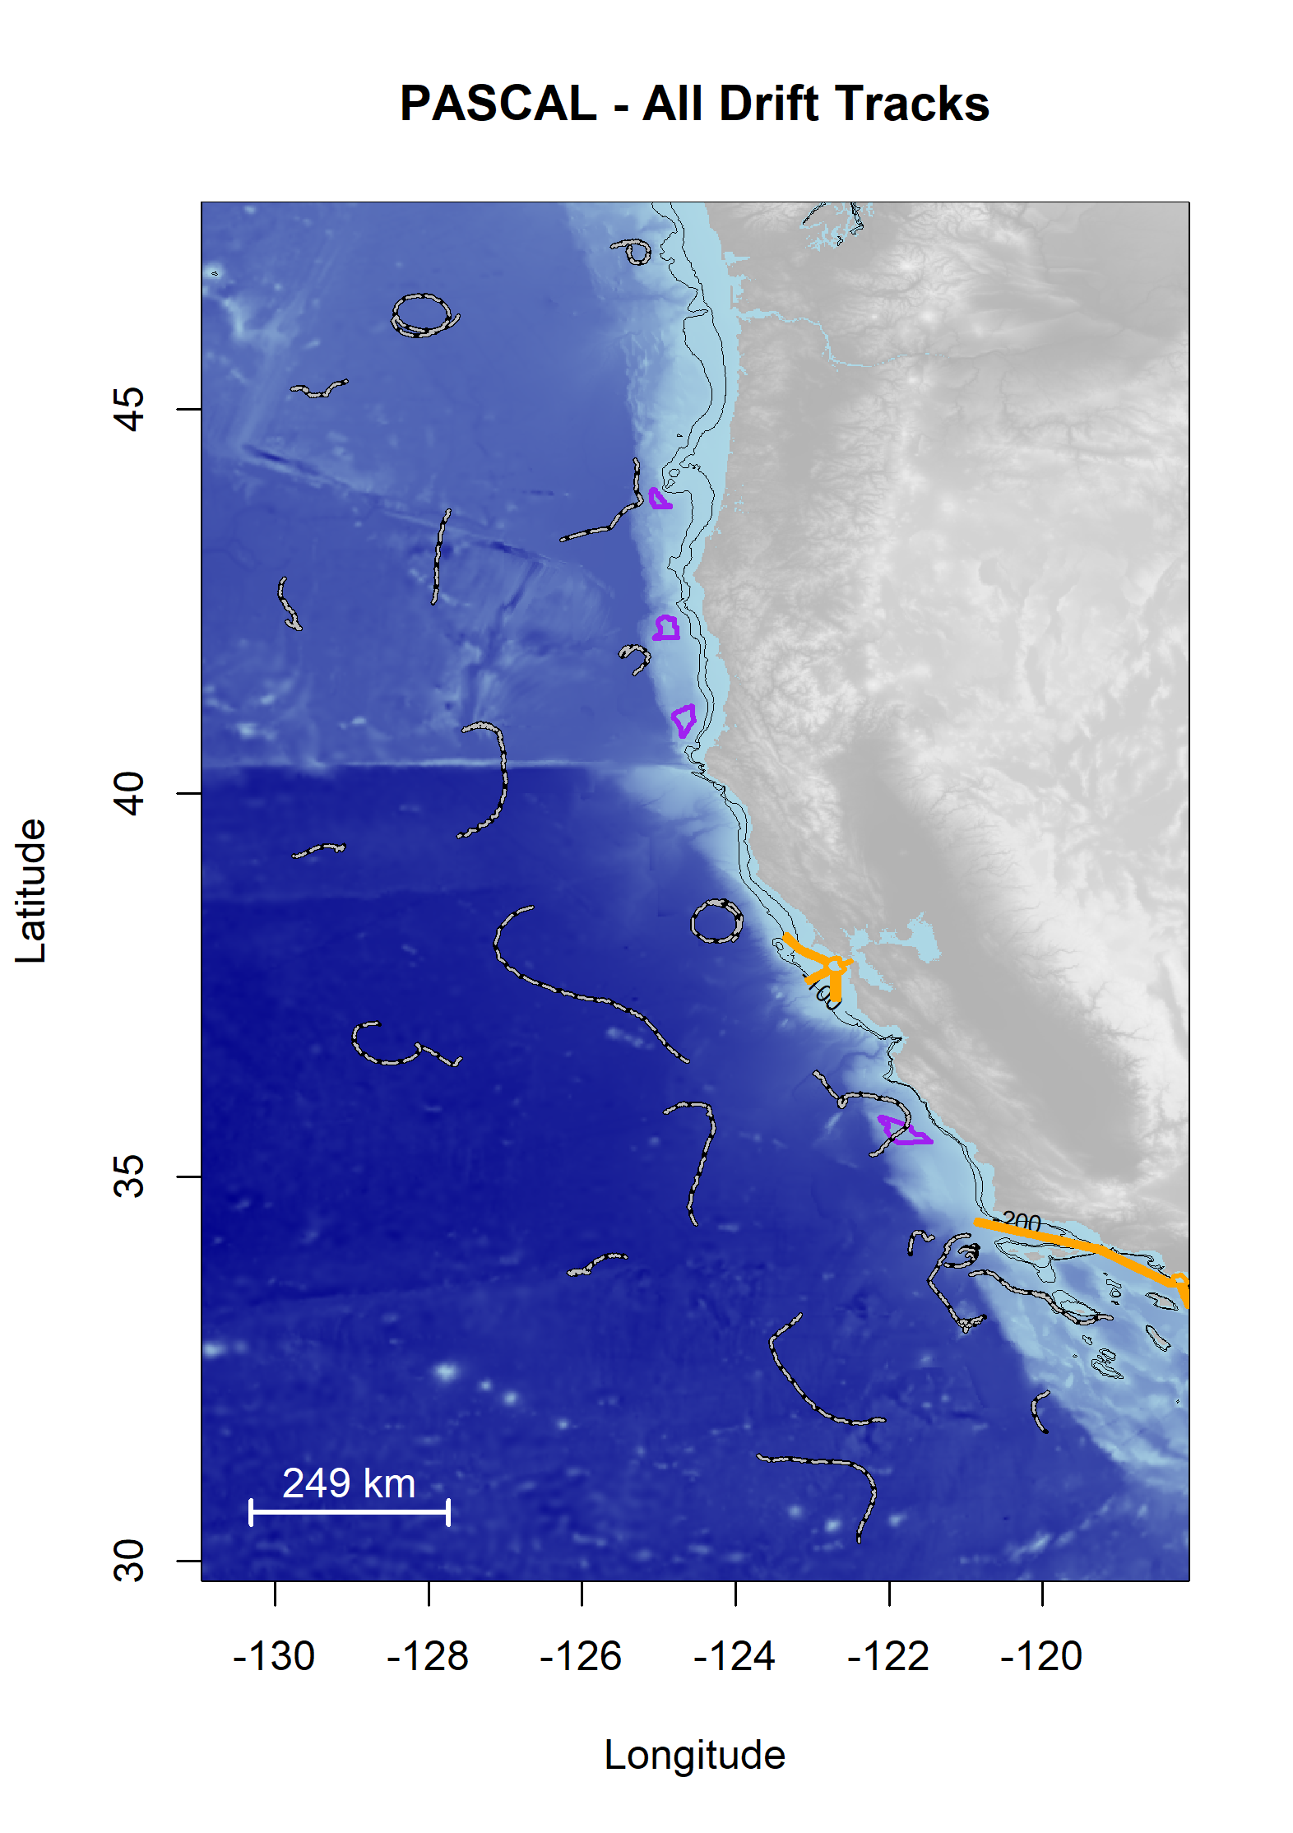

Figure B‑1. Plot of all successful drifts deployed during the PASCAL Survey.

Drifts are shown as black/white lines; Wind Energy Areas are outlined in purple, and shipping lanes for entry to San Francisco Bay and in Southern California Bight are outlined in yellow

Data were analyzed following methods consistent with the Adrift data analysis, with slight modifications to address duty cycled data. The power spectral density plots (PSD) can be found online.[46]

Each of the major odontocete groups were detected during the PASCAL study (Figure B‑2).

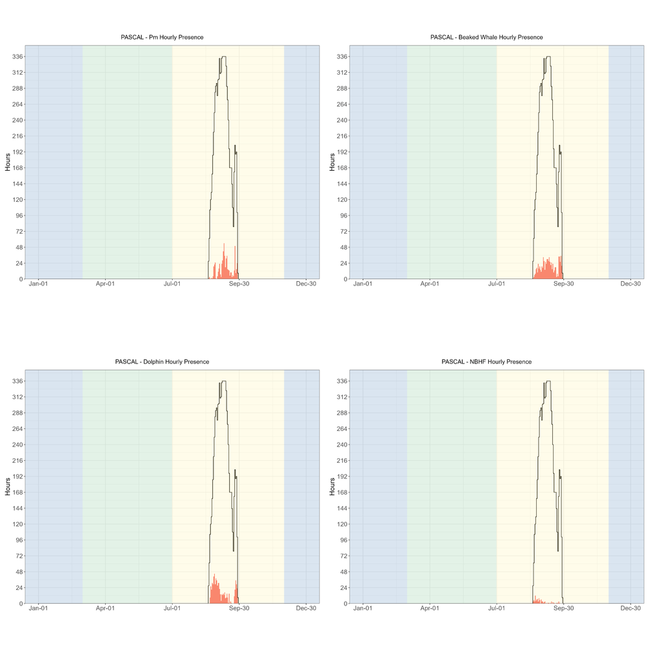

Figure B‑2. Hourly presence of sperm whales, beaked whales, dolphins, and NBHF during the PASCAL 2016 survey.

Hourly presence (x axis) of sperm whales (top left), beaked whales (top right), dolphins (lower left), and NBHF (lower right) for months (y axis) and seasons (color bands) during the PASCAL 2016 survey. Black lines represent total available hours (effort) and bottom graph shows total effort for survey. Blue shading represents winter, green represents upwelling, and yellow represents the post-upwelling oceanographic season.

Blue whale detections were dominated by song, as the low hourly presence of D calls indicates that A/B (song) calls dominated the blue whale detections (Figure B‑3). Likewise, detection of fin whales was dominated by 20 Hz calls (Figure B‑3). There were no calls associated with Bryde's or Gray whales.

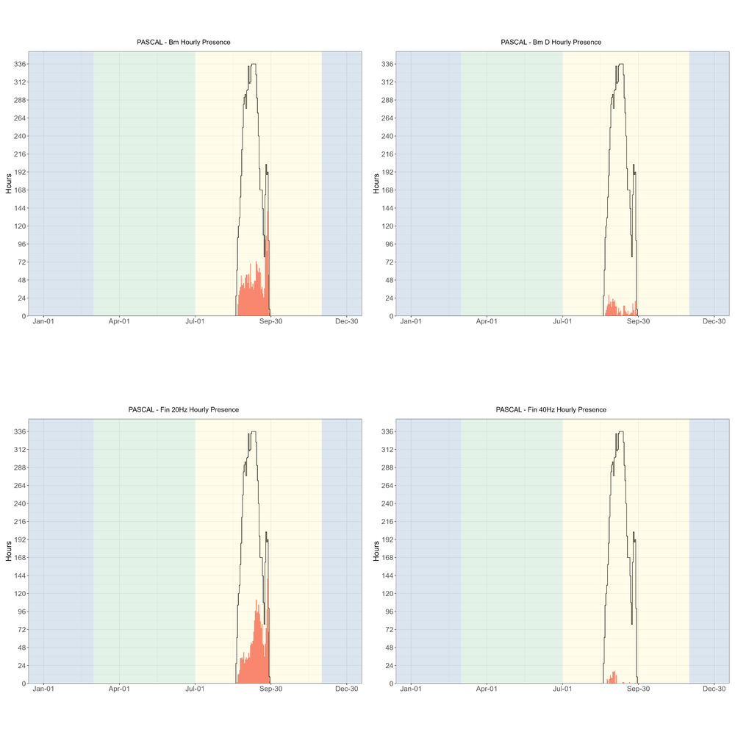

Figure B‑3. Hourly presence of blue whales (all calls), blue whale D calls, fin whale 20 Hz, and fin whale 40 Hz during the PASCAL 2016 survey.

Hourly presence (x axis) of blue whales (all calls, top left), (b) blue whale D calls (top right), fin whale 20 Hz (lower left), and fin whale 40 Hz (lower right) for months (y axis) and seasons (color bands) during the PASCAL 2016 survey. Black lines represent total available hours (effort) and bottom graph shows total effort for survey. Blue shading represents winter, green represents upwelling, and yellow represents the post-upwelling oceanographic season.

There were few hourly detections of humpback whales (hourly presence plots can be found in our GitHub Repository.[47] Most of the PASCAL deployments were further offshore than the Adrift deployments, and this offshore distribution may be the reason for such low detection rates.

There were a few calls associated with sei and minke whales. There is little known about the vocal repertoire of sei whales in the Pacific Ocean, although a single encounter with four loud low-frequency downsweeps were detected and considered as 'possible' sei whale vocalizations (see spectrogram in GitHub Repository.[48] Minke whale boings are seasonal vocalizations and more frequently detected during the winter.

A complete list of successful drifting acoustic recorder deployments during the PASCAL survey are provided in Table B‑1 . Sites include Washington (WAS), Columbia River (COL), Oregon (ORE), Humboldt (HUM), Mendocino (MND), Point Arena (PTA), Monterey Bay (MBY), Morro Bay (MOB), Channel Islands (CHI), San Diego (SND), and Baja California Norte (BCN). See Figure 3.1 for more information on regions.

Table B‑1. Summary of PASCAL deployments.

|  |  |  |  |  |  |  |  |  |  |  |  |  |  |  |  |  |  |  |  |  |  |  |  |  |  |  |  |
| --- | --- | --- | --- | --- | --- | --- | --- | --- | --- | --- | --- | --- | --- | --- | --- | --- | --- | --- | --- | --- | --- | --- | --- | --- | --- | --- | --- |
| **Drift ID** | **Site** | **Status** | **Deploy Date** | **Deploy Lat** | **Deploy Long** | **Recover Date** | | | | **Recover Lat** | | | | **Recover Long** | | **Recorder** | | **SR (kHz)** | | **Duty Cycle** | | **HP Depth (m)** | | **Data Start Date** | | **Data End Date** | |
| PASCAL_001 | ORE | Complete | 8/19/2016 | 44.35 | −125.31 | 8/31/2016 | | | | 43.29 | | | | −126.29 | | ST4300 | | 288 | | 2 min per 10 | | 100 | | 8/20/2016 | | 8/31/2016 | |
| PASCAL_002 | HUM | Complete | 8/21/2016 | 41.49 | −125.36 | 9/1/2016 | | | | 41.9 | | | | −125.32 | | ST4300 | | 288 | | 2 min per 10 | | 100 | | 8/20/2016 | | 9/1/2016 | |
| PASCAL_003 | MND | Complete | 8/21/2016 | 38.57 | −124.36 | 9/2/2016 | | | | 38.08 | | | | −124.03 | | ST4300 | | 288 | | 2 min per 10 | | 100 | | 8/21/2016 | | 9/2/2016 | |
| PASCAL_004 | MBY | Complete | 8/22/2016 | 36.35 | −122.95 | 9/3/2016 | | | | 36.05 | | | | −122.68 | | ST4300 | | 288 | | 2 min per 10 | | 100 | | 8/22/2016 | | 9/3/2016 | |
| PASCAL_005 | CHI | Complete | 8/22/2016 | 34.21 | −121.43 | 9/4/2016 | | | | 33.99 | | | | −121.72 | | ST4300 | | 288 | | 2 min per 10 | | 100 | | 8/22/2016 | | 9/4/2016 | |
| PASCAL_006 | BCN | Complete | 8/24/2016 | 32.19 | −119.91 | 9/12/2016 | | | | 32.61 | | | | −119.50 | | ST4300 | | 288 | | 2 min per 2 | | 100 | | 8/24/2016 | | 8/30/2016 | |
| PASCAL_007 | BCN | Complete | 8/25/2016 | 31.37 | −123.71 | 9/13/2016 | | | | 30.24 | | | | −122.39 | | SM3M | | 256 | | Continuous | | 100 | | 8/25/2016 | | 9/13/2016 | |
| PASCAL_008 | CHI | Complete | 8/26/2016 | 33.76 | −125.92 | 9/14/2016 | | | | 33.95 | | | | −125.39 | | SM2Bat | | 192 | | 2 min per 4 | | 100 | | 8/26/2016 | | 9/14/2016 | |
| PASCAL_009 | MBY | Complete | 8/27/2016 | 36.54 | −127.57 | 9/15/2016 | | | | 36.99 | | | | −128.64 | | ST300 | | 48 | | 2 min per 2 | | 100 | | 8/27/2016 | | 9/15/2016 | |
| PASCAL_009 | MBY | Complete | 8/27/2016 | 36.54 | −127.57 | 9/15/2016 | | | | 36.99 | | | | −128.64 | | ST4300 | | 288 | | 2 min per 10 | | 100 | | 8/27/2016 | | 9/15/2016 | |
| PASCAL_010 | MND | Complete | 8/27/2016 | 39.25 | −129.19 | 9/16/2016 | | | | 39.18 | | | | −129.76 | | SM3M | | 256 | | Continuous | | 100 | | 8/27/2016 | | 9/17/2016 | |
| PASCAL_011 | ORE | Complete | 8/28/2016 | 42.24 | −129.85 | 9/17/2016 | | | | 42.79 | | | | −129.87 | | SM2Bat | | 192 | | 2 min per 4 | | 100 | | 8/28/2016 | | 9/17/2016 | |
| PASCAL_012 | COL | Complete | 8/29/2016 | 45.26 | −129.78 | 9/17/2016 | | | | 45.37 | | | | −129.07 | | ST4300 | | 288 | | 2 min per 10 | | 100 | | 8/29/2016 | | 9/17/2016 | |
| PASCAL_013 | COL | Complete | 8/29/2016 | 46.23 | −127.61 | 9/18/2016 | | | | 46.33 | | | | −128.11 | | SM3M | | 256 | | 2 min per 2 | | 100 | | 8/29/2016 | | 9/15/2016 | |
| PASCAL_014 | WAS | Unusable | 8/30/2016 | 47.11 | −125.61 | 9/18/2016 | | | | 47.11 | | | | −125.38 | | SM2Bat | | 192 | | 2 min per 4 | | 100 | | 8/30/2016 | | 9/18/2016 | |
| PASCAL_015 | ORE | Complete | 8/31/2016 | 43.68 | −127.74 | 9/16/2016 | | | | 41.64 | | | | −129.28 | | ST4300 | | 288 | | 2 min per 2 | | 100 | | 8/31/2016 | | 9/5/2016 | |
| PASCAL_016 | HUM | Complete | 9/1/2016 | 40.81 | −127.54 | 9/20/2016 | | | | 39.43 | | | | −127.61 | | ST4300 | | 288 | | 2 min per 10 | | 100 | | 9/1/2016 | | 9/21/2016 | |
| PASCAL_017 | PTA | Complete | 9/2/2016 | 38.52 | −126.64 | 9/21/2016 | | | | 36.51 | | | | −124.62 | | SM3M | | 256 | | Continuous | | 100 | | 9/2/2016 | | 9/21/2016 | |
| PASCAL_018 | MBY | Complete | 9/3/2016 | 35.84 | −124.92 | 9/22/2016 | | | | 34.38 | | | | −124.52 | | SM2Bat | | 192 | | 2 min per 4 | | 100 | | 9/3/2016 | | 9/22/2016 | |
| PASCAL_019 | CHI | Complete | 9/4/2016 | 33.22 | −123.16 | 9/23/2016 | | | | 31.83 | | | | −122.06 | | ST4300 | | 288 | | 2 min per 10 | | 100 | | 9/4/2016 | | 9/23/2016 | |
| PASCAL_020 | CHI | Complete | 9/6/2016 | 33.14 | −118.99 | 9/29/2016 | | | | 33.73 | | | | −120.95 | | ST4300 | | 288 | | 2 min per 10 | | 100 | | 9/7/2016 | | 9/29/2016 | |
| PASCAL_021 | MOB | Complete | 9/4/2016 | 35.29 | −122.24 | 9/25/2016 | | | | 36 | | | | −122.56 | | ST4300 | | 288 | | 2 min per 10 | | 100 | | 9/3/2016 | | 9/25/2016 | |
| PASCAL_022 | SND | Complete | 9/5/2016 | 33.06 | −120.99 | 9/28/2016 | | | | 34.24 | | | | −120.95 | | ST4300 | | 288 | | 2 min per 10 | | 100 | | 9/5/2016 | | 9/28/2016 | |
| PASCAL_023 | SND | Complete | 9/24/2016 | 33 | −121.00 | 9/28/2016 | | | | 33.11 | | | | −120.92 | | ST4300 | | 288 | | 2 min per 2 | | 100 | | 9/24/2016 | | 9/28/2016 | |
| PASCAL_024 | SND | Complete | 9/24/2016 | 33.08 | −120.98 | 9/28/2016 | | | | 33.14 | | | | −120.81 | | ST300 | | 288 | | 2 min per 2 | | 100 | | 9/24/2016 | | 9/28/2016 | |
| PASCAL_024 | SND | Complete | 9/24/2016 | 33.08 | −120.98 | 9/28/2016 | | | | 33.14 | | | | −120.81 | | ST4300 | | 288 | | 2 min per 2 | | 100 | | 9/24/2016 | | 9/28/2016 | |
| **Table B-1. Summary of PASCAL deployments, con’t.** | | | | | |  |  |  |  | |  |  |  | |  | |  | |  | |  | |  | |  | |  | |
| **Drift ID** | **Site** | **Status** | **Deploy Date** | **Deploy Lat** | **Deploy Long** | **Recover Date** | | | | **Recover Lat** | | | | **Recover Long** | | **Recorder** | | **SR (kHz)** | | **Duty Cycle** | | **HP Depth (m)** | | **Data Start Date** | | **Data End Date** | |
| PASCAL_025 | SND | Complete | 9/24/2016 | 33.14 | −121.06 | 9/28/2016 | | | | 33.18 | | | | −120.75 | | ST4300 | | 288 | | 2 min per 2 | | 100 | | 9/24/2016 | | 9/28/2016 | |
| PASCAL_026 | CHI | Complete | 9/24/2016 | 34.35 | −121.08 | 9/26/2016 | | | | 34.09 | | | | −120.84 | | ST300 | | 288 | | 2 min per 2 | | 250 | | 9/24/2016 | | 9/26/2016 | |
| PASCAL_026 | CHI | Complete | 9/24/2016 | 34.35 | −121.08 | 9/26/2016 | | | | 34.09 | | | | −120.84 | | ST4300 | | 288 | | 2 min per 2 | | 100 | | 9/24/2016 | | 9/26/2016 | |
| PASCAL_027 | CHI | Complete | 9/24/2016 | 34.06 | −121.05 | 9/26/2016 | | | | 34.1 | | | | −120.86 | | ST4300 | | 288 | | 2 min per 2 | | 100 | | 9/24/2016 | | 9/26/2016 | |
| PASCAL_028 | CHI | Complete | 9/24/2016 | 33.97 | −120.99 | 9/29/2016 | | | | 33.86 | | | | −121.26 | | ST4300 | | 288 | | 2 min per 2 | | 100 | | 9/24/2016 | | 9/29/2016 | |
| PASCAL_029 | CHI | Complete | 9/26/2016 | 34.05 | −121.05 | 9/28/2016 | | | | 33.97 | | | | −120.87 | | ST4300 | | 288 | | 2 min per 2 | | 100 | | 9/26/2016 | | 9/28/2016 | |
| PASCAL_029 | CHI | Complete | 9/26/2016 | 34.05 | −121.05 | 9/28/2016 | | | | 33.97 | | | | −120.87 | | ST300 | | 288 | | 2 min per 2 | | 250 | | 9/26/2016 | | 9/28/2016 | |
| PASCAL_030 | CHI | Complete | 9/26/2016 | 34.04 | −121.08 | 9/28/2016 | | | | 34.02 | | | | −120.86 | | ST4300 | | 288 | | 2 min per 2 | | 100 | | 9/26/2016 | | 9/28/2016 | |

3. CCES Expanded Datasets

CCES was a multidisciplinary survey of the marine ecosystem from the US-Canada border south to Northern Baja California, Mexico. Background information on this survey as well as preliminary analysis of beaked whale, sperm whale, and narrow band high frequency species are provided in (Simonis 2020). A map of tracklines is provided in Figure C‑1.

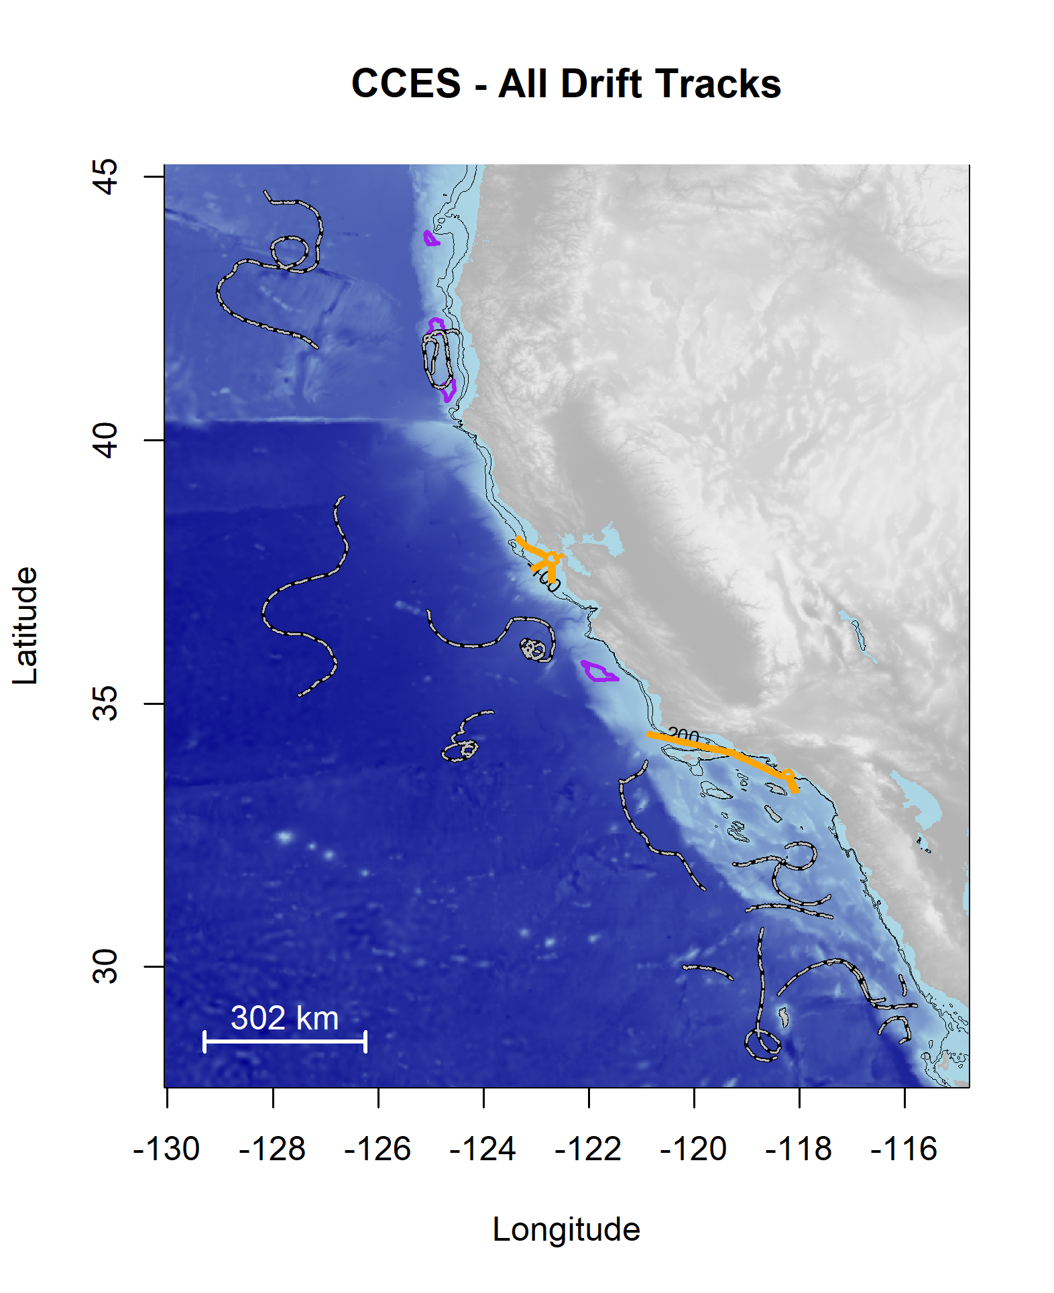

Figure C‑1. Plot of all successful drifts deployed during the CCES Survey.

Drifts are shown as black/white lines; Wind Energy Areas are outlined in purple, and shipping lanes for entry to San Francisco Bay are outlined in yellow.

Data were analyzed following methods consistent with the Adrift data analysis, with slight modifications to address duty cycled data. The power spectral density plots (PSD) can be found online.[49]

Each of the major odontocete groups were detected during the CCES study (Figure C‑2).

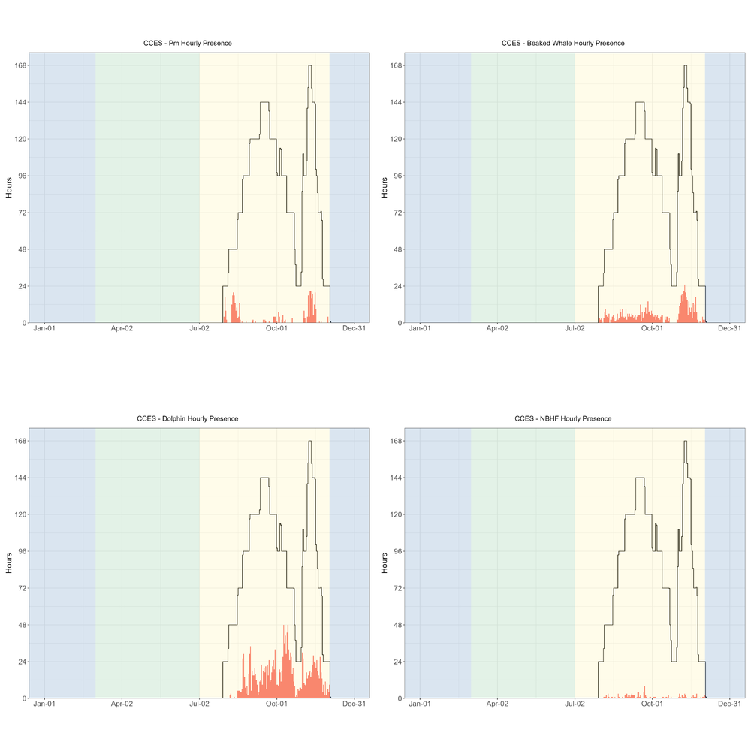

Figure C‑2. Hourly presence of sperm whales, beaked whales, dolphins, and narrow band high frequency species during the CCES 2018 survey.

Hourly presence (y axis) of sperm whales (top left), beaked whales (top right), dolphins (lower left), and narrow band high frequency species (lower right) for months (x axis) and seasons (color bands) during the CCES 2018 survey. Black lines represent total available hours (effort) and bottom graph shows total effort for survey. Blue shading represents winter, green represents upwelling, and yellow represents the post-upwelling oceanographic season.

Blue whale detections were dominated by song, as the low hourly presence of D calls indicates that A/B (song) calls dominated the blue whale detections (Figure C‑3). There were a few minke whale detections in the later months of the survey. Detection of fin whales was dominated by 20 Hz calls (Figure C‑3). There were no Fin whale 40 Hz calls, or calls associated with Bryde's, sei, or gray whales.

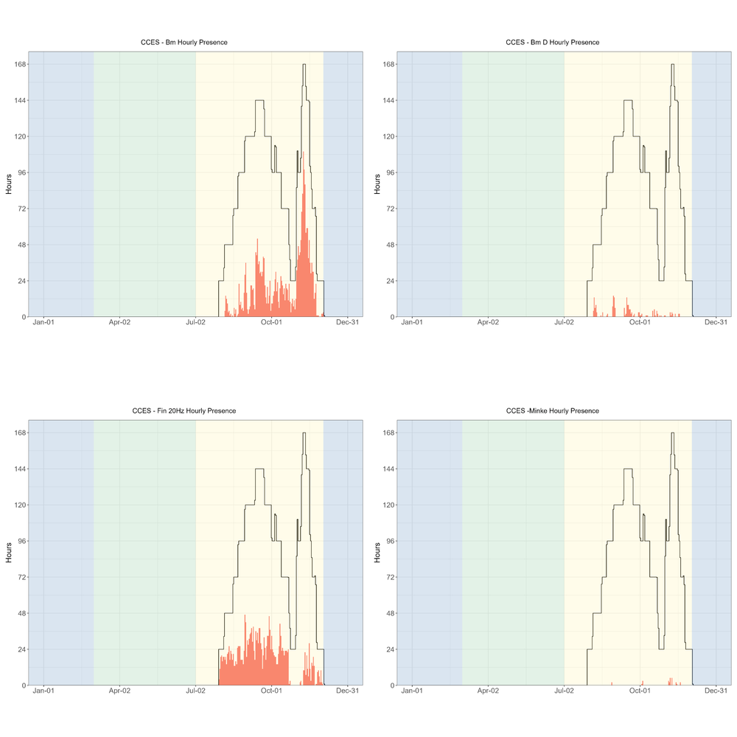

Figure C‑3. Hourly presence of blue whales (all calls), blue whale D calls, fin whale 20 Hz, and minke whale calls during the CCES 2018 survey.

Hourly presence (y axis) of blue whales (all calls, top left), blue whale D calls (top right), fin whale 20 Hz (lower left), and minke whale calls (lower right) for months (x axis) and seasons (color bands) during the CCES 2018 survey. Black lines represent total available hours (effort) and bottom graph shows total effort for survey. Blue shading represents winter, green represents upwelling, and yellow represents the post-upwelling oceanographic season.

There were few hourly detections of humpback whales (hourly presence plots can be found in our GitHub Repository.[50] Most of the CCES deployments were further offshore than the Adrift deployments, and this offshore distribution may be the reason for such low detection rates.

A complete list of successful drifting recorder deployments during the CCES survey are provided in Table C‑1. Sites include Humboldt (HUM), Point Arena (PTA), Morro Bay (MOB), Channel Islands (CHI), and Baja California Norte (BCN). See Figure 3.1 for more information on regions.

Table C‑1. Summary of CCES Deployments.

|  |  |  |  |  |  |  |  |  |  |  |  |  |  |  |
| --- | --- | --- | --- | --- | --- | --- | --- | --- | --- | --- | --- | --- | --- | --- |
| **Drift ID** | **Site** | **Status** | **Deploy Date** | **Deploy Lat** | **Deploy Long** | **Recover Date** | **Recover Lat** | **Recover Long** | **Recorder** | **SR (kHz)** | **Duty Cycle** | **HP Depth (m)** | **Data Start Date** | **Data End Date** |
| **CCES_004** | HUM | Complete | 7/25/2018 | 45.08 | −128.21 | 10/13/2018 | 41.76 | −127.15 | SM3M | 256 | 2 min per 20 | 100 | 7/30/2018 | 10/12/2018 |
| **CCES_007** | HUM | Complete | 8/5/2018 | 41.26 | −125.02 | 10/22/2018 | 42.04 | −124.48 | ST4300HF | 288 | 2 min per 20 | 150 | 8/5/2018 | 9/22/2018 |
| **CCES_008** | HUM | Complete | 8/16/2018 | 38.95 | −126.64 | 10/10/2018 | 34.38 | −128.32 | ST4300HF | 288 | 2 min per 20 | 150 | 8/16/2018 | 10/1/2018 |
| **CCES_010** | PTA | Complete | 8/22/2018 | 36.76 | −125.06 | 10/22/2018 | 35.97 | −122.94 | ST4300HF | 576 | 2 min per 20 | 150 | 8/22/2018 | 10/21/2018 |
| **CCES_012** | MOB | Complete | 8/30/2018 | 34.83 | −123.81 | 10/6/2018 | 34.03 | −124.39 | ST4300HF | 288 | 2 min per 20 | 150 | 8/30/2018 | 10/6/2018 |
| **CCES_013** | CHI | Complete | 9/11/2018 | 33.9 | −120.91 | 10/23/2018 | 31.44 | −119.78 | ST4300HF | 288 | 2 min per 20 | 150 | 9/11/2018 | 10/23/2018 |
| **CCES_014** | BCN | Complete | 10/5/2018 | 32.27 | −118.26 | 11/1/2018 | 31.95 | −119.25 | ST4300HF | 576 | 2 min per 20 | 150 | 10/5/2018 | 11/1/2018 |
| **CCES_016** | BCN | Complete | 10/30/2018 | 31.35 | −117.42 | 11/21/2018 | 32.13 | −118.03 | ST4300HF | 576 | 2 min per 10 | 150 | 10/30/2018 | 11/15/2018 |
| **CCES_017** | BCN | Complete | 10/31/2018 | 30.73 | −118.69 | 11/24/2018 | 28.29 | −118.44 | SM3M | 256 | 2 min per 4 | 100 | 10/31/2018 | 11/24/2018 |
| **CCES_018** | BCN | Complete | 10/31/2018 | 30.01 | −120.18 | 11/23/2018 | 29.51 | −118.82 | ST4300HF | 576 | 2 min per 6 | 150 | 10/31/2018 | 11/16/2018 |
| **CCES_019** | BCN | Complete | 11/1/2018 | 30.05 | −117.46 | 11/27/2018 | 28.4 | −115.55 | ST4300HF | 576 | 2 min per 10 | 150 | 11/1/2018 | 11/18/2018 |
| **CCES_020** | BCN | Complete | 11/5/2018 | 29.46 | −118.39 | 11/22/2018 | 29.39 | −116.34 | ST4300HF | 576 | 2 min per 10 | 150 | 11/5/2018 | 11/22/2018 |
| **CCES_021** | BCN | Complete | 11/6/2018 | 29.47 | −116.01 | 11/11/2018 | 29.82 | −116.08 | ST4300HF | 576 | 2 min per 6 | 150 | 11/6/2018 | 11/11/2018 |
| **CCES_022** | BCN | Complete | 11/7/2018 | 28.72 | −116.48 | 11/27/2018 | 28.28 | −116.68 | ST4300HF | 576 | 2 min per 10 | 150 | 11/7/2018 | 11/23/2018 |
| **CCES_023** | BCN | Complete | 11/22/2018 | 30.93 | −117.38 | 12/3/2018 | 31.05 | −119.01 | ST4300HF | 576 | 2 min per 5 | 150 | 11/22/2018 | 12/3/2018 |

1. Sperm Whales Demographic Composition[51]

Male and female sperm whales are sexually dimorphic and differences in body size (males are larger than females) have been linked to differences in echolocation click characteristics (Solsona-Berga et al. 2022). The Inter-Pulse Interval (IPI) is a result of the time taken for the click to reflect multiple times between air sacs at opposite ends of the spermaceti organ and to exit the rostrum in several subsequent pulses (Møhl et al. 2000), and thus the IPI has been found to relate to body size. Similarly, the Inter-Click Interval (ICI), which is the time between pulse trains, can serve as a proxy for sperm whale body size and sex, as males click every ~1s and females click every 0.5s (Solsona-Berga et al. 2022). This pilot study investigated the potential for assessing demographic composition of sperm whales in the California Current using inter-click interval as a proxy for sex/size in acoustic data from six drifting buoys.

Sperm whale echolocation clicks were detected using the multi-step approach described in (Solsona-Berga et al. 2022) appendix, with manual review of putative sperm whale acoustic encounters using DetEdit. Histograms of ICI provide a visualization to indicate sperm whale size and sex (Solsona-Berga et al. 2022). A plot of concatenated histograms, referred to as ICIgrams, was annotated and categorized for each time period at each site (see Figure D‑1). Detections with a modal ICI of 600 ms or less were presumed to be females and their young, or Social Groups. Detections with a modal ICI of 0.8 s and greater will be considered Adult Males. The detections with a modal ICI between the Social Groups and Adult Males (< 0.6 s and > 0.8 s) could contain large females or juvenile males, and will be referred to as Mid-Size.

The ICIgram method was originally developed for sperm whales in the Gulf of Mexico (Solsona-Berga et al. 2022), and has been applied to sperm whales in the Gulf of Alaska (Posdaljian et al. 2023) and in southern New England (Westell et al. 2024). To compare how effectively the ICIgram method can be used to categorize the size/sex of sperm whales in the California Current, length estimates using IPI from individual animals were matched with the size/sex classification using the ICIgram method.

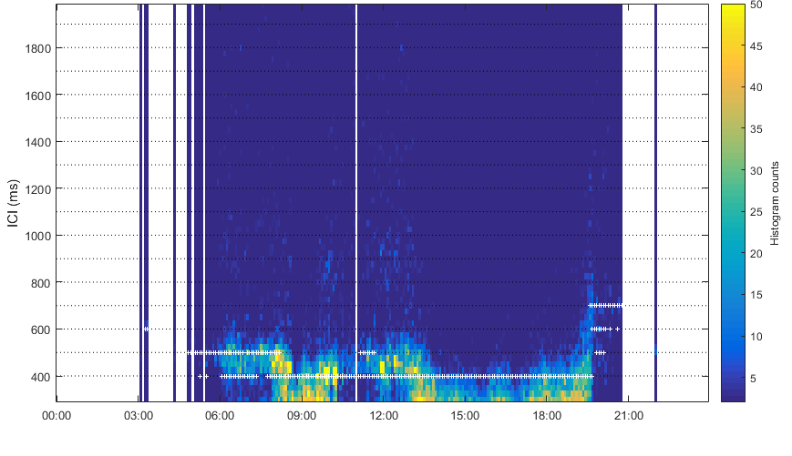

Figure D‑1. Example ICIgram GUI for November 9th, 2023 from Adrift-105.

Time is represented on the x-axis, interclick interval (ms) on the y-axis, and color represents the histogram count of each value. The white markers represent 5-min size class classification bins. White markers 700 ms and below represent Social Groups.

IPIs were extracted using the Cachalot Automatic Body Length Estimator (CABLE) (Beslin et al. 2018). This tool estimates the body length of sperm whales by compiling and clustering their IPI distributions. To avoid including the same animal more than once, only unique IPI values were retained in the final analysis.

The results of this pilot study identified only one size/sex class (Social Groups) based on their echolocation ICI, supported by examining IPI for individual clicks. Sperm whale body length estimates were calculated using both their IPI and ICI for 34 animals encountered across six Adrift study deployments. The animal lengths obtained from the IPI were plotted against the ICI to confirm the linear relationship between the two acoustic characteristics (Figure D‑2, left). A Thiel-sen regression revealed a slope between ICI and body length suggesting a 1.2 m increase in size associated with a 100 ms increase in ICI (line of best fit: body length = 0.0120*ICI + 2.5, R2 = 0.4, p-value = 0.02: Spearman's correlation coefficient). No ICIs above 800 ms and total body length above 12.3 m were identified, indicating that only Social Groups with potentially a few subadult males were detected. The Adrift study data suggested a steeper linear relationship between ICI and total length compared to (Solsona-Berga et al. 2022), likely because the Adrift study data only included 34 animals and these were all females and their young with potentially a few subadult males.

The six Adrift deployments were relatively close to one another spatially and overlapped temporally. The animals recorded across the six deployments were likely part of the same group foraging in the region based on the time series of detections (Figure D‑2, center). The median body length of animals in the Social Group class (10.3 m) is comparable to the average body lengths documented for sperm whale females and immature animals which ranges from 8 to 11 m (Figure D‑2, right).

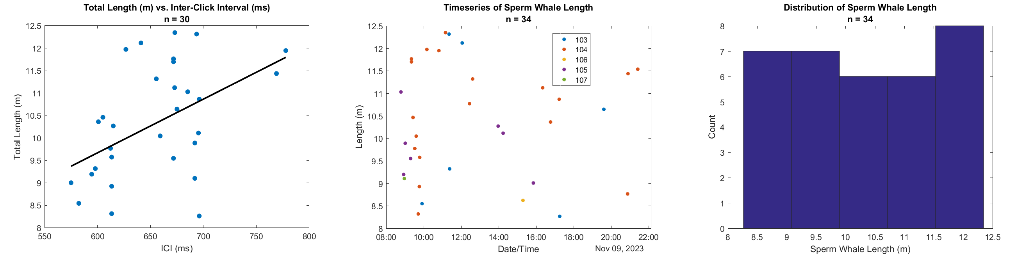

Figure D‑2. Total length calculated using IPI, ICI; time series of animal length estimations across six deployments, and histogram of animal length.

The relationship between total length (m) calculated using interpulse interval (IPI) and interclick interval (ICI) (left); slope between ICI and body length suggests a 1.2 m increase in size with a 100 ms increase in ICI. Time series of animal length estimations on November 9th, 2023 across the six deployments (center). Each point represents a unique animal and the color represents the deployment on which that animal was recorded. Histogram of animal length (m)(right).

This pilot study investigated the potential for assessing demographic composition of sperm whales in the California Current using inter-click interval as a proxy for sex/size in acoustic data from a subset of six drifting recorders. A total of 34 animals with a mean total body length of 10.3 m, likely Social Groups and Mid-Size animals, were identified in the region on November 9th, 2023. By applying this method to the entire dataset, we can further understand the demographics of sperm whales utilizing the California Current and potentially identify regions preferred by different demographic groups (i.e., Social Groups, Mid-Size, and Adult Males). Different demographic groups have differences in behavior and ecology that likely translate to demographic-specific responses to increasing anthropogenic threats and climate change. This type of analysis can play an important role for monitoring future changes to sperm whales in the California Current.

6. Beaked Whales Density Estimation Tools

Previous research by SWFSC found that drifting acoustic recorders could be used to estimate density of goose-beaked whales (Barlow et al. 2022), and efforts were made to streamline this analytical process to allow us to estimate beaked whale density from the Adrift survey as well as other archived and future surveys (CCES 2018 and CalCurCEAS 2024).

Development of the RoboJ tool to streamline a systematic approach to density estimation was based off the process developed by SWFSC in (Barlow et al. 2022) and it was generalized for adoption by other researchers (see RoboJ GitHub Repository[52]). While most of the process is now streamlined, there remains a significant manual effort for identifying acoustic events. Our team initiated a process for improving automation of this tedious process, however they were unable to complete the automation of identifying acoustic events and we recommend investing in this development in the future (see Appendix: Open Science for more details on development of a beaked whale matched template classifier). The RoboJ tool has been tested by colleagues at Pacific Islands Fisheries Science Center, and documentation and final preparation of the software is underway.

RoboJ Pipeline:

* Incorporates acoustic detections stored in PAMGuard databases and binaries.
* Estimate detection range based on incoming bearing angle, presumed foraging depth, and modeled sound speed profile at each position.
* Estimate detection function for recorders

The original research was developed for the PASCAL dataset, and we have prepared the CCES 2018 dataset for analysis, but we were unable to complete the analysis in the timeframe of this study. These methods will be used for the CalCurCEAS 2024 survey data, and if opportunity allows, analysis will also be completed for the CCES 2018 dataset.

Future research should consider (1) funding further development of an automated approach to acoustic event delineation, (2) beaked whale density estimation for the Adrift dataset, and (3) expansion of this analysis to species beyond goose-beaked whales.

6. Acoustics Classification of NBHF Species[53]

There are four known cetacean species that produce NBHF echolocation clicks in the California Current Ecosystem, including harbor, Dall's porpoise, as well as dwarf and pygmy sperm whales (*Kogia sima* and *Kogia breviceps*, respectively). These species all produce NBHF clicks with similar acoustic features (peak frequency greater than 100 kHz and 3 dB bandwidth less than 10 kHz), and to date, the species cannot be distinguished acoustically. Their presence in acoustic surveys is generally reported within a "NBHF" category; however, each species has distinct habitat preferences (Carretta 2023), and likely responds differently to anthropogenic impacts and environmental stressors. We build upon unsupervised clustering methods developed by (Griffiths et al. 2020) by adding visually-verified species assignments to train an event level classification model in a supervised approach. This work also expands on a San Francisco State University master's thesis by Jackson VanFleet-Brown (thesis will be publicly available summer 2024[54]).

Visually verified acoustic recordings for Dall's and harbor porpoises from PASCAL, CCES, and Adrift surveys and NBHF clicks in the offshore waters of Baja California (*Kogia* spp. are the only NBHF here) were used as a training dataset (Table F‑1) to train a 2-stage BANTER (BioAcoustic EveNT ClassifiER) model. Click detections were assigned to a detector category based on the presence of a peak frequency below 125 kHz (lo-range) and greater than 125 kHz (hi-range). A suite of features was calculated for each click detection using the R package PAMpal, and the median inter-click interval for each event was included as an event-level feature. The model was trained in an iterative way to achieve high classification accuracy and stability. The classification model was then used to predict labels on the Adrift survey data.

Table F‑1. Summary of predicted NBHF species occurrence in Adrift survey, including *Kogia* spp (Kspp), Dall’s porpoise (Pd) and harbor porpoise (Pp). The total number of acoustic events shown, separated by season and study area.

| Species | Survey | N Events | Event Clicks | Total Clicks |
| --- | --- | --- | --- | --- |
| **Kspp.** | CCES-drifter | 13 | 7 (3–8) | 106 |
| **Pd** | BC-array | 4 | 7 (4–13) | 40 |
| **Pd** | CalCURCeas-array | 6 | 14 (10–9) | 84 |
| **Pd** | PASCAL-array | 5 | 10 (5–-12) | 44 |
| **Pp** | ADRIFT-drifter | 40 | 34 (9–116) | 2,954 |
| **Pp** | CalCURCeas-array | 7 | 6 (5–64) | 278 |

The classification accuracy of the BANTER model was 83% overall (Figure F‑1), ranging from 77% for harbor porpoise to 93% for Dall's porpoise. All classification results were greater than expected by chance (see priors in Figure F‑1).

Dall's porpoise were the dominant species found in all study areas and seasons, accounting for 91% (n=2,836 of 3093 events) of NBHF detections overall. Harbor porpoises were detected in all study areas, although 54% (n=105 of 192) of events were detected during the upwelling season in Oregon. Only 2% (n=65 of 3093) of all NBHF events were attributed to *Kogia* spp., and 77% (n=50) of these events occurred within the San Francisco and Morro Bay study areas.

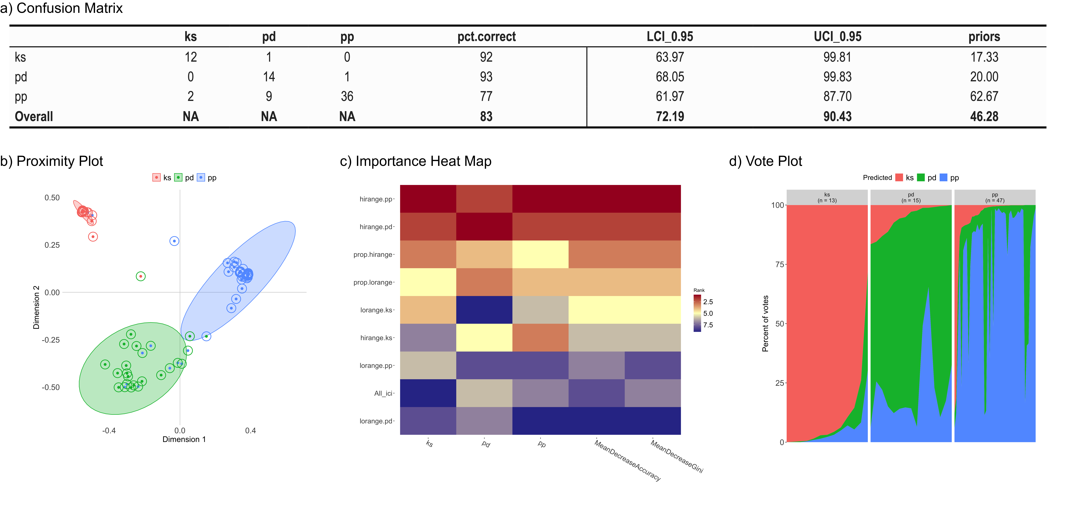

Figure F‑1. NBHF BANTER classification results from the training dataset.

Confusion matrix (a) provides the percent correct classification for each species (pct.correct), lower confidence intervals (LCI_0.95), upper confidence intervals (UCI_0.95), and priors (expected error rate). Proximity plot (b) for species events from BANTER model (central dot color represents true species identity; color of circle surrounding dot represents BANTER species classification). Heat map (c) for ranks of ten most important variables; colors scale from most important predictors (dark red) to least important predictors (dark blue). Vote Plot (d) shows the vote distribution for each event (vertical slice) for each species; distribution of votes by species is shown by their representative color.

This NBHF acoustic classifier can then be used to predict on archived Adrift NBHF detections to better resolve the three separate taxa in the California Current, including *Kogia* spp., Dall's and harbor porpoises (Figure F‑1). The overall classification accuracy of the model (83%) is acceptable, however there are several avenues to improve the model. Recently, (Zahn et al. 2024) reported significant gains in BANTER model performance by considering the ratios of third-octave levels at specific frequencies. The mean spectra of each class within our training data indicate distinct distributions of spectral energy in each class, and the inclusion of a third octave level ratio (or other similar metric) may improve model performance. Additionally, the use of an iterative training approach merits consideration. Acoustic events that are labeled with high probabilities can be included when re-training a new model (Figure F‑2).

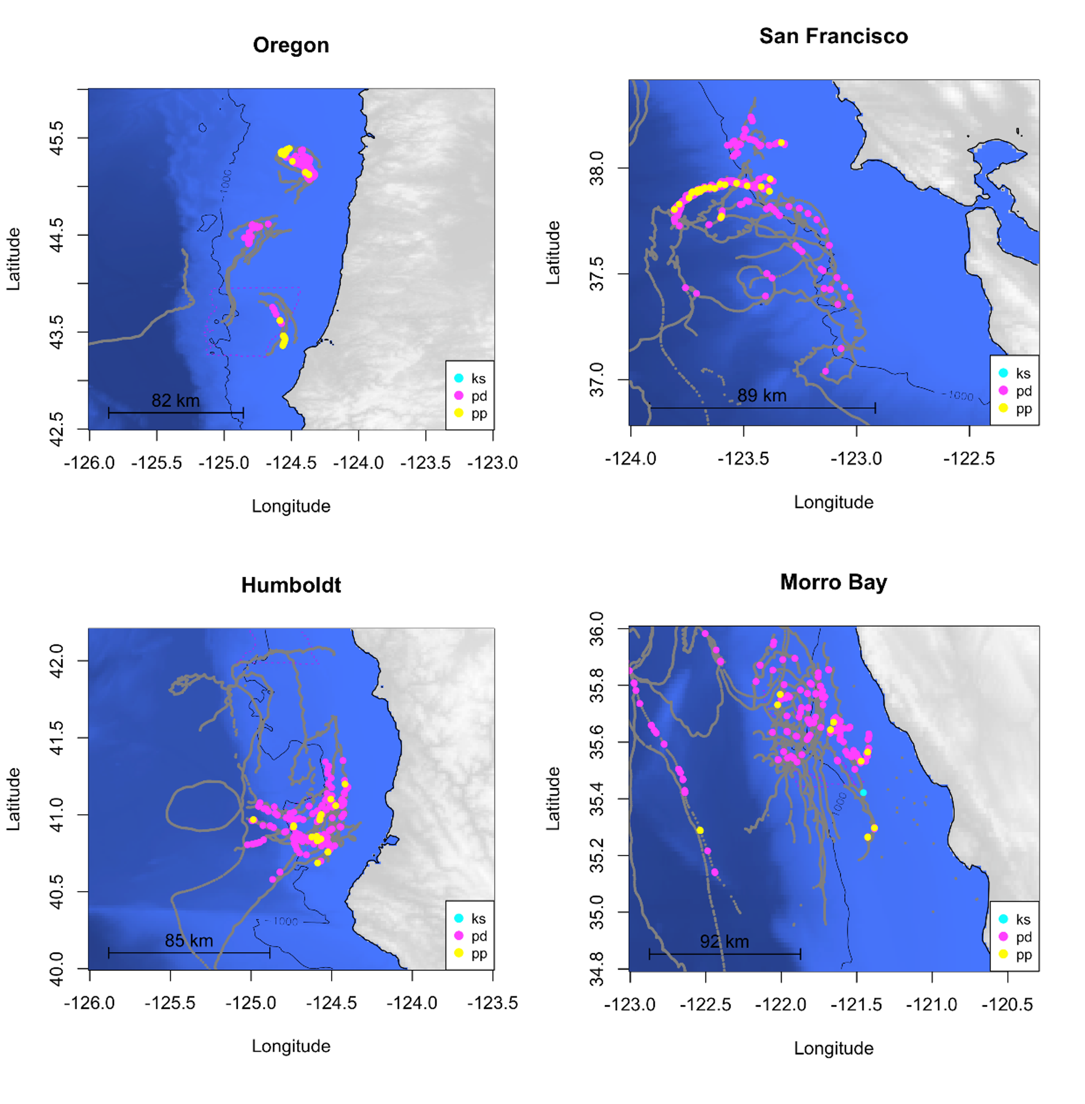

Figure F‑2. Maps with drift tracks and predicted species labels for NBHF events.

Maps with drift tracks shown in gray and predicted species labels for NBHF events including *Kogia* spp. (Ks, blue), Dall's porpoise (Pd, pink) and harbor porpoise (Pp, yellow).

This iterative approach would be biased toward acoustic events most similar to the original training dataset, however the gains from including additional variation in an increased sample size should be evaluated. The development of a more robust classification model should be investigated, but the model we report here has sufficient classification performance to apply to *Kogia*-specific species habitat models, investigations of species-specific responses to disturbance, and the potential development of acoustic density estimates.

7. Deep Learning to Detect Fin Whales[55]

OSA was tasked with processing low frequency drifting recorder data for the explicit purpose of identifying the occurrence of 40 Hz calls from fin whales and calls from sei whales. A related analytical objective was to develop an improved method of detecting fin whale low-frequency calls within obscure acoustic environments using a deep learning approach. Using a deep learning network development and detection tool DeepAcoustics, we iteratively tested ideal image and network parameters for the calls procured from the data review process. Network development encompassed training with both 20 Hz and 40 Hz whale call types and resulted in successful detection despite excessive instrument noise within the dataset.

Data were evaluated in two ways, by assessing performance in comparison to an annotated test file and by comparing the network detection performance to our semi-automated PAMGuard processing approach, which involves a human in the loop to classify calls and assign to an acoustic encounter. After identifying 40 Hz and 20 Hz calls in the PAMGuard approach, we annotated approximately 1,400 calls in Raven to include in network training. Annotations of 20 Hz calls from another dataset were included to increase sample size.

Three network architectures were evaluated: tiny YOLO (You Only Look Once), CSP-DarkNet-53, and the ResNet-50. We tested performance using a separate set of annotated calls and assessed performance in the absence of vocalizations with varying degrees of instrument noise. Extensive instrument noise and small sample size contribute to performance metrics; however, we considered these results favorable considering the degree of noise (Table G‑1).

Table G‑1. Precision ('Precise'), recall, and F-Score for Tiny Yolo (TY), CSP-DarkNet-53 (CSP), and ResNet-50 models ran on test Adrift drifting recorder data.

|  |  |  |  |  |  |  |  |  |  |
| --- | --- | --- | --- | --- | --- | --- | --- | --- | --- |
| Drift(s) | TY Precise | TY Recall | TY F-Score | CSP Precise | CSP Recall | CSP F-Score | RN Precise | RN Recall | RN F-Score |
| **Adrift-027** | 0.8 | 0.55 | 0.65 | 0.58 | 0.8 | 0.67 | 0.45 | 0.72 | 0.55 |
| **Adrift-053-063** | 0.73 | 0.69 | 0.71 | 0.63 | 0.82 | 0.72 | 0.48 | 0.79 | 0.6 |

When incorporating false positive rates in the evaluation, the tiny YOLO and CSP-DarkNet-53 demonstrate the additional benefit of deep network development (see detailed report on GitHub repository).[56]

The next step was to evaluate the performance of the network on a larger dataset, as the aim of network development is to derive a model that can process a dataset both quickly and accurately. The Adrift-083 dataset was selected because it contained fin whale 40 Hz calls and blue whale D calls. In the figure below, both types of calls are included in the PAMGuard annotations, and blue whale D calls are known to result in false positives for this version of the network. Humpback whale social calls were also present but were not annotated in our review (thus not represented in these figures). Over the seven-day period of this drift, the detection pattern by the PAMGuard method (approximately six hours to process) was matched by the detection pattern of DeepAcoustics (approximately 30 minutes to process). A low false positive rate during periods without calls was consistent across the drift (Figure G‑1).

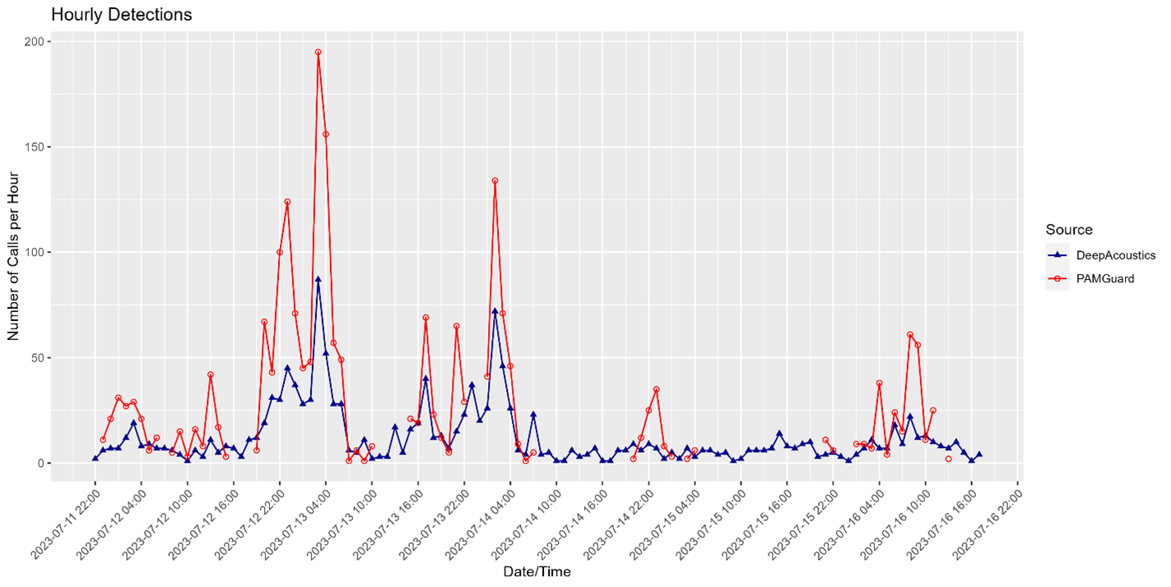

Figure G‑1. Number of hourly detections of fin whale calls from PAMGuard and DeepAcoustics Methods.

Deep learning is indispensable for managing the immense volumes of acoustic data, facilitating efficient processing and precise analysis of extensive datasets. This capability is critical for fulfilling the monitoring requirements of organizations such as NOAA and BOEM, ensuring timely and thorough assessment of marine environments and protected species.

Future research should consider further enhancing network performance by integrating multi-class training for blue whale D calls and expanding the sample size of the training dataset. Research should consider developing networks tailored for challenging calls like these, as well as for additional species, to make them accessible for public use. OSA is also collaborating with the PAMGuard software developers to enable the integration of DeepAcoustics models into their detection platform. Future funding should consider processing archival data in BOEM repository using the developed networks.

1. Modeling Habitat Use[57]

In order to consider passive acoustic data for population assessment of marine mammals, these methods must account for varying detection probabilities due to uncertainty in the source location and with changing background noise levels.

The clustered deployments off Morro Bay provide a test bed for evaluating the ability of drifting recorders to contribute to population assessment models. Mysticete calls can be detected on multiple instruments; however, localization of the sound source is limited by gaps in known sensor location (30 min GPS updates). As part of the exploratory analysis, we built a simulation of fin whale habitat use using regional density estimates, simplified propagation models and noise levels from one Morro Bay datasets. This simulation examined the potential spatial resolution of calls given the changing spacing of recorders throughout the deployment.

We simulated 4,000 calls distributed in the survey area according to predicted fin whale densities by (Becker et al. 2020) (Figure H‑1). We determined the minimum spatial resolution to which each call could potentially be localized using between 1 and 7 of the drifting recorders to compare the tradeoffs between localization resolution and the number of sensors.

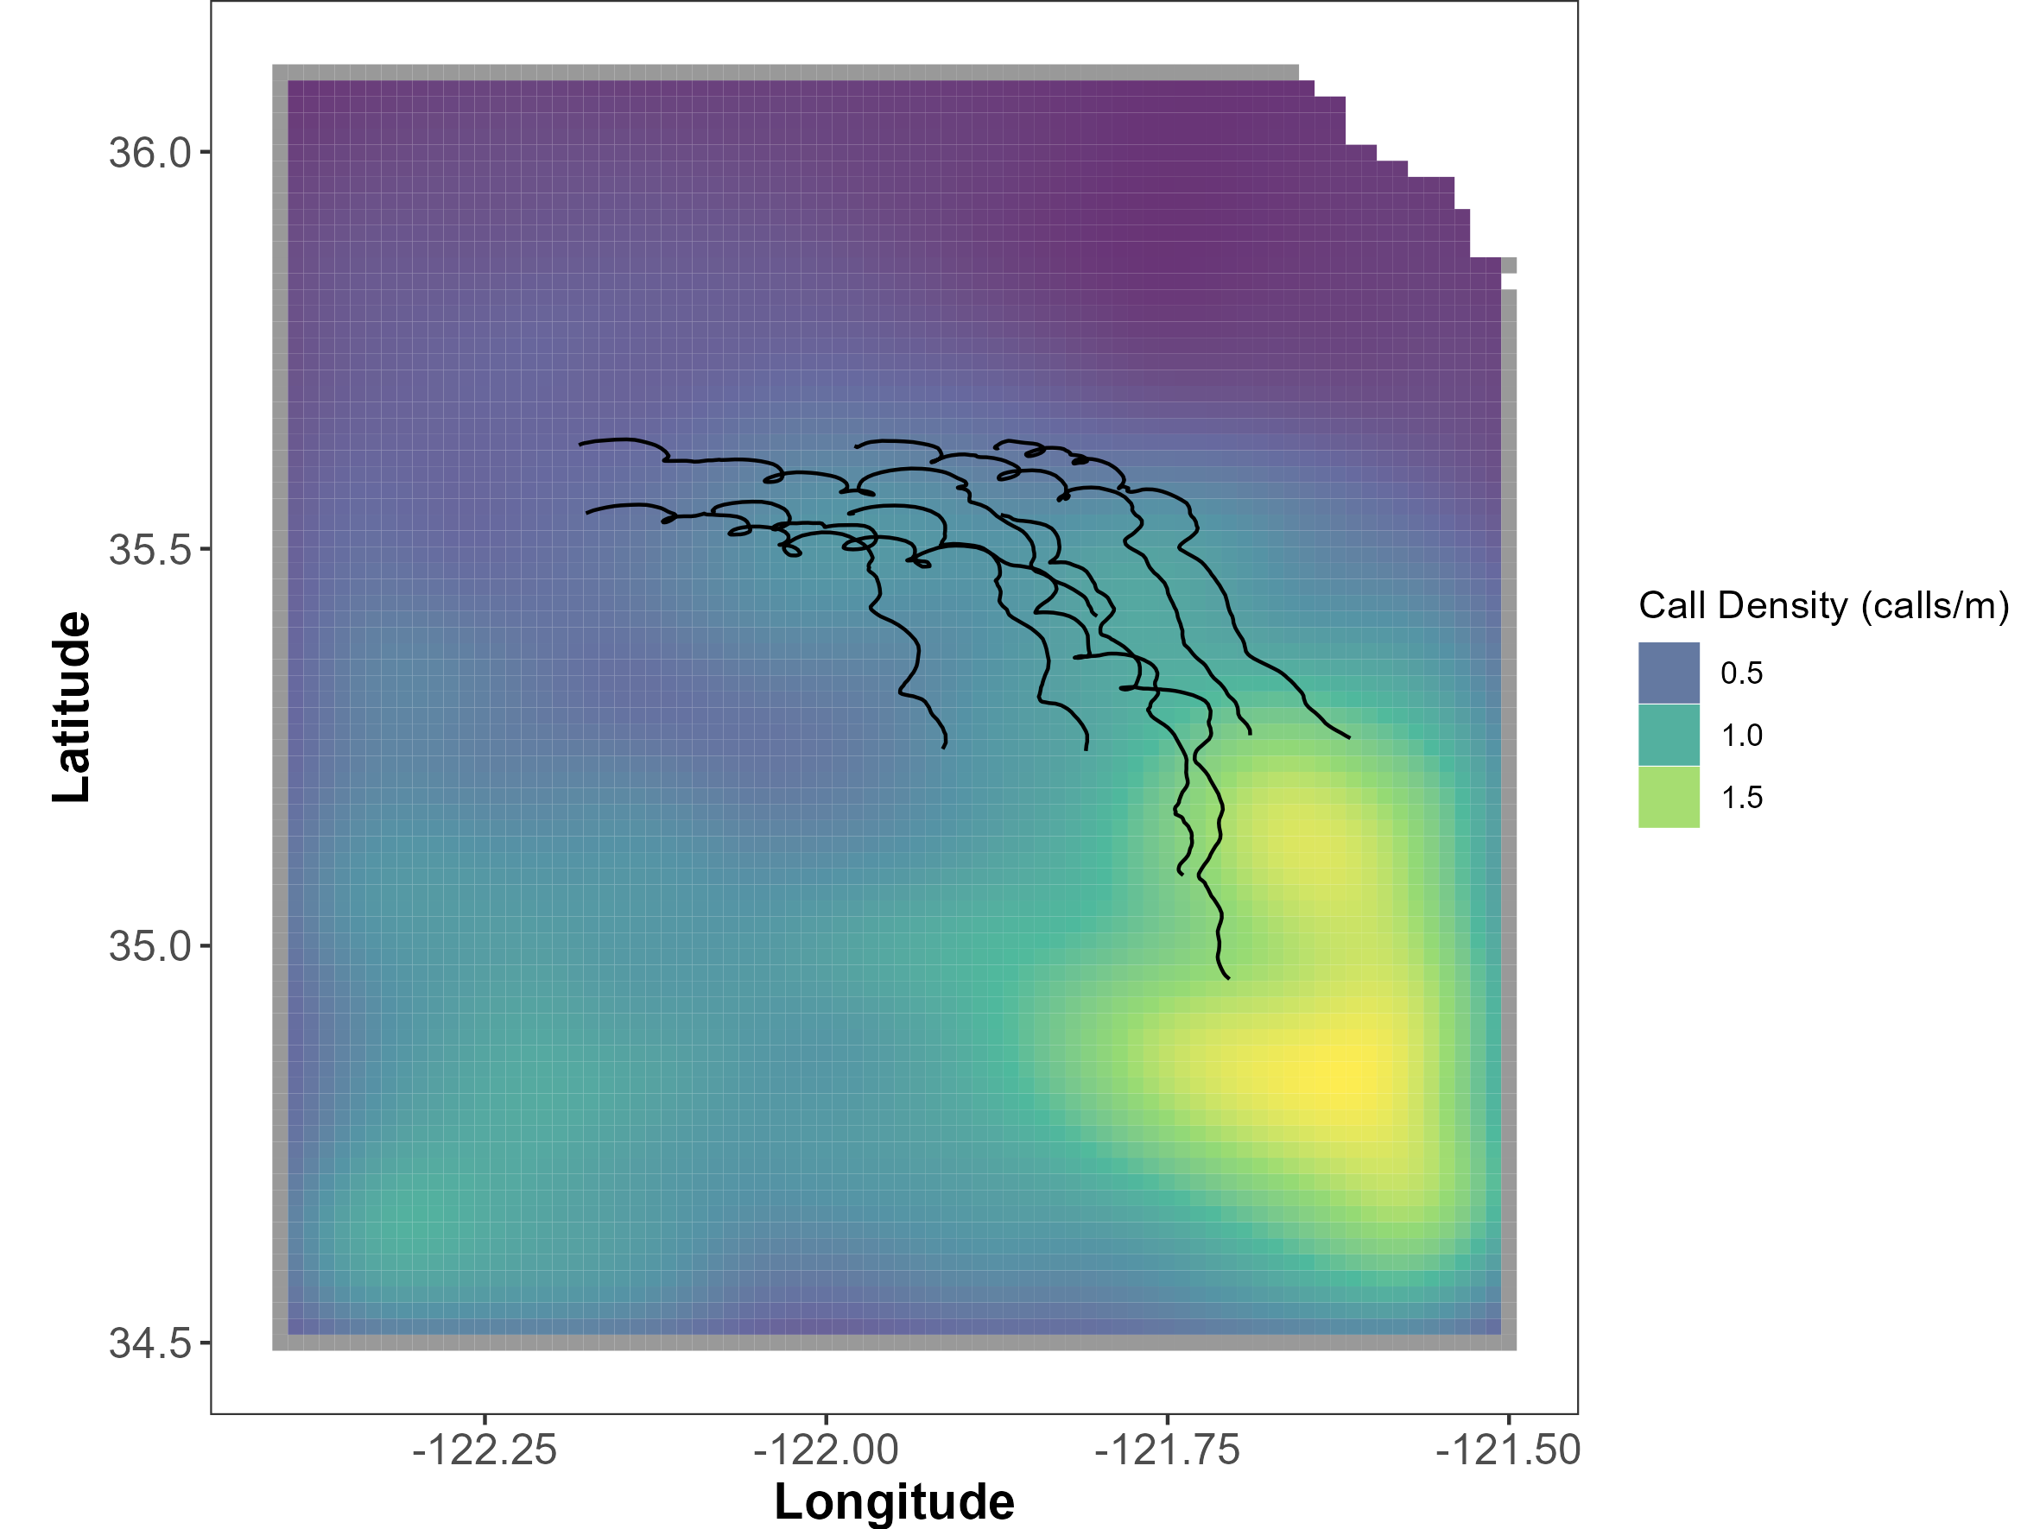

Figure H‑1. Tracks of 8 clustered drifting recorders with simulated fin whale call density.

Filled area represents simulated fin whale call density based on (Becker et al. 2020). Black lines indicate the drift path.

The proposed method is a grid approach that asks whether or not a call could have been produced by an animal in each of the grid cells within the survey region. The method involves two steps and accounts for spatial uncertainty throughout.

The first step in the localization method considers known biological parameters of the species and the measured SNR of the arriving call to determine the minimum and maximum range at which a call could have arrived.

SNR is defined as the Source level of a call minus the noise level at the sensor and the transmission loss over the range between the source and sensor.[58] Thus, if a call arrives at a sensor with an SNR of 45 dB, the ambient noise level in the fin whale band was 120 dB, then we can use knowledge of source level distribution to estimate the minimum and maximum range of each call. If fin whale source levels range between 170 and 190 dB then we know the animal must have been 3.6 to 46.4 km from the receiver. Thus, an annulus (doughnut!) of potential call origin centered at each drifting recorder location is created for each call. This information is particularly informative by itself but with multiple drifting recorders the annuli can be overlapped to narrow down the region of origin (Figure H‑2).

The second step applies to calls that were detected on two or more drifting recorders. In this case, the time-difference-of arrival, with associated positional error, is used to further limit the region of origin established in the first step.

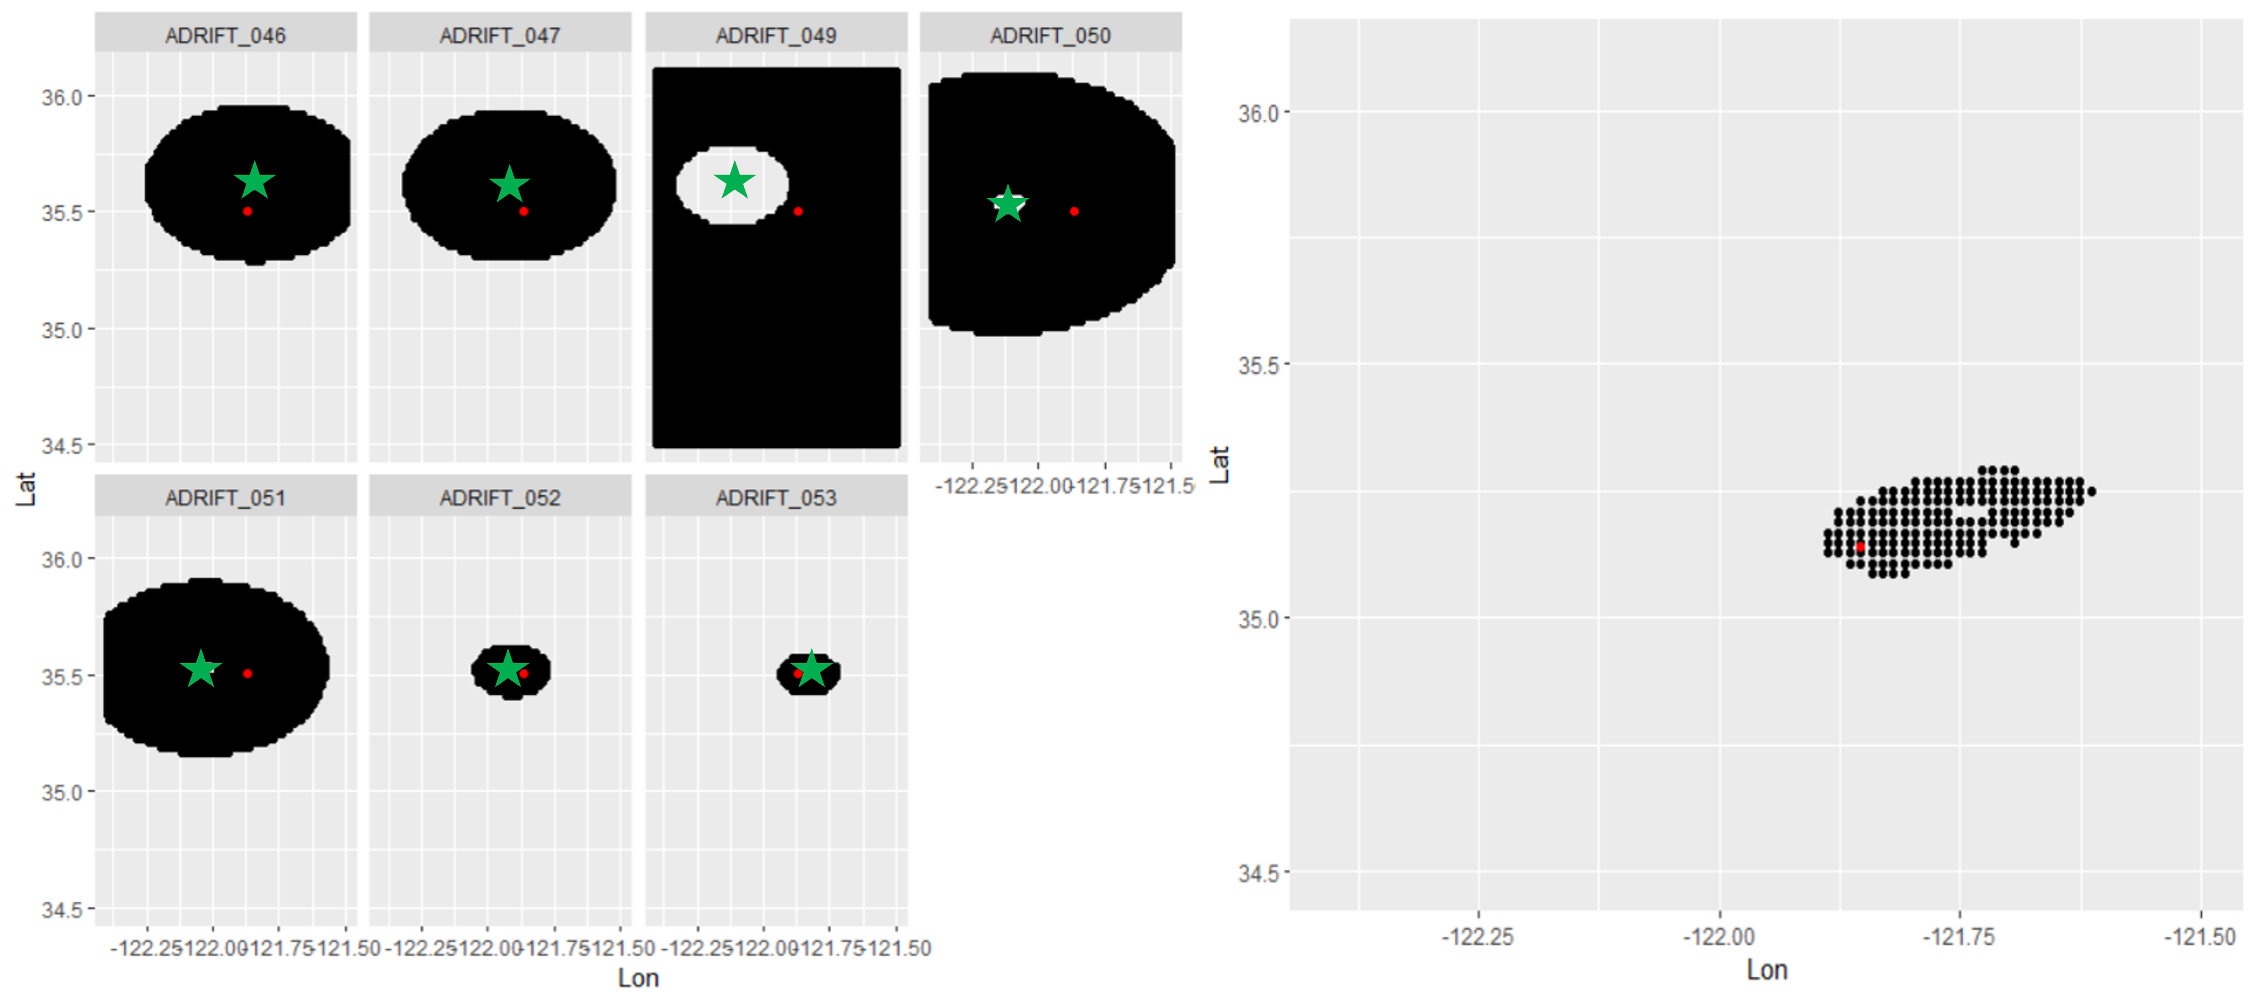

Figure H‑2. Variability in sound source location using multiple sensors.

Potential location of a source (red point) as detected by each of the drifting recorders (green star) at a given point during the deployment. Black areas represent the region from which the call could have originated according to the arrival SNR at each drifting recorder. Note the call was not detected by Adrift-047 and as such only a minimum location is known (left). The potential region of origin for the call based on the intersection of all drifting recorders (right).

Using the above approach, we estimated the area associated with each region of origin produced from the calls in the simulation (4,000 calls). The histogram densities show a bi-modal distribution with a low region size associated with larger numbers of drifting recorders, and larger region size associated with lower numbers of drifting recorders (Figure H‑3). The scatterplot provides the mean and 95% confidence intervals of the regions of origin based on the number of sensors deployed in the array (Figure H‑3) The majority of the calls were in the southern portion of the survey area and calls in these regions could only be detected by one or two instruments at most.

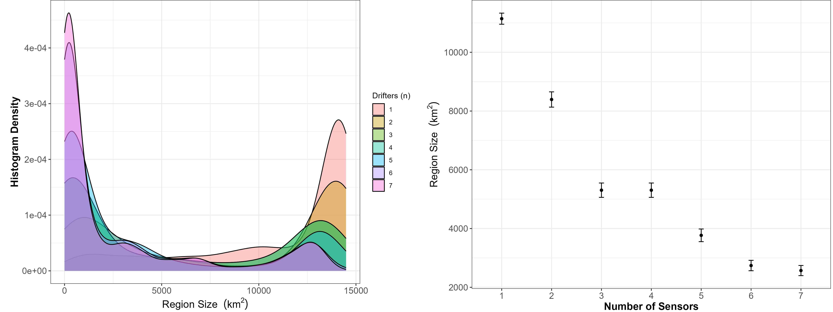

Figure H‑3. Histogram densities and scatterplot of estimated sound source location size based on number of drifting recorders.

Histogram densities (left) for the estimated total size of the sound source location for all calls in the simulation for different numbers of drifting recorders (shown as color). Scatterplot (right) of region size for different numbers of drifting recorders.

This preliminary modeling suggests that the dispersed sensors provided by the clustered deployment of multiple drifting recorders can allow for reducing the possible source location for sounds detected on multiple sensors. This improved spatial resolution of the sound source may improve the viability for using these data for population assessment. Future research should test these analytical methods on real data such as those provided during the Morro Bay surveys and identify how these methods can be used for population assessment.

1. Spatial Variation in Noise[59]

There is a concerted effort to understand whether and how ambient noise levels change between the baseline, construction, and operational phases of offshore wind farms and how this may affect different species present in the region. These baseline data are critical to monitor changes in sound levels from anthropogenic sources in space and time as activities related to offshore wind development increase.

Sound pressure levels vary as a function of three-dimensional location as well as time. Vertical placement of sensors will lead to different propagation conditions due to the temperature profile and thermocline, through surface and bottom reflections, and proximity to noise sources. Understanding the spatial extent of noise is a particularly challenging question for single sensor studies. Some of the principal questions needing to be addressed include, are the noise levels measured at a given hydrophone representative of those experienced by the species monitored? How do assumptions about frequency bands and integration periods (e.g., minutes vs. hours) vary over space?

The Adrift study project uses clusters of drifting recorders to produce snapshots of ambient noise levels and animal presence in wind energy areas that compliment single sensor seafloor hydrophones. With these buoys, we can begin to document spatial variability in soundscapes, validate propagation models, and better understand how well single sensors represent sound within the greater region.

A preliminary examination of the spatial cohesion of ambient noise levels was conducted across an array of 7 recorders drifting for 8 days in the Morro Bay region. Figure I‑1 shows the 2-minute median noise level in two third octave bins. Considerable variation in noise levels were observed in the first few days across both third octave bins with considerable variation in the 20 kHz bin. Storms moving through the area during the second half of the deployment raised the baseline noise levels nearly uniformly.

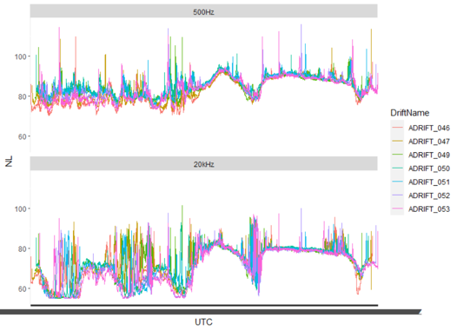

Figure I‑1. Time series of noise levels in 500 Hz and 20 kHz third octave bin.

Time series of noise levels recorded by the drifting recorders in the 500 Hz third octave bin (top) and the 20 kHz third octave bin (bottom).

The cohesion of these noise levels can be quantified using correlation scores. Correlation scores measure the strength and direction of the linear relationship between multiple measurements. Scores range from -1, indicating a perfectly inverse relationship between noise levels at different locations, and +1 indicating a perfect and positive correlation between noise levels at different locations. In order to assume that noise levels are similar across the study area, we would expect correlation scores between all instruments at or approaching 1.

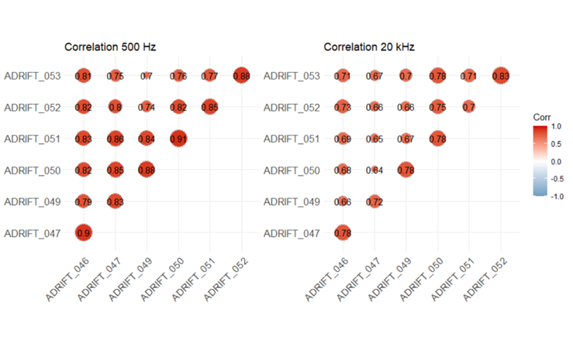

Figure I‑2. Correlation scores in 500 H z and 20 kHz third octave bins.

Correlation scores across the Morro Bay March 2023 drifting period in the 500 Hz third octave bin (left) and the 20 kHz third octave bin (right).

Figure I‑2 shows positive correlation between all drifting recorders within the region with scores ranging between 0.7 and 0.91 in the 500 Hz band and 0.64 and 0.83 in the 20 kHz band. This indicates that, on average, noise levels were somewhat correlated over the deployment and that noise levels from more closely spaced units were more highly correlated, as expected. Much of this correlation is attributed to the regional scale storms that uniformly affected the area.

Because the data from the drifting recorders inherently cover both space and time, we can model sound levels across the entire region (Figure I‑3). This pre-storm modelled data provides a view of the soundscape averaged across the region. The brighter colors (relating to higher noise levels) in the northwest were attributed to the approaching storm.

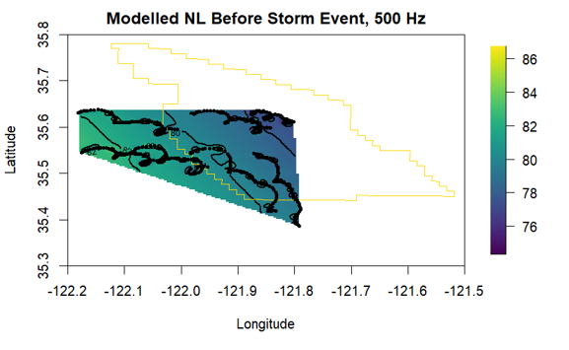

Figure I‑3. Noise map from clustered drifting recorders off Morro Bay.

Noise map for data from cluster of drifting recorders, with latitude on the x axis and longitude on the y axis. The Morro Bay WEA is outlined in gold and drift tracks are provided as black lines. The Morro Bay WEA is outlined in gold and drift tracks are provided as black lines. The modelled noise level before the storm is provided in color, ranging from 76 dB in dark blue to 86 dB in bright yellow.

This preliminary exploration of the data highlights some interesting spatial aspects of noise that warrant further investigation. Future analyses may include:

* Evaluate noise levels as a function of distance between sensors. Quantifying this relationship will help to validate propagation models and improve future estimates of noise levels from disparate sensors.
* Parse environmental and anthropogenic contributions to noise levels. Depth-dependent empirical models for wind-generated noise can be applied to drifting recorders (Hildebrand et al. 2021). Then, subtraction of wind-associated noise allows evaluation of sound maps such as Figure I‑3 for biological and anthropogenic activity.
* Evaluate depth-dependent changes in ambient noise levels. Sound levels recorded by drifting recorders can be compared with bottom-moored sensors to measure depth dependent changes in ambient noise levels. This is particularly relevant if future acoustic monitoring is limited to seafloor sensors, which do not occupy the predominant habitat of most marine mammals, or sensors that modulate their depth throughout the survey period (e.g., gliders).

1. Open Science
   1. Beaked Whale Classifier

Anne Simonis and Taiki Sakai developed a preliminary automated workflow for identifying and classifying beaked whale events. The initial approach used a MTC to identify candidate beaked whale clicks and group these into events. Initial attempts to use the MTC-defined events to train a BANTER model were not successful enough to deploy the model on new Adrift study data, so an attempt was made to incorporate a computer vision-based model to add additional information for the BANTER model. This combined outputs from a computer vision model that was trained on other beaked whale data with the original MTC data.

Preliminary results suggest there is a need for further development of the initial MTC detection step. The combined models results were promising but required improved training data.

* Detailed project status report can be found on GitHub.[60]
* Detailed summary of the original computer-vision model can be found on GitHub.[61]
  1. RoboJ

RoboJ (Robotic Jay) is an extension of work by Jay Barlow and Jeff Moore to estimate the density of beaked whales using detections from drifting recorders. The methods use the received angles of beaked whale events combined with known dive depth distributions to estimate the distance to the calling animals, which then is used to estimate the density using more traditional methods. Development is still ongoing with collaborators at Pacific Islands Fisheries Science Center (Janelle Badger and Jennifer McCullough), but near-final code for this project is available on RoboJ GitHub.[62]

* 1. Fin Model

Cory Hom-Weaver and Taiki Sakai developed a random forest model for classifying fin whale 20 Hz calls. This method uses PAMGuard's click detector and PAMpal to process click data and create a model training dataset. The model was trained on a subset of manually annotated Adrift study data, and results were validated on a subset of data. The validation set was used to identify criteria for manually reviewing the predictions, and then the model was used to predict on the remainder of Adrift study data. A set of functions to create review products for each predicted drift allowed the analyst to quickly scan data to verify fin whale presence.

* Code for creating review products and model training is available on GitHub.[63]
* Detection, Classification, Localization and Density Estimation (DCLDE) Workshop 2022 poster about an early version of the model is available on GitHub Repository.[64]
  1. PAMpal

PAMpal is an R package for processing passive acoustic data collected using PAMGuard software (PAMGuard.org). PAMpal was initially funded by NOAA's Advanced Sampling Technology Working Group; additional functionality to support the Adrift project was made to PAMpal to allow others to benefit from these developments. PAMpal is increasingly being adopted by scientists using mobile platforms.

* PAMpal on CRAN[65]
* PAMpal User Guide[66]
* PAMpal GitHub[67]
  1. PAMscapes

The NOAA-funded "Biotic, Abiotic, and Anthropogenic Contributors to the Soundscapes: Development of an Open -Source Method for Data Integration & Visualization" developed the PAMscapes R package, including several of the visualizations used in this report. This effort also allows for integration of Automatic Identification System ship tracks and weather data with acoustic detections from PAMpal.

* Final report[68]
* PAMscapes on CRAN[69]
* PAMscapes GitHub[70]

2. Education and Outreach Details
   1. Formal and Information Education and Outreach

* "Bringing Ocean Acoustics Data to Classrooms"- Educator workshop to develop K-12 lesson plans based on passive acoustic datasets. Partners include San Diego County Office of Education and UCSD's Center for Research on Educational Equity, Assessment & Teaching Excellence. August 3-6, 2020.
* "Eavesdropping on the Ocean" Data Nugget.[71]
  1. Participatory research (aka "Citizen Science")

Ocean Voices, Zooniverse

* Collaboration with Dagny Ysais, SFSU (San Francisco State University) Master's student
* Beta version of online acoustic data analysis[72]
* Supporting code available.[73]
  1. Public access to acoustic data and tools
* Soundcloud[74] access to sample audio files (biological and anthropogenic sounds)
* Public Soundscape literature repository.[75]
  1. Media
* Will San Francisco’s wind farms damage underwater life? Here’s what scientists are finding.[76] San Francisco Chronicle, July 7 2022.
* How could offshore wind impact marine life off SLO County coast? Experts listen for answers.[77] San Luis Obispo Tribune. March 20, 2023.
  + 1. Blog Posts
* NOAA's Ocean Exploration Expedition Mission Logs: Partnerships for Common Goals: Acoustic Buoy to Study Marine Mammals in the California Current,[78] October 3, 2019
* Sound Bytes: Passive Acoustics Starts with the Right Equipment,[79] October 21, 2021
* Sound Bytes: The Power of Partnerships,[80] November 22, 2021
* Sound Bytes: Fresh Catch – Lessons from a Fisherman,[81] December 7, 2021
* Sound Bytes: Visualizing Marine Soundscapes Through CalSound,[82] December 16, 2021
* Sound Bytes: DriftWatch—What to Do When Buoys Go Rogue,[83] January 20, 2022
* Sound Bytes: The Coolest Pool You’ve Ever Seen,[84] February 3, 2022
* Sound Bytes: How I Acquired My Superpower,[85] February 10, 2022
* Sound Bytes: Out To Sea And Off To The Races,[86] March 3, 2022
* Sound Bytes: Ohana Means family,[87] April 6, 2022
* Sound Bytes: Hooking Young Students on Research,[88] May 3, 2022
* Sound Bytes: A High School Student’s Journey Into Marine Acoustic Research,[89] July 12, 2022
* Sound Bytes: Why We Look at Sound, and How You Can Help!,[90] September 23, 2022
* Sound Bytes: What We Can Learn From How Indigenous Peoples Listen,[91] October 11, 2022
* Sound Bytes: Championing Open Science,[92] December 7, 2022
* Sound Bytes: Gearing up for Field Work,[93] February 28, 2023
* Sound Bytes: Adventures of a Drifting Buoy,[94] April 25, 2023
* Sound Bytes: Learning Through Experience,[95] July 10, 2023
* Sound Bytes: Waving Goodbye to Adrift Fieldwork,[96] December 26, 2023
  1. Presentations
* F.O.S.S.A. Open-source software to simplify DCLDE Workflows. 2022. Taiki Sakai. Oral Presentation at DCLDE Workshop 2022, Honolulu, Hawaii.
* An Automated Approach to the Detection and Classification of Fin Whales in the California Current Ecosystem using Open-Source Software. 2022. Cory Ann Hom-Weaver, Taiki Sakai, and Shannon Rankin. Poster Presentation at DCLDE Workshop 2022, Honolulu, Hawaii.
* Beyond performance - advanced techniques and lessons learned from training a neural network to classify visual representations of beaked whale echolocation clicks 2024. Taiki Sakai. Oral presentation at the DCLDE Workshop 2024, Rotterdam, Netherlands.
* Introduction to FOSSA (Free & Open-Source Software for Acoustics). 2022. Shannon Rankin, Taiki Sakai, and Eric Archer. Tutorial at NOAA's Third Protected Species Assessment Workshop. Complete Tutorial and dataset publicly available on Figshare.[97]
* "Adrift in the California Current", webinar for representatives from the Bureau of Ocean Energy Management, Ocean Protection Council, and the California Coastal Commission. March 19, 2020.
* "Adrift with a Triple Helix Twist", oral presentation at Blue Tech Week Conference. November 20-22, 2019, San Diego, CA.
* "Active Listening: Using Sound to Study Marine Mammals and the California Current Ecosystem", Anne Simonis, an invited lecture for SFSU Rosenberg Institute Seminar Series. February 22, 2023
* "Eavesdropping on the underwater world: Studying acoustics to protect whales and dolphins," Anne Simonis, an invited lecture for St. Francis Yachting Luncheon.[98] February 22, 2023.
  + Adrift in the California Current: Passive acoustic monitoring for ecosystem studies. Anne Simonis, Shannon Rankin, Jan Roletto, and Danielle Lipski. Oral presentation at Beyond the Golden Gate Research Symposium. January 19-21, 2022.
  + Adrift in the California Current: Clustered drifting recorders describe spatial variation in soundscapes and marine mammal presence within offshore wind energy areas along the US West Coast. Anne Simonis, Cory Hom-Weaver, Kourtney Burger, Kaitlin Palmer, Taiki Sakai, Shannon Rankin. Poster presentation at Ocean Observing in California Conference. May 15-17, 2024
  1. Student and Intern Projects
* Pacific white-sided and Risso's dolphin acoustic monitoring in a warming California Current.[99] Alexandra Fiske, Seatech intern, Oakland Technical High School, 2021-2022
* Diurnal and Nocturnal Delphinid Echolocation Click Patterns off the California Coast in 2018.[100] Keisha Askoak, Seatech intern, Mt. Edgecumbe High School, 2022-23
* Occurrence of Anthropogenic Noise and Humpback Whales in California in 2018.[101] Audrey Bahnke, Sarah Bahnke, Virginia Pearson, Seatech interns, Mt. Edgecumbe High School, 2022-23.
* Spatial patterns in humpback whale song in central California waters.[102] Virginia Pearson, Seatech intern, Mt. Edgecumbe High School, 2023-24
* Spatial and temporal patterns of Bocaccio rockfish chorusing in central California.[103] Gale McCrary, Rie Christensen, Seatech interns, Mt. Edgecumbe High School, 2023-24.
* CalSound: Visualizing the Sounds of the Ocean. UC Berkeley Fung Fellowship Conservation + Technology.[104] Spring semester 2021 Design Challenge. 9 undergraduate students.
* Using passive acoustic data to assess sperm whale population structure in the California Current. NOAA EPP Scholar Brittany Melton.
* 2021 NOAA EPP Projects: Humpback Whale Acoustics. NOAA EPP Scholar Maya Philipp.
* Assessing noise exposure to beaked and sperm whales in the California Current. Marina Bozinovic, Master of Science thesis, SFSU.
* Classifying species producing narrowband high-frequency echolocation clicks in the California Current. Jackson Vanfleet-Brown, Master of Science thesis, SFSU

|  |  |
| --- | --- |
| Image result for department of interior logo | **U.S. Department of the Interior (DOI)**  DOI protects and manages the Nation's natural resources and cultural heritage; provides scientific and other information about those resources; and honors the Nation’s trust responsibilities or special commitments to American Indians, Alaska Natives, and affiliated island communities. |
| BOEM Logo with wave through O | **Bureau of Ocean Energy Management (BOEM)**  BOEM’s mission is to manage development of U.S. Outer Continental Shelf energy and mineral resources in an environmentally and economically responsible way. |
|  | **BOEM Environmental Studies Program**  The mission of the Environmental Studies Program is to provide the information needed to predict, assess, and manage impacts from offshore energy and marine mineral exploration, development, and production activities on human, marine, and coastal environments. The proposal, selection, research, review, collaboration, production, and dissemination of each of BOEM’s Environmental Studies follows the DOI Code of Scientific and Scholarly Conduct, in support of a culture of scientific and professional integrity, as set out in the DOI Departmental Manual (305 DM 3). |

1. https://github.com/SAEL-SWFSC/Adrift/blob/main/supplement/AdriftOSU_Report_Feb2024_ASzesciorka.pdf
2. https://sael-swfsc.github.io/adrift-field-methods/content/Hardware-Summary.html
3. https://www.oceanscienceanalytics.com/
4. https://sael-swfsc.github.io/adrift-analysis-methods/
5. https://sael-swfsc.github.io/adrift-analysis-methods/content/DataArchive/DataPrep.html
6. https://github.com/SAEL-SWFSC/Adrift/blob/main/supplement/OSA_ADRIFT_060_UID1_Event.pdf
7. https://github.com/MarineBioAcousticsRC/Triton
8. https://sael-swfsc.github.io/adrift-analysis-methods/content/ToothedWhales/SpermWhales-Detection.html
9. http://pamguard.org/
10. https://sael-swfsc.github.io/adrift-analysis-methods/content/ToothedWhales/BeakedWhales-Detection.html
11. https://github.com/taikiSan21/roboj
12. https://sael-swfsc.github.io/adrift-analysis-methods/content/ToothedWhales/Dolphins-Detection.html
13. https://sael-swfsc.github.io/adrift-analysis-methods/content/ToothedWhales/NBHF-Detection.html
14. https://sael-swfsc.github.io/adrift-analysis-methods/content/BaleenWhales/Overview.html#blue-whales
15. https://github.com/SAEL-SWFSC/Adrift/blob/main/supplement/OSA_NMSF_2023.578_Project_Report.pdf
16. https://sael-swfsc.github.io/adrift-analysis-methods/content/BaleenWhales/Overview.html#fin-20-hz-adrift
17. https://github.com/SAEL-SWFSC/Adrift/blob/main/supplement/OSA_NMSF_2023.578_Project_Report.pdf
18. https://store.birds.cornell.edu/collections/raven-sound-software
19. https://sael-swfsc.github.io/adrift-analysis-methods/content/BaleenWhales/Overview.html#gray-and-humpack
20. https://seamap.env.duke.edu/species/180530
21. https://sael-swfsc.github.io/adrift-analysis-methods/content/BaleenWhales/Overview.html#fin-20-hz-adrift
22. https://github.com/SAEL-SWFSC/Adrift/blob/main/supplement/OSA_NMSF_2023.578_Project_Report.pdf
23. https://github.com/SAEL-SWFSC/Adrift/blob/main/figs/PossSei_Pascal010.png
24. https://sael-swfsc.github.io/adrift-analysis-methods/content/BaleenWhales/Overview.html#gray-and-humpack
25. https://seamap.env.duke.edu/dataset/861
26. https://sael-swfsc.github.io/adrift-analysis-methods/content/BaleenWhales/Overview.html#minke
27. https://sanctsound.ioos.us
28. https://sael-swfsc.github.io/adrift-analysis-methods/content/DataArchive/DataQualityCheck.html#scan-ltsa-for-noisy-data
29. https://sael-swfsc.github.io/adrift-analysis-methods/content/Soundscapes/Metrics.html#detect-vessels
30. https://apps-nefsc.fisheries.noaa.gov/pacm
31. https://sael-swfsc.github.io/adrift-analysis-methods/content/DataArchive/TethysDeployments.html
32. https://cran.r-project.org
33. https://drive.google.com/file/d/1VE2-jXCJet4iO_4bWywwW0dPtOK1BcLA/view
34. https://drive.google.com/file/d/1MsorXXkcHk8YNyHgldJ_-ApASLcEkoJy/view
35. https://drive.google.com/file/d/17qMPka0tTKjmF8jlAQD24QiWRzs3E9P4/view
36. https://www.sdcoe.net/ngss/phenomena-and-the-ngss
37. https://datanuggets.org/2024/04/eavesdropping-on-the-ocean
38. https://www.zooniverse.org/projects/annelistens/ocean-voices
39. https://github.com/TaikiSan21/wav2mp3
40. https://www.fisheries.noaa.gov/science-blog/sound-bytes-fresh-catch-lessons-fisherman
41. https://www.fisheries.noaa.gov/science-blog/sound-bytes-gearing-field-work
42. https://www.fisheries.noaa.gov/science-blog/sound-bytes-hooking-young-students-research
43. https://www.fisheries.noaa.gov/taxonomy/term/1000356091
44. https://www.ncei.noaa.gov/maps/passive-acoustic-data/
45. https://apps-nefsc.fisheries.noaa.gov/pacm
46. https://github.com/SAEL-SWFSC/Adrift/blob/main/figs/PASCAL_PSD_SeasonRegion.png
47. https://github.com/SAEL-SWFSC/Adrift/blob/main/figs/PASCAL_humpbackSongSocial_HourlyPresence.png
48. https://github.com/SAEL-SWFSC/Adrift/blob/main/figs/PossSei_Pascal010.png
49. https://github.com/SAEL-SWFSC/Adrift/blob/main/figs/CCES_PSD_SeasonRegion.png
50. https://github.com/SAEL-SWFSC/Adrift/blob/main/figs/CCES_humpbackSongSocial_HourlyPresence.png
51. Analysis and Summary by Natalie Posdaljian, nposdalj@ucsd.edu
52. https://github.com/TaikiSan21/RoboJ
53. Analysis and Summary by Anne Simonis, asimonis@sfsu.edu
54. https://scholarworks.calstate.edu
55. Analysis and Summary by Elizabeth Ferguson, eferguson@oceanscienceanalytics.com
56. https://github.com/SAEL-SWFSC/Adrift/blob/main/supplement/OSA_NMSF_2023.578_Project_Report.pdf
57. Analysis and Summary by Kaitlin Palmer, kpalmer@coa.edu
58. https://github.com/JPalmerK/AmbiguityGrids
59. Analysis and Summary by Kaitlin Palmer, kpalmer@coa.edu
60. https://github.com/SAEL-SWFSC/Adrift/blob/main/supplement/Simonis.Sakai_BeakerMTC_May2024.pdf
61. https://github.com/SAEL-SWFSC/Adrift/blob/main/supplement/TSakai_beakerVisionModel_May2024.pdf
62. https://github.com/TaikiSan21/RoboJ
63. https://github.com/TaikiSan21/Fin_RF
64. https://github.com/shannonrankin/ADRIFT_Report/blob/main/supplement/DCLDE2022_HomWeaver_An%20automated%20approach%20to%20the%20detection%20and%20classification%20of%20fin%20whales%20in%20the%20California%20Current%20Ecosystem%20using%20open%20source%20software.pdf
65. https://cran.r-project.org/package=PAMpal
66. https://taikisan21.github.io/PAMpal
67. https://github.com/TaikiSan21/PAMpal
68. https://github.com/shannonrankin/fossa_soundscape/files/13231870/Rankin.etal_FOSSA.Soundscape.Report_OAP2023.pdf
69. https://cran.r-project.org/package=PAMscapes
70. https://github.com/TaikiSan21/PAMscapes
71. https://datanuggets.org/2024/04/eavesdropping-on-the-ocean
72. https://www.zooniverse.org/projects/annelistens/ocean-voices
73. https://github.com/asimonis/OceanVoices
74. https://soundcloud.com/southwestacousticecology
75. https://www.zotero.org/groups/58164/soundscape
76. https://www.sfchronicle.com/climate/article/california-wind-farm-17277935.php#photo-22656909
77. https://www.sanluisobispo.com/news/local/environment/article273259360.html
78. https://oceanexplorer.noaa.gov/explorations/19express/logs/oct3/oct3.html
79. https://www.fisheries.noaa.gov/science-blog/sound-bytes-passive-acoustics-starts-right-equipment
80. https://www.fisheries.noaa.gov/science-blog/sound-bytes-power-partnerships
81. https://www.fisheries.noaa.gov/science-blog/sound-bytes-fresh-catch-lessons-fisherman
82. https://www.fisheries.noaa.gov/science-blog/sound-bytes-visualizing-marine-soundscapes-through-calsound
83. https://www.fisheries.noaa.gov/science-blog/sound-bytes-driftwatch-what-do-when-buoys-go-rogue
84. https://www.fisheries.noaa.gov/science-blog/sound-bytes-coolest-pool-youve-ever-seen
85. https://www.fisheries.noaa.gov/science-blog/sound-bytes-how-i-acquired-my-superpower
86. https://www.fisheries.noaa.gov/science-blog/sound-bytes-out-sea-and-races
87. https://www.fisheries.noaa.gov/science-blog/sound-bytes-ohana-means-family
88. https://www.fisheries.noaa.gov/science-blog/sound-bytes-hooking-young-students-research
89. https://www.fisheries.noaa.gov/science-blog/sound-bytes-high-school-students-journey-marine-acoustic-research
90. https://www.fisheries.noaa.gov/science-blog/sound-bytes-why-we-look-sound-and-how-you-can-help
91. https://www.fisheries.noaa.gov/science-blog/sound-bytes-what-we-can-learn-how-indigenous-peoples-listen
92. https://www.fisheries.noaa.gov/science-blog/sound-bytes-championing-open-science
93. https://www.fisheries.noaa.gov/science-blog/sound-bytes-gearing-field-work
94. https://www.fisheries.noaa.gov/science-blog/sound-bytes-adventures-drifting-buoy
95. https://www.fisheries.noaa.gov/science-blog/sound-bytes-learning-through-experience
96. https://www.fisheries.noaa.gov/science-blog/sound-bytes-waving-goodbye-adrift-fieldwork
97. https://figshare.com/account/home#/projects/137197
98. https://www.youtube.com/watch?v=uIotjEp7YmY
99. https://www.youtube.com/watch?v=eGEglgvAQY8
100. https://youtu.be/qkdHeOOh0VY?t=2070
101. https://www.youtube.com/watch?v=qkdHeOOh0VY&t=1078s
102. https://youtu.be/XU-3Fo1XcBw?feature=shared
103. https://youtu.be/XU-3Fo1XcBw?feature=shared
104. https://www.youtube.com/watch?v=Mbwbx2YY4kA